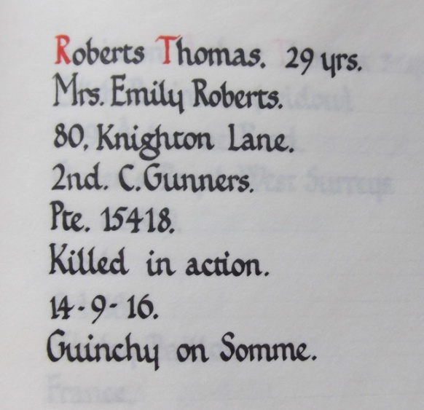
Private Tom Roberts
2nd Coldstream Guards
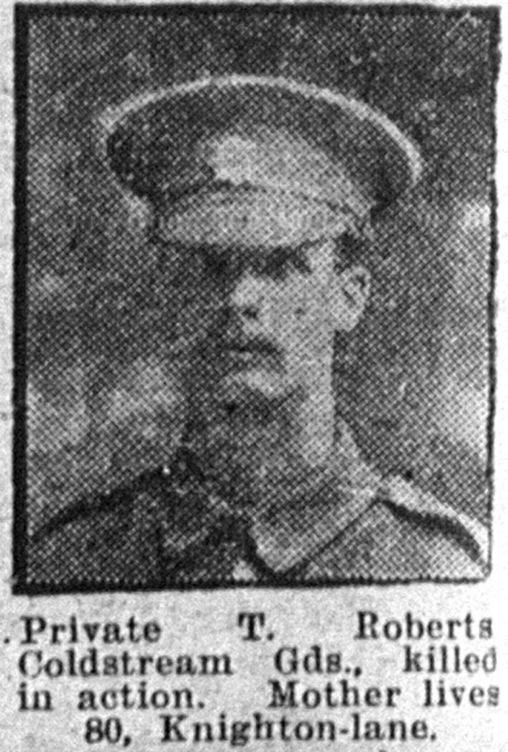
Service No: 15418
School Records give Thomas Roberts birthday as 14thDecember 1887 no baptism found- the son of William & Emily Roberts.

William ROBERTS & Emily Amphlett married in
Nottingham St Mary 24th February 1879

1891 census for: Main Street, Granby, Sutton Close
ROBERTS, WilliamHead Married M311860Agricultural LaborerSutton, Notts
ROBERTS, EmilyWife Married F44 1847 Hartpury, Gloucestershire
ROBERTS, Gertrude Daughter Single F 14 1877 Gloucester, ROBERTS, Kate Daughter F9 1882 Scholar Sutton, Nottinghamshire
ROBERTS, John W Son M7 1884 Scholar Redhill, Nottinghamshire
ROBERTS, TomSon M3 1888 Daybrook, Nottinghamshire
Illus. Chron 16-Dec1916 ROBERTS, MaryDaughter F1 1890 Sutton, Nottinghamshire

1901 census: 80, Knighton Lane, Leicester
ROBERTS, William Head Married M 44 1857 Gas Labourer Sutton, Nottinghamshire
ROBERTS, Emily Wife Married F 58 1843 Hartpuory, Gloucestershire
ROBERTS, Kate Daughter Single F 19 1882 Hosiery Stamper Sutton in Vale, Notts
ROBERTS, John W Son Single M 17 1884 Hosiery Trimmer Arnold, Notts
ROBERTS, Tom Son Single M 13 1888 Cycle Trade Tyre MakerDaybrook, Notts
ROBERTS, Mary E Daughter F 11 1890 Sutton, Nottinghamshire

1911 census: 80 Knighton Lane Leicester
ROBERTS, William Head Married M 60 1851 Gas Labourer Notts Sutton in the Vale
ROBERTS, Emily Wife Married 32 years F 67 1844 Gloucestershire Hartpury
ROBERTS, Tom Son Single M 24 1887 Hosiery Trimmer NottsDaybrook
WELLS, Bertie Gleeson Boarder Married M 22 1889 AsstSchool Teacher Leics Knighton
WELLS, Mary Eleanor Boarder Married 2 years F 21 1890 Hosiery Counter Notts Sutton in the Vale
WELLS, Blanche Eleanor Daughter F 2 1909 Leicester

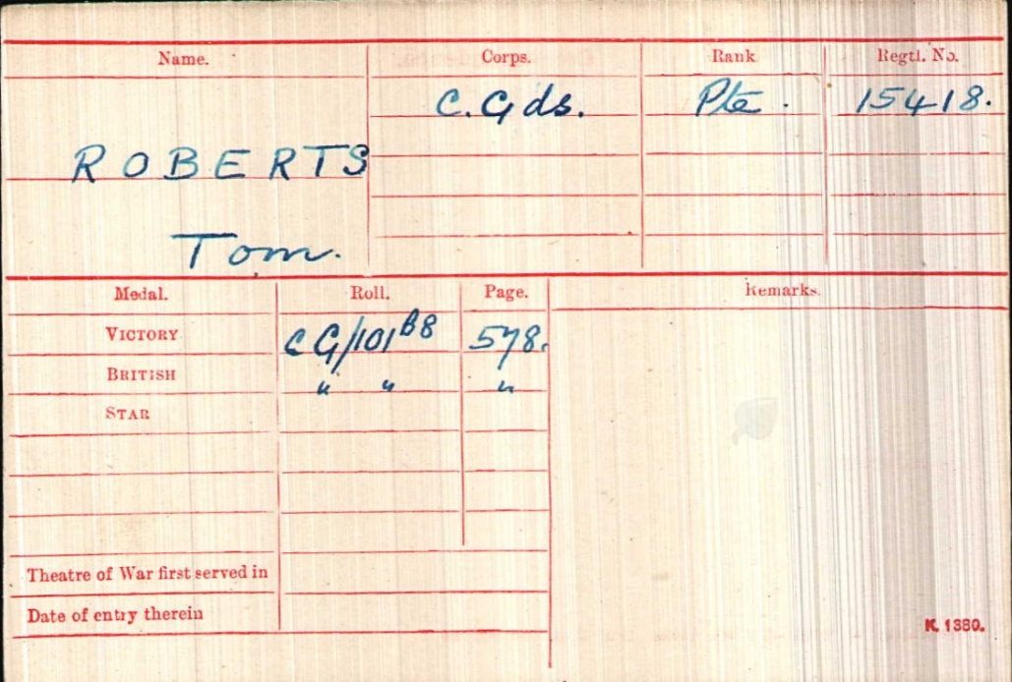
Service Records

Tom Roberts was killed in action on 16th September 1916

He is remembered on
Panel Reference Pier,
Face 7D & 8D.
Thiepval Memorial

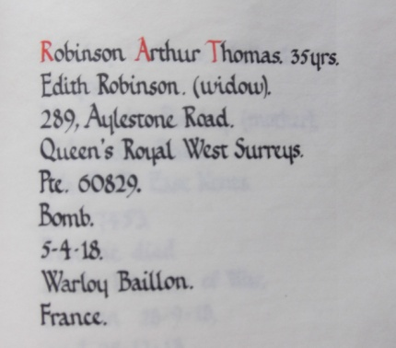
Private Arthur Edward Robinson,
The Queen's (Royal West Surrey Regiment) 6th Bn
Service No:60829

School records give his date of birth as 31st October 1881
Son of William Henry & Ada Robinson
Husband of Edith Robinson, of Aylestone Rd., Leicester.

1901 census transcription details for: 42, Milligan Road, Leicester
ROBINSON, William H Head Married M 41 1860 Bricklayer Blaby, Leicestershire
ROBINSON, Ada Wife Married F 40 1861 Aston, Warwickshire
ROBINSON, Arthur E Son Single M 19 1882 Cigar Maker Leicester
ROBINSON, William H Son Single M 17 1884 Gas Fitter Leicester
ROBINSON, Herbert E Son Single M 14 1887 Office Boy Shoe Factory Leicester
ROBINSON, Sidney F Son Single M 10 1891 Leicester
Marriage 05-Sep 1908 Aylestone Park, St James
Arthur Edward ROBINSON
& Edith POTTERTON

ROBINSON, Rowland A Son Single M 6 1895 Leicester
ROBINSON, Doris E Daughter Single F 2 1899 Leicester
ROBINSON, Phyllis L Daughter Single F 0 (5W) 1901 Leicester
SMITH, Mary J Boarder Single F 31 1870 Hosiery Machinist Leicester

1911 census: 41 Duncan Road Leicester
ROBINSON, Arthur Edward Head Married M 29 1882 Leaf Sorter LeicsAylestone
ROBINSON, Edith Wife Married 2 years F 27 1884 Leicester Leics

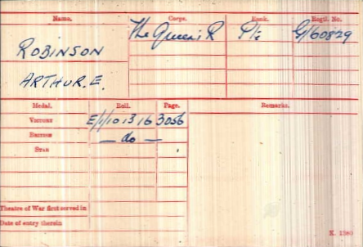

Date of Death:05/04/1918 Age:36
Grave Reference IV. E. 8. WARLOY-BAILLON COMMUNAL CEMETERY EXTENSION

Soldier’s effects
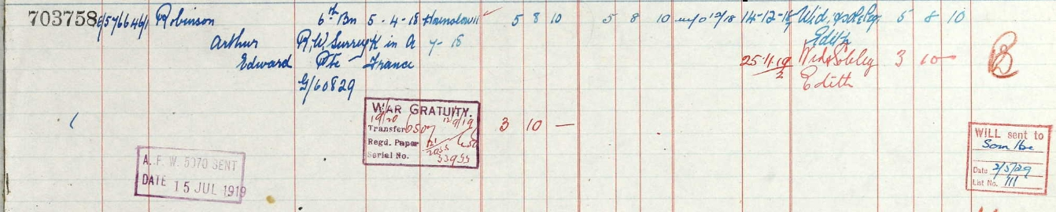
Private Albert Edward Rowe, Illus. Chron 26-Feb 1916
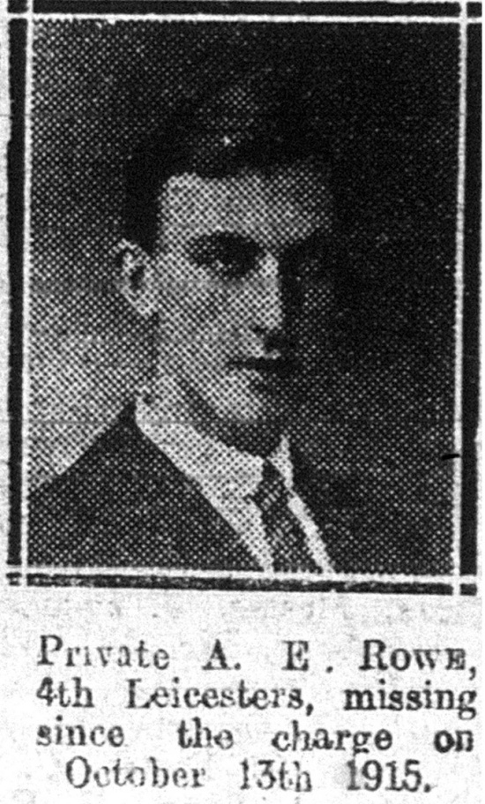
Leicestershire Regiment 1st/4th Bn.
Service No:3581

Born the son of Ernest & Margaret Roe and Baptised at St James on 28th April 1897 – His father died in 1897 aged 23 and his mother remarried late in 1901
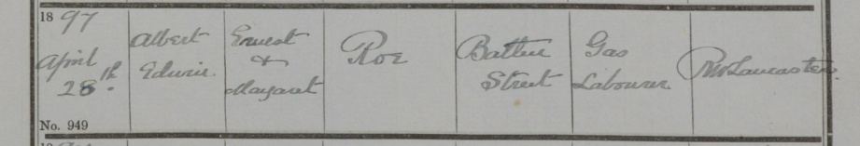

Son of Mrs. Margaret Day, of 76, Boundary Rd., Aylstone Park, Leicester.

1901 Census Batten Street, Leicester,
John Lane Head Married Male 55 1846 Contractor's Navvy
Buckinghamshire,
Eliza Lane Wife Married Female 53 1848 Salford, Bedfords
Mary A Lane Daughter Single Female 27 1874 Shirt Machinist Hosiery Salford, Bedfordshire,
Margaret Roe Daughter Widow Female 24 1877 Ironer Hosiery
Old Basford, Notts
John Lane Son Single Male 22 1879 Bricklayer Labourer Old Basford, Nottinghamshire,
Alice Lane Daughter Single Female 18 1883 Shirt Machinist Hosiery Old Basford, Notts
Albert Roe Grand Son Male 61895Leicestershire,
Gertie Roe Grand Daughter Female 4 1897 Leicestershire,

1911 census: Batten St Leicester
DAY, William G Head Married M 36 1875 Gas Labourer Saltley Birmingham
DAY, Margaret Wife Married9 years F 34 1877 Old Basford Notts
ROE, Albert E Son Single M 16 1895 Hosiery Hand Warehouseman Leicester Leicestershire
ROE, Gertrude Daughter F 14 1897 Corset Trade Leicester Leicestershire
DAY, Margaret Daughter F 0 (5 MONTHS) 1911 Leicester Leicestershire

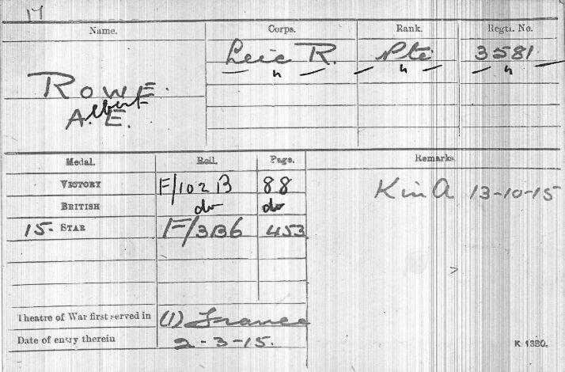

Date of Death: 13/10/1915
Age:21
ReferencePanel
42 to 44.
LOOS MEMORIAL

Private Charles William Sargeant, Mercury 02-Jun 1915
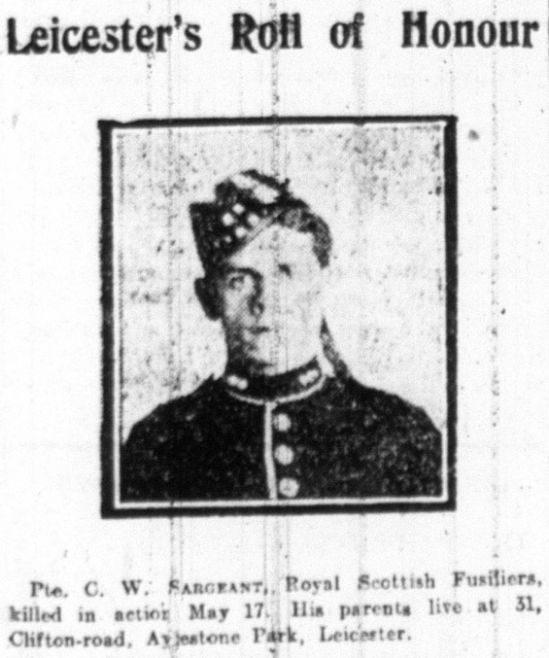
Royal Scots Fusiliers 1st Bn.
Service No:11054

Son of Charles B. Sargeant, of 31, Clifton Rd., Leicester.

Charles Bird Sargeant& Alice Jephcote married in 1897

1911 census: 31 Clifton Road Leicester
SARGEANT, Charles Head Married M 35 1876 Shoe Press Man Northampton
SARGEANT, Alice Wife Married13 years F 29 1882 Hosiery Turner Warwickshire Birmingham
SARGEANT, William Son M 13 1898 School Leicester
SARGEANT, Birt Son M 11 1900 School Leicester
SARGEANT, John Son M 10 1901 School Leicester
SARGEANT, Liley Daughter F 9 1902 Leicester
SARGEANT, Doris Daughter F 7 1904 Leicester
SARGEANT, Earnest Son M 5 1906 Leicester

1901 Census 36, Cromwell Road, Leicester,
Charles B Sargeant Head Married Male 25 1876 Rough Stuff Cutter Shoe Trade Northampton,
Alice Sargeant Wife Married Female 20 1881 - Hinckley, Leicestershire,
Charles W Sargeant Son - Male 3 1898 - Leicester, Leicestershire,
Bert H Sargeant Son - Male 1 1900 - Leicester, Leicestershire,
John E Sargeant Son - Male 0 1901 - Leicester, Leicestershire,
Sarah Adcock Boarder Single Female 21 1880 Laundress Hinckley, Leicestershire
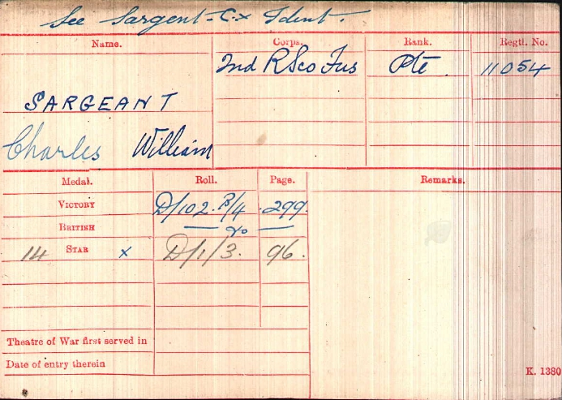

Date of Death:
17/05/1915Age:18
ReferencePanel
19 and 33.
YPRES
(MENIN GATE) MEMORIAL

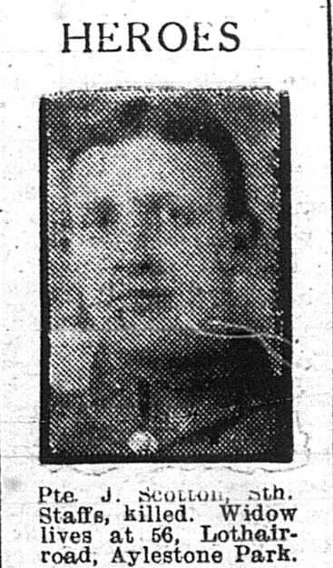
Private Joseph Scotton, Illus.Chron 23-Feb 1918
South Staffordshire Regiment 7th Bn.
Service No:40512

Husband of Florence ElizthScotton, of 56, Lothair Rd. Aylestone Park, Leicester.
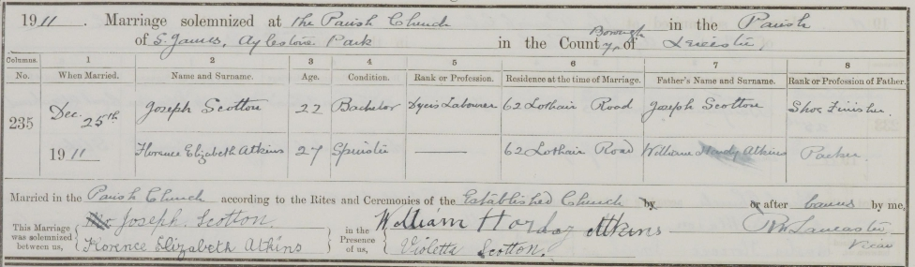
1911 census: 62 Lothair Road Leicester
SCOTTON, Joseph Head Married M 49 1862 Boot And Shoe Finisher Leicester
SCOTTON, Elizabeth Wife Married25 years F 52 1859 Leicester
SCOTTON, Violet Daughter F 24 1887 Fancy Hosiery Leicester
SCOTTON, Elizabeth Daughter F 22 1889 Boot And Shoe Vamper Leicester
SCOTTON, Joseph Son M 21 1890 Dyer's Labourer Leicestershire
SCOTTON, Albert Son M 19 1892 Hosiery Trimer Leicestershire
SCOTTON, Elsie Daughter F 18 1893 Warehouse Girl Leicestershire
SCOTTON, Sarah Daughter F 15 1896 Fancy Hosiery Leicestershire
SCOTTON, Bertie Son M 14 1897 Cane Worker Leicestershire
SCOTTON, Lily Daughter F 12 1899 School Girl Leicestershire
SCOTTON, Walter Son M 10 1901 School Boy Leicestershire
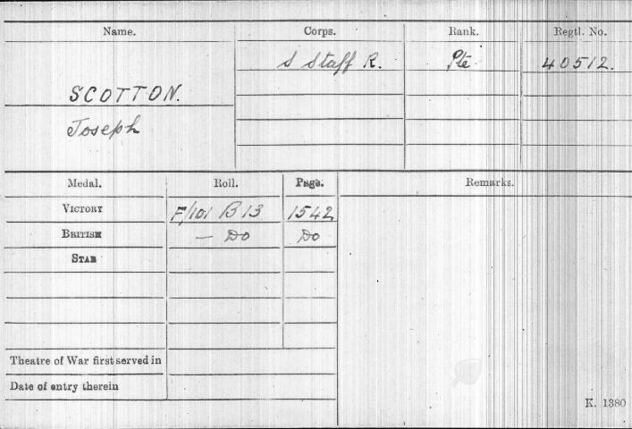

Date of Death:16/12/1917Age:28
Grave ReferenceXX. D. 8.LOOS BRITISH CEMETERY

Soldiers Effects
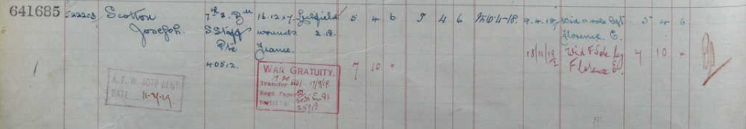

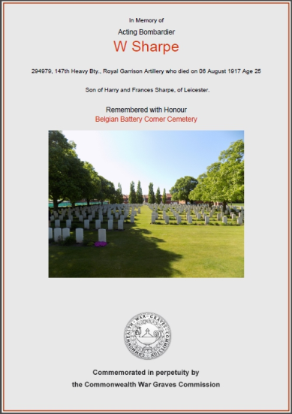
Acting Bombardier William Sharpe
Royal Garrison Artillery 147th Heavy Bty.,
Service No. 294979,

School Records give his date of birth as 12th July 1892
The son of Harry and Frances Sharpe, of Leicester

Harry Sharpe & Frances Standley
were married in Cosby on 12th October 1885

1901 Census 35, Denmark Road, Leicester,
Harry Sharpe HeadMarried Male39 1862 Labourer At Shoe Works Leicester,
FrancesSharpeWifeMarried Female 39 1862 - Croft, Leics.
Florence ASharpeDaughter Single Female 12 1889 - Leicester,
WilliamSharpe Son Single Male 8 1893 - Leicester,
Alfred Sharpe BrotherSingle Male 29 1872 Shoe Hand Rivetter Leicester

1911 Census 245 Milligan Road Leicester,
Harry Sharpe Head Married Male 49 1862 Hoistman Leicester Leics
Frances Sharpe Wife Married Female 49 1862 - Leics. Cosby
Florence Anneta Sharpe Daughter Single Female 22 1889 Boot Machinist Leicester
William Sharpe Son Single Male 18 1893 Boot & Shoe Manufactures Clerk Leicester

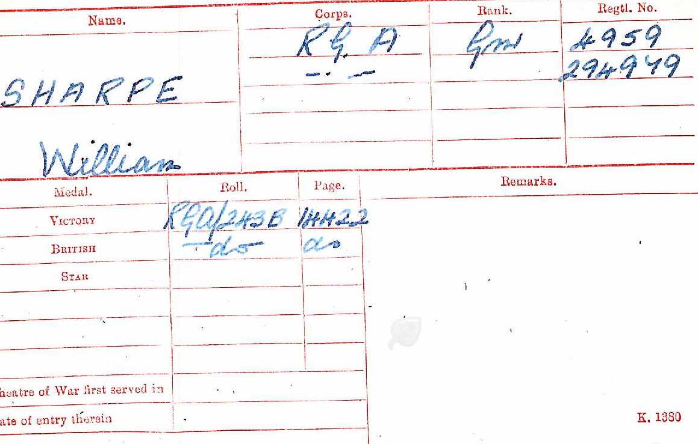

Died 06 August 1917
Age 25

Remembered with Honour
Belgian Battery Corner Cemetery

Soldiers Effects
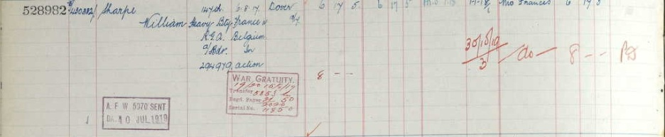

LanceCorporal Fred Sheffield, Illus. Chron25-Mar 1916
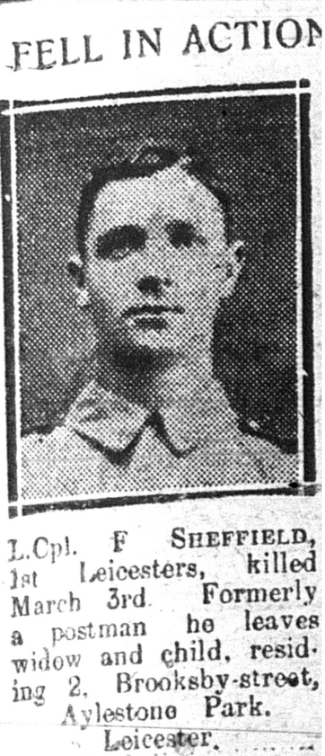
Leicestershire Regiment 1st Bn.
Service No:7444

Born in 1886 son of William & Ann Sheffield
Husband of Florence Amelia Sheffield, 2, Brooksby St., AylestonePk, Leicester

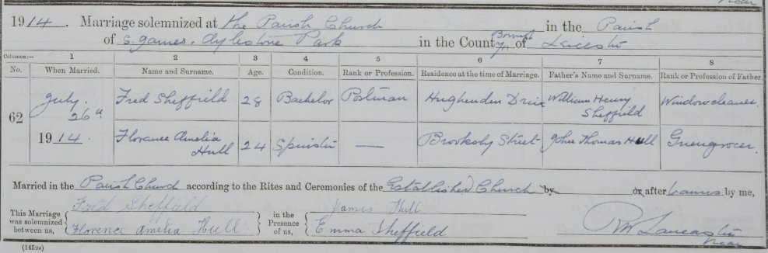
1901 census: 284, Tudor Road, Leicester
SHEFFIELD, William H Head Married M 46 1855 Boot & Shoe Pressman Coventry, Wks
SHEFFIELD, Ann Wife Married F 47 1854 Leicester, Leicestershire
SHEFFIELD, Sarah Wafforne Daughter Single F 19 1882 Wool Spinner Leicester,
SHEFFIELD, William Son Single M 18 1883 Sole Moulder Leicester, Leicestershire
SHEFFIELD, George Son Single M 17 1884 Heel Builder Leicester, Leicestershire
SHEFFIELD, Fred Son Single M 15 1886 Boot & Shoe Skiver Leicester,
1911 census 2nd Battalion Leicestershire Regiment, Fort Saint George, Madras, India
Military details: Private 2 Leicestershire Regt
Sheffield, Fred Single ? 251886 Leicester

SHEFFIELD, John Wafforne Son Single M 14 1887 Gas Fitter Nottingham,
SHEFFIELD, Emma Daughter Single F 12 1889 Leicester, Leicestershire

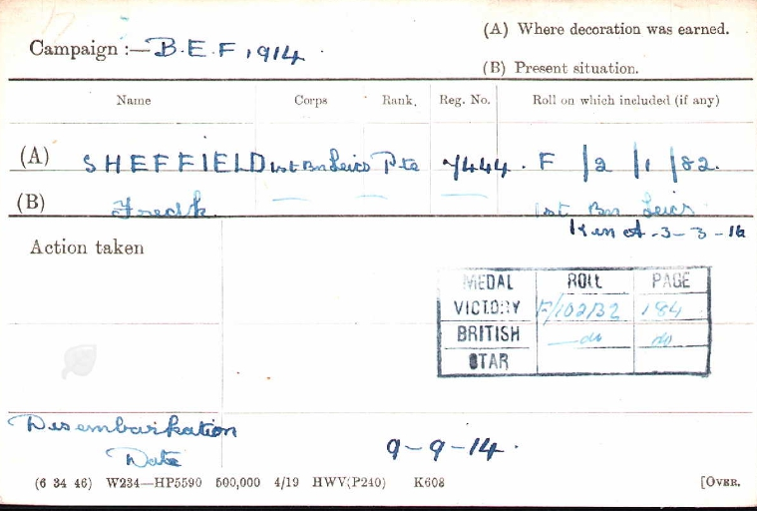

Date of Death:03/03/1916 Age:30 Grave Reference I. C. 7.White House Cemetery, St. Jean-Les-Ypres

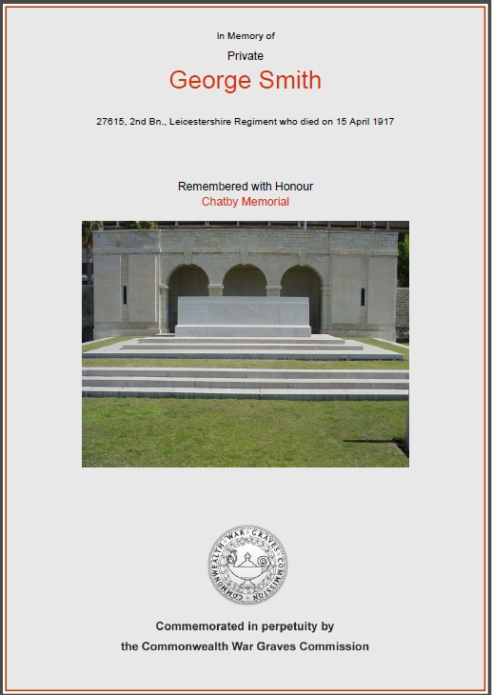
Private George Smith,
2nd Btn Leicestershire Regiment
Service No. 27615

School records give his Date of birth as 22nd August 1890 in Leicester the son of William Smith, a gas labourer, and his wife Mary Ann Smith (nee Mawby) who were married in 1873 in Oundle,

1891 Census Denmark Road, Aylestone, Blaby, Leics,
William Smith Head Married Male 35 1856 Gas Labourer Northamptonshire,
Mary A Smith Wife Married Female 34 1857 Deene Nthants
Arthur Smith Son Single Male 16 1875 Basket Maker Nthnts
Herbert Smith Son Male 12 1879 Errand Boy Northamptonshire
Frederick Smith Son Male 11 1880 Scholar Northants
Rose A Smith Daughter Female 9 1882 Scholar Northants
Lena Smith Daughter Female 7 1884 Scholar Northants
Alice Smith Daughter Female 4 1887 Scholar Aylestone,
George Smith Son - Male 2 1889 - Leicestershire,
Mary Mawby Mother In Law Widow Female 66 1825 Charwoman Northamptonshire,

1901 Census 12, Denmark Road, Leicester, Leicestershire
William Smith Head Married Male 46 1855 Gas Works Engine Driver Deene, Northamptonshire,
Mary A Smith Wife Married Female 45 1856 - Deene, Northamptonshire,
Herbert Smith Son Single Male 22 1879 Tinman Apprentice Deene, Northamptonshire,
Rose Ann Smith Daughter Single Female 18 1883 Shoe Upper Machinist Deene, Northamptonshire,
Lena Smith Daughter Single Female 16 1885 Shoe Hand Fitter Deene, Northamptonshire,
George Smith Son Single Male 12 1889 - Leicestershire
Kate Smith Daughter Single Female 7 1894 - Leicestershire,
Emily Smith Daughter Single Female 5 1896 - Leicestershire,

1911 Census 51 Dartford Road Leicester,
William Smith Head Married Male 57 1854 Engineman Gasworks Deene Northamptonshire
Mary Ann Smith Wife Married Female 55 1856 - Dene Northamptonshire
George Smith Son Single Male 22 1889 Coneworker Leicestershire Leicester
Kate Emma Smith Daughter Single Female 17 1894 Hosiery Hand Shirts Leicester
Emily Florance Smith Daughter Single Female 15 1896 Hosiery Hand Shirts Leicester
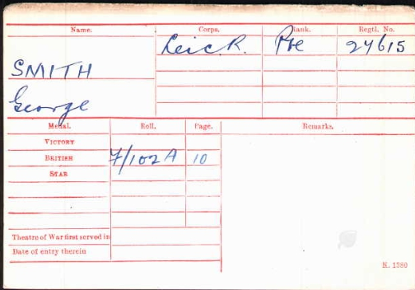
George married Nellie Peet in the Leicester Register Office, on
19th October 1912,

George was drowned at sea from H.T. Cameronia. He died 15th April 1917 Age - 26

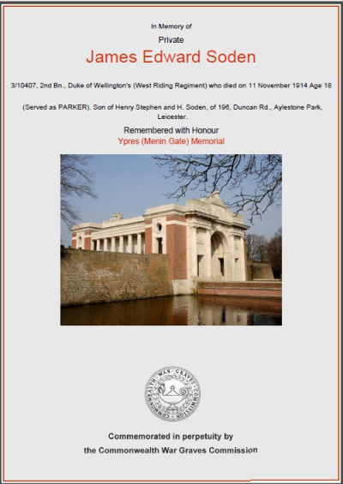
Private James Edward Soden, (brother)
Duke of Wellington's
(West Riding Regiment) 2nd Bn.
Service No:3/10407
(Served as PARKER).

Son of Henry Stephen and H. Soden, of 196, Duncan Rd., Aylestone Park,

1901 Census 39, Hawkesbury Road, Leicester,
Henry S Soden Head Married Male 36 1865 Gas Labourer London, M/sex,
Nellie Soden Wife Married Female 32 1869 - London, M/sex
Eliza Soden Daughter Single Female 12 1889 - Leicestershire,
Ethel Soden Daughter Single Female 11 1890 - Leicestershire,
Henry Soden Son Single Male 9 1892 - London, Middlesex,
Ellen Soden DaughterSingleFemale6 1895 - London, Middlesex,
James Soden Son Single Male 4 1897 - London, Middlesex,
WilliamSodenSon Single Male 2 1899 - Leicestershire,
FrederickSodenSon Single Male 0 1901 - Leicestershire,

1911 census: 196 Duncan Road Leicester
SODEN, Henry Stephen Head Married M 46 1865 Stoker London City
SODEN, Nelly Married23 years F 42 1869 London South Bermondsey
SODEN, Ethel Single F 21 1890 Machinist Leicester Leics
SODEN, Ellen Single F 16 1895 Winder London Essex Canning Town
SODEN, James Edward Single M 14 1897 Shoe Hand General London Essex Canning Town
SODEN, William Thomas Single M 12 1899 School Boy Leicester Leics
SODEN, Fred John Single M 10 1901 School Boy Leicester Leics
SODEN, Alice May Single F 7 1904 School Girl Leicester Leics
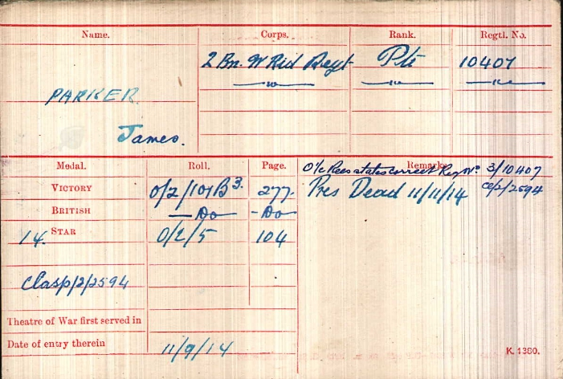
SODEN, George Arther M 4 1907 LeicesterLeics
SODEN, Robert Walter M 2 1909 LeicesterLeics

Date of Death 11/11/1914
Age:18
Panel 58.YPRES (MENIN GATE)
MEMORIAL

Soldiers Effects

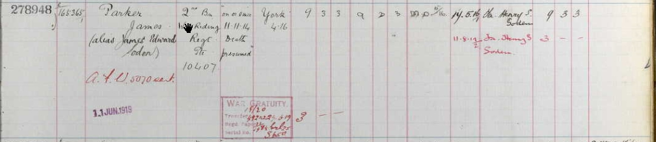

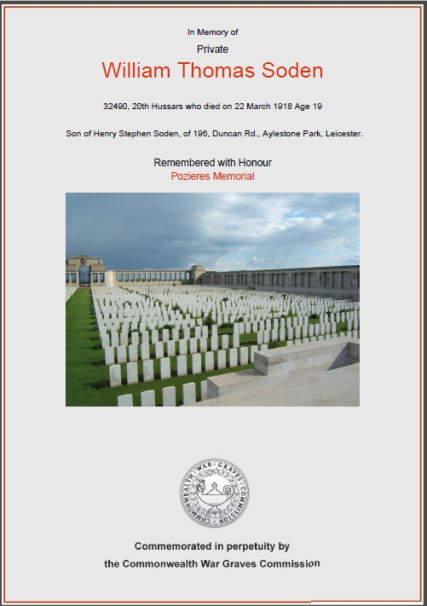
Private William Thomas Soden, (brother)
20th Hussars
Service No:32490

Son of Henry Stephen Soden, of 196, Duncan Rd., Aylestone Park, Leicester.

1901 Census 39, Hawkesbury Road, Leicester,
Henry S Soden Head Married Male 36 1865 Gas Labourer London, M/sex,
Nellie Soden Wife Married Female 32 1869 - London, M/sex
Eliza Soden Daughter Single Female 12 1889 - Leicestershire,
Ethel Soden Daughter Single Female 11 1890 - Leicestershire,
Henry Soden Son Single Male 9 1892 - London, M/sex,
Ellen Soden Daughter Single Female 6 1895 - London, M/sex,
James Soden Son Single Male 4 1897 - London, Msex,
William Soden Son Single Male 2 1899 - Leicestershire,
Frederick Soden Son Single Male 0 1901 - Leicestershire,

1911 census: 196 Duncan Road Leicester
SODEN, Henry Stephen Head Married M 46 1865 Stoker London City
SODEN, Nelly Married23 years F 42 1869 London South Bermondsey
SODEN, Ethel Single F 21 1890 Machinist Leicester Leics
SODEN, Ellen Single F 16 1895 Winder London Essex Canning Town
SODEN, James Edward Single M 14 1897 Shoe Hand General London Essex Canning Town
SODEN, William Thomas Single M 12 1899 School Boy Leicester Leics
SODEN, Fred John Single M 10 1901 School Boy Leicester Leics
SODEN, Alice May Single F 7 1904 School Girl Leicester Leics
SODEN, George Arther M 4 1907 LeicesterLeics
SODEN, Robert Walter M 2 1909 LeicesterLeics
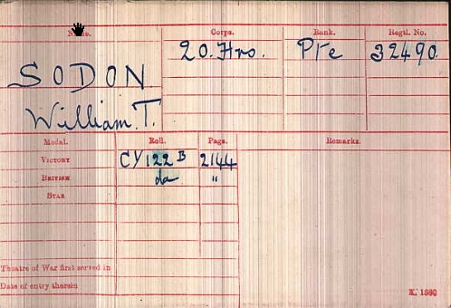

Date of Death:
22/03/1918
Age:19
Reference Panel 6. POZIERES
MEMORIAL

