J JOSEPH
Joseph | Dorothy Lucy M | 3 | Nov | 1897 | 30D73/03-10 | 482

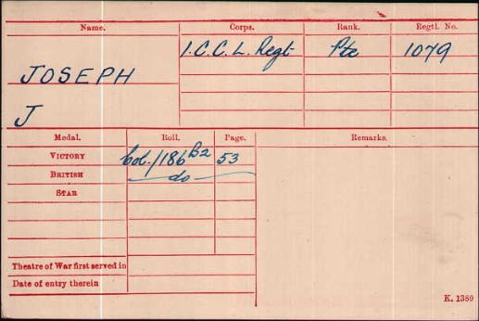

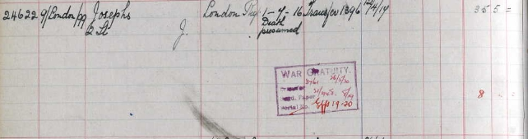

Rank Private
Regiment Cape Coloured Labour Regiment
Service record Soldier Number: 1079, Rank: Private, Corps: Cape Coloured Labour Regiment
Image link http://discovery.nationalarchives.gov.uk/SearchUI/Details?uri=D3177086
Country Great Britain
Medal type British Army Medal Index Cards, 1914-1920
Archive reference WO372/11
Archive reference description Campaign Medal Index Cards and Silver War Badge Cards
Record set Britain, Campaign, Gallantry& Long Service Medals & Awards
Category Military, armed forces & conflict
Subcategory Medal Rolls and Honours
Collections from Great Britain, UK None

L JUDD
1911 census transcription details for: 52 Vernon Road Leicester
NEALE, Charles Henry Head Married M 46 1865 Bricklayer Camberwell London
NEALE, Annie Louisa Wife Married5 years F 34 1877 Leicestershire Leicester
JUDD, Louis Son M 14 1897 Fitting Cutter Leicestershire Leicester Aylestone PK
NEALE, Elsie Louisa Daughter F 5 1906 School Leicestershire Leicester Aylestone PK
NEALE, Charles Henry Son M 3 1908 Leicestershire Leicester Aylestone PK
NEALE, Lilian Susana Daughter F 2 1909 Leicestershire Leicester Aylestone PK
Judd Louis 3 Sep 1896 30D73/03-10 474

JUDD, LOUIS |  |  |  | SILVER
GRO Reference: 1896 D Quarter in LEICESTER Volume 07A Page 288
Marriages Dec 1895
Judd | Noah William |  | Leicester |  | 7a | 471
Silver | Annie Louisa |  | Leicester |  | 7a | 471

PrivateJUDD, LEWIS
Service Number G/32997
Died 17/10/1917
Aged 32
12th Bn.
Middlesex Regiment
Son of Emily Collins (formerly Judd); husband of Mary Ann Judd, of Newman's End, Matching, Harlow, Essex.
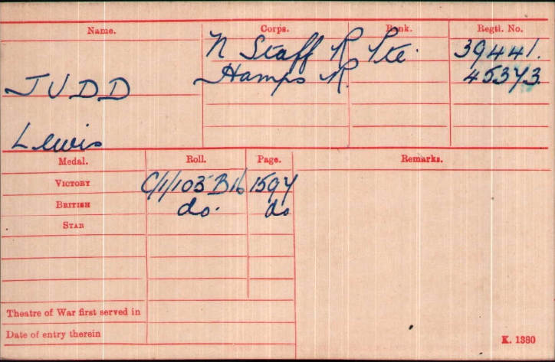
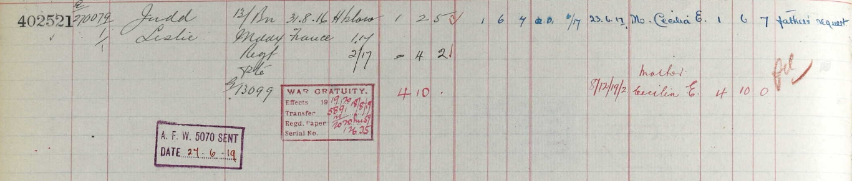
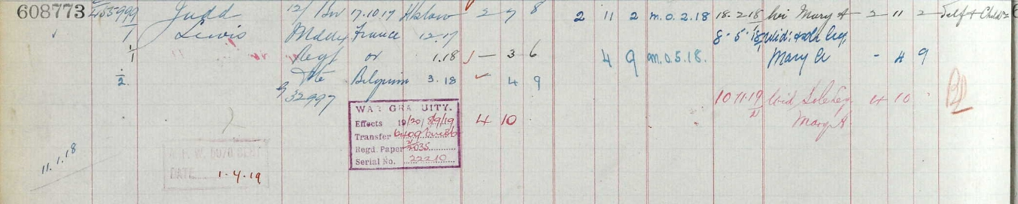

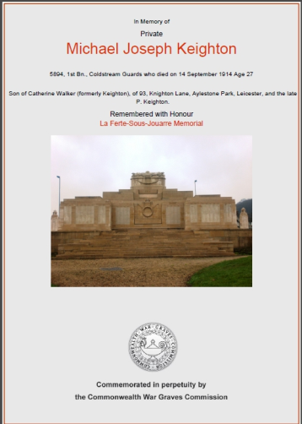
Private Michael Joseph Keighton,
Coldstream Guards 1st Bn.
Service Number 5894
Son of Catherine Walker (formerly Keighton),
of 93, Knighton Lane, Aylestone Park, Leicester, and the late P. Keighton.

1901 Census 19, Milligan Road, Leicester,
WilliamWalkerHead MarriedMale 361865Window Cleaner Leicestershire,
Catherine Walker Wife Married Female 38 1863 - Ireland
Mary EWalkerStep DaughterSingle Female 17 1884 Laundry Maid
Chatham, Kent,
Margaret K Walker Step Daughter Single Female 16 1885 Laundry Maid Plymouth, Devon,
Michael J WalkerStep Son Single Male 14 1887 Folder Corset Making Ireland
Emma Walker Daughter Single Female 10 1891 - Ireland

1911 Census 56 Lothair Road Leicester,
CatherineWalkerHeadWidowFemale481863- Caherciveen Kerry Ireland
Emma Walker Daughter SingleFemale20 1891 Packer And Sorter Fermoy County Cork Ireland
William Samuel WalkerSon Single Male191892 Points Aldershot Hants
Albert Walker Son Single Male 17 1894 Machinist Aldershot Hants
Catherine Walker Daughter Single Female 14 1897 Assistant Leicester
Michael JosephKeightonSonSingle Male 241887Attendant Caherciveen County Kerry Ireland
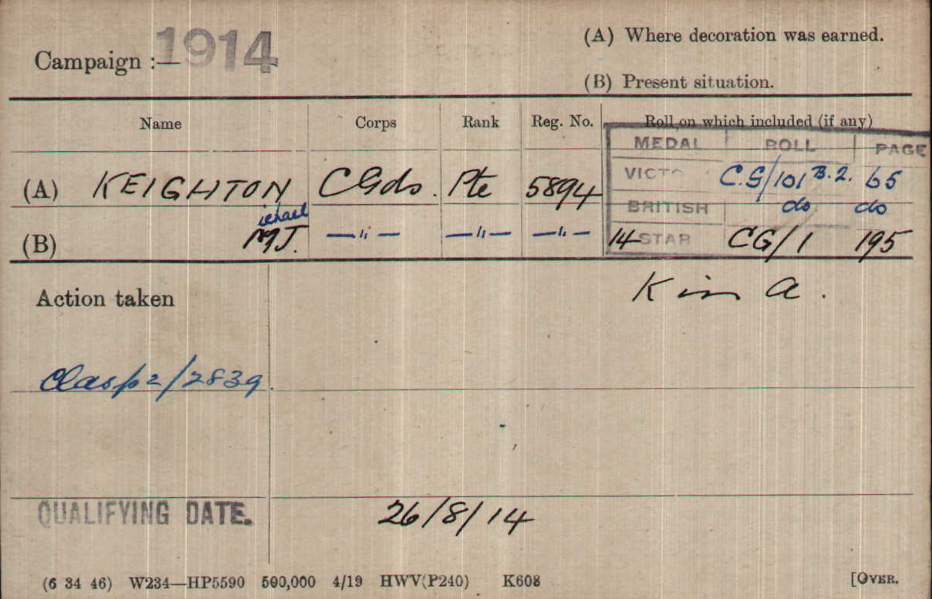

Died 14/09/1914
Aged 27
Remembered with Honour
La Ferte-Sous-Jouarre
Memorial

Soldiers Effects
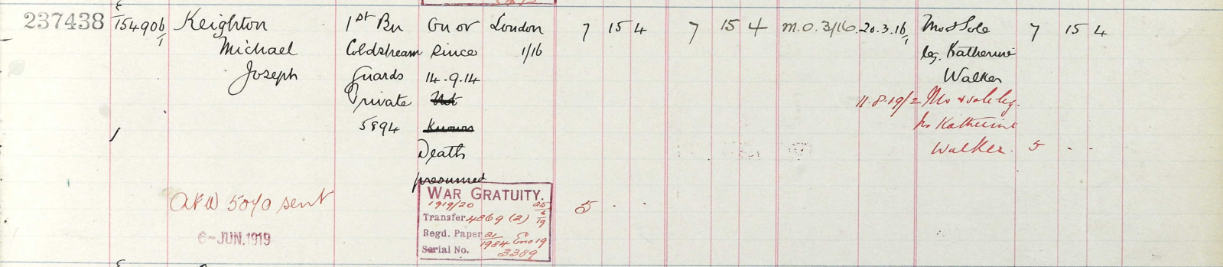

Bombardier Frank Kirby Illus. Chron 13-Oct 1917
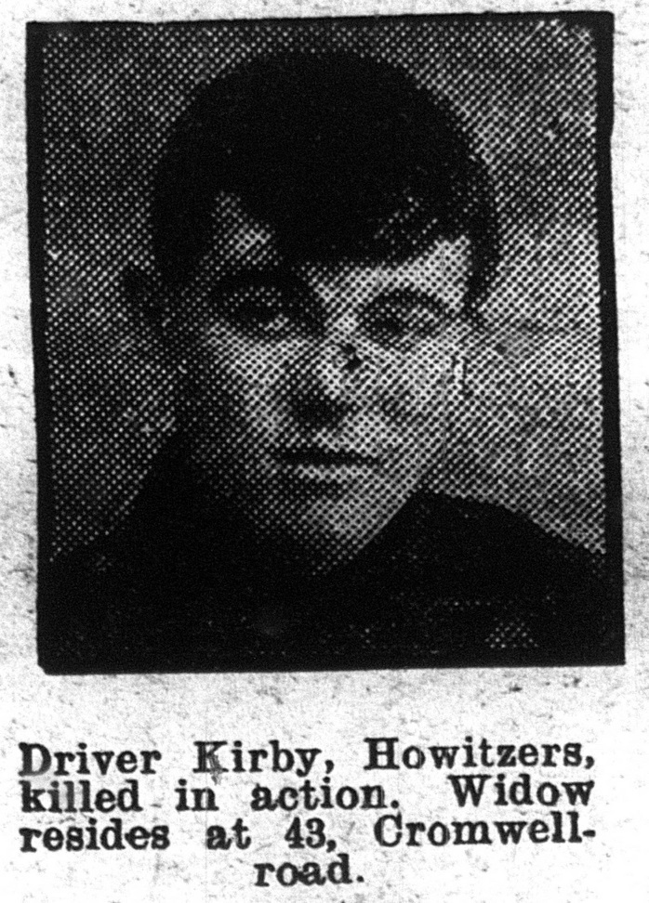
Royal Field Artillery ‘D’Baty 236thBde
Service No L/32356

School records give his date of birth as 10th August 1891
And the census returns infer that he was born in New South Wales Australia, He married Emma E Chapman in 1912 and they may have had 3 children
Phyllis J 1913, William W 1914, Frank H 1916
Emma E is still listed as widowed in 1939 at Percy Road
It seems the family were in Australia from 1886 – 1896

1911 census: 12 Richmond Road Leicester
KIRBY, William Head Married M 55 1856 Bricklayers Labourer Rothley Leicestershire
KIRBY, Amy Martha Wife Married36 years F 56 1855 None Leamington Warwickshire
KIRBY, Frank Son Single M 19 1892 Rubber Hand Cycle Tyres West Maitland N S W A
KIRBY, George Son Single M 15 1896 Rubber Hand Cycle Tyres West Maitland N S W A
KIRBY, John Bodley Son Single M 10 1901 School Leicester
1901 Census 122, Cavendish Road, Leicester,
WilliamKirby Head Married Male 44 1857 Bricklayers Labourer Belgrave, Leics.
Amy MKirby Wife Married Female 46 1855 - Leamington, Warwickshire,
Edwin Kirby Son Single Male 16 1885 Railway Van Boy Leicester,
Daisy Kirby Daughter Single Female 14 1887 Shoe Fitter Australia
Lily Kirby Daughter Single Female 11 1890 - Australia
Frank Kirby Son - Male 9 1892 - Australia
George Kirby Son - Male 5 1896 - Australia
John Kirby Son - Male 0 1901 - Leicester,

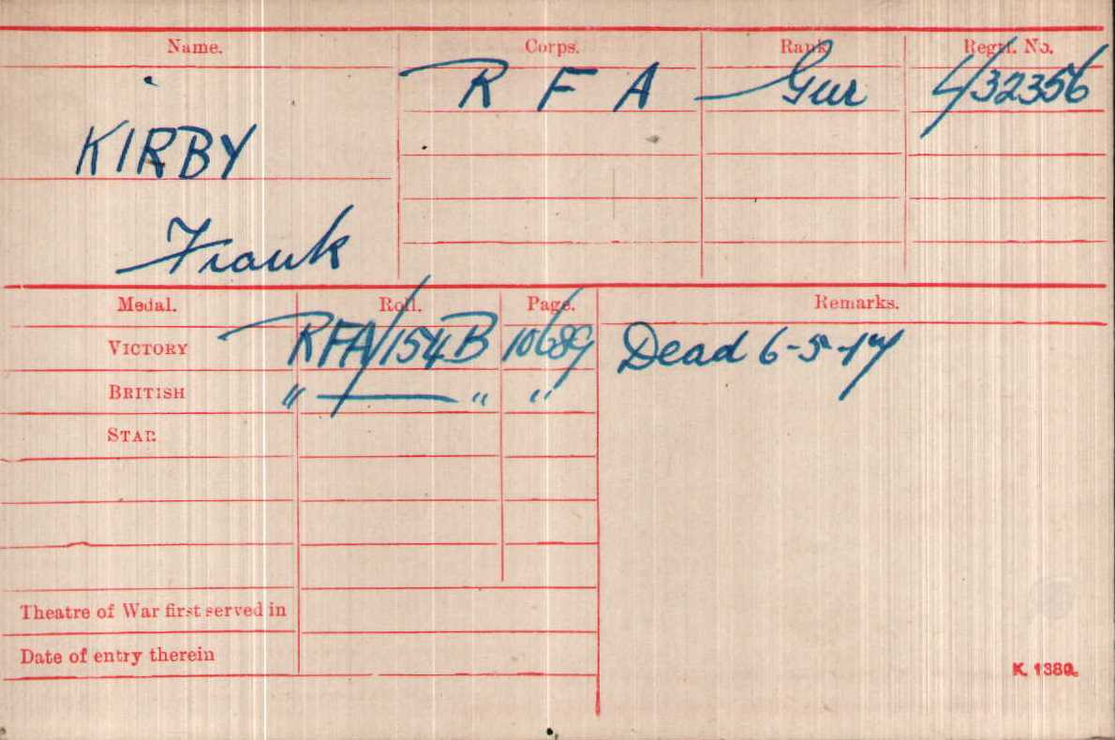

Died 06/05/1917

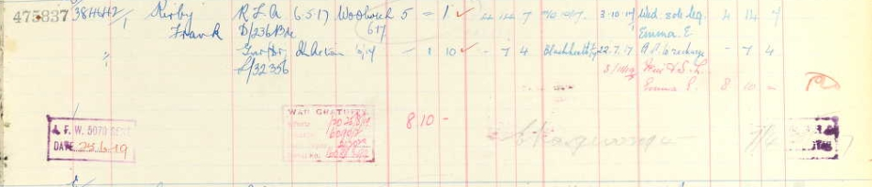
Remembered with Honour
At Dickebusch New Military Cemetery

Soldier’s Effects
Private George Kirby Daily Post01-Dec1915
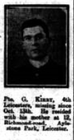
Leicestershire Regiment 1st/4th Bn
Service No:4145

Son of Mrs. Kirby, of 12, Richmond Rd., Aylestone Park, Leicester.
It seems the family were in Australia from 1886 – 1896

1911 census: 12 Richmond Road Leicester
KIRBY, William Head Married M 55 1856 Bricklayers Labourer Rothley Leicestershire
KIRBY, Amy Martha Wife Married36 years F 56 1855 None Leamington Warwickshire
KIRBY, Frank Son Single M 19 1892 Rubber Hand Cycle Tyres West Maitland N S W A
KIRBY, George Son Single M 15 1896 Rubber Hand Cycle Tyres West Maitland N S W A
KIRBY, John Bodley Son Single M 10 1901 School Leicester

1901 Census 122, Cavendish Road, Leicester,
WilliamKirby Head Married Male 44 1857 Bricklayers Labourer Belgrave, Leics.
Amy MKirby Wife Married Female 46 1855 - Leamington, Warwickshire,
Edwin Kirby Son Single Male 16 1885 Railway Van Boy Leicester,
Daisy Kirby Daughter Single Female 14 1887 Shoe Fitter Australia
Lily Kirby Daughter Single Female 11 1890 - Australia
Frank Kirby Son - Male 9 1892 - Australia
George Kirby Son - Male 5 1896 - Australia
John Kirby Son - Male 0 1901 - Leicester,
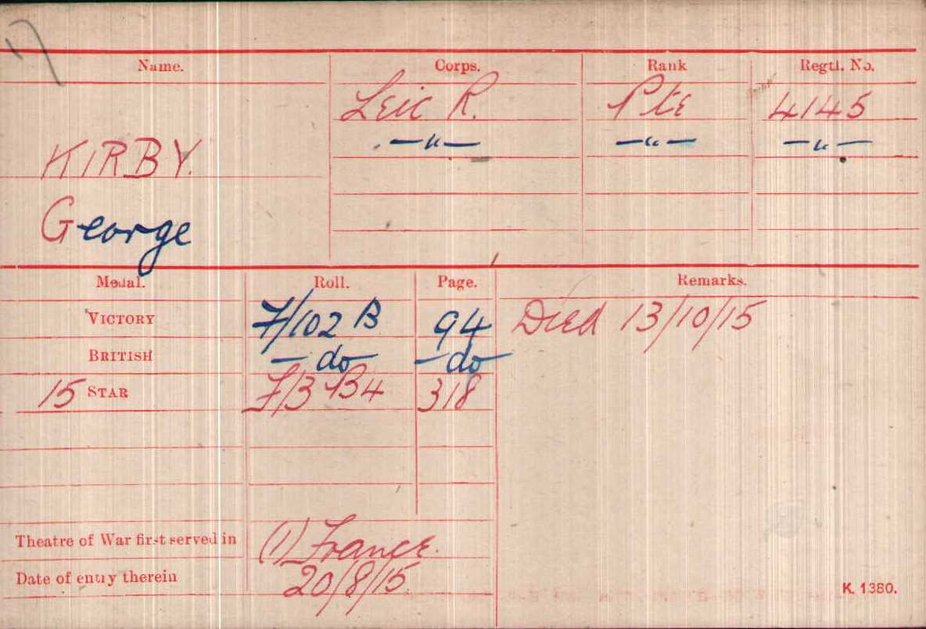

Date of Death: 13/10/1915 Age:19
Reference
Panel 42 to 44. LOOS MEMORIAL

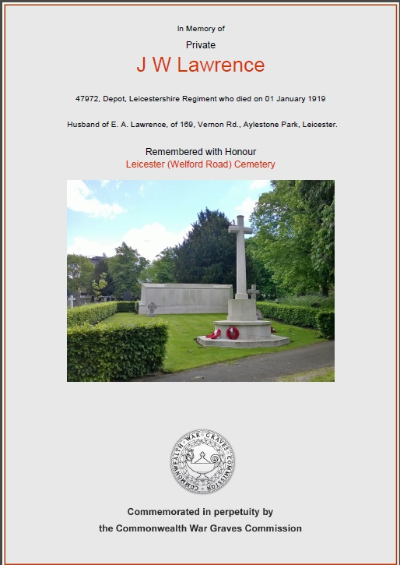
Private John Wm Lawrence
Leicestershire Regiment Depot
Service No:47972

Husband of E. A. Lawrence, of 169, Vernon Rd., Aylestone Park, Leicester.

1901 Census The Hollow, Leicester, Leicestershire,
Elizabeth Lawrence Wife Married Female 22 1879 Husband In S Africa Leicestershire,
Florence Lawrence Daughter Single Female 2 1899 - Aylestone, Leicestershire,
Lizzie Lawrence Daughter Single Female 1 1900 - Aylestone, Leicestershire,

1911 census: 169 Vernon Road Leicester
LAWRENCE, John William Head Married M 39 1872 Gas Works OsbournbyLincs
LAWRENCE, Elizabeth Ann Wife Married 13 years F 32 1879 Leicester Leics
LAWRENCE, Florence Amelia Daughter Single F 12 1899 Labourer Leicester Leics
LAWRENCE, Lizzie Belmont Daughter Single F 11 1900 Leicester Leics
LAWRENCE, Doris Hilda Daughter Single F 7 1904 Leicester Leics
LAWRENCE, George Henry Son Single M 5 1906 Leicester Leics
LAWRENCE, Lilian May Daughter Single F 2 1909 Leicester Leics
LAWRENCE, John Leonard William Son Single M 0 (1 MONTH) 1911 Leicester Leics

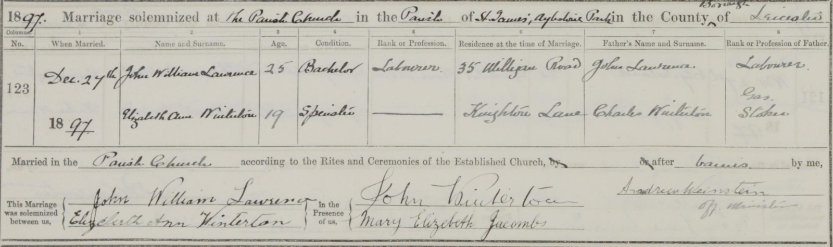

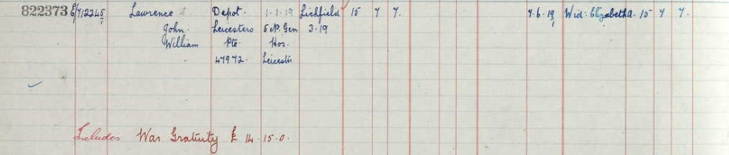

He also served in Boer war

Date of Death:01/01/1919: Grave ReferenceScreen Wall. O1. 279.
LEICESTER (WELFORD ROAD) CEMETERY

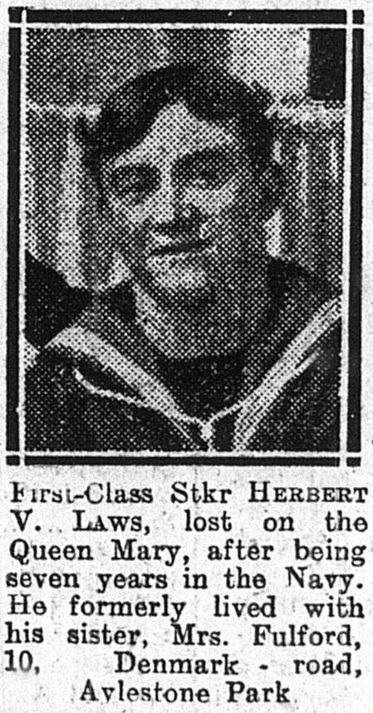
Stoker 1st Class Herbert Victor Laws,
Royal Navy H.M.S. "Queen Mary."
ServiceNo:SS/109446

Son of the late Charles and Dinah Laws, of Windsor.

Births Jun 1891 Laws Herbert Victor Windsor 2c 447

1881 census transcription details for: 3, Albert St, Clewer
LAWS, Charles Head Married M 35 1846 Cordwainer Gosport, Hants
LAWS, Dinah Wife Married F 34 1847 Whitton, Northamptonshire
LAWS, Gertrude L Daughter Single F 2 1879 Windsor, Berkshire
LAWS, Sarah A Daughter Single F 0 1881 Windsor, Berkshire

Deaths Jun 1891 LAWS Dinah 45 Windsor 2c 318
Deaths Dec 1896 Laws Charles 51 Windsor 2c 275
Marriage 3rd August 1903 at St James Church
FULFORD William Rupert Leicester 7a 336
LAWS Sarah Ann Leicester 7a 336 Daily Post 12-July 1916

1911 Census 10 Denmark Road Leicester,
William Fulford Head -Male 29 1882 Rubber Hand MichanicalDp Aylestone Leicestershire
Annie Fulford Wife Female 30 1881 - Windsor Berkshire
Gertie Fulford Daughter Female 5 1906 - AylestonePk Leicestershire

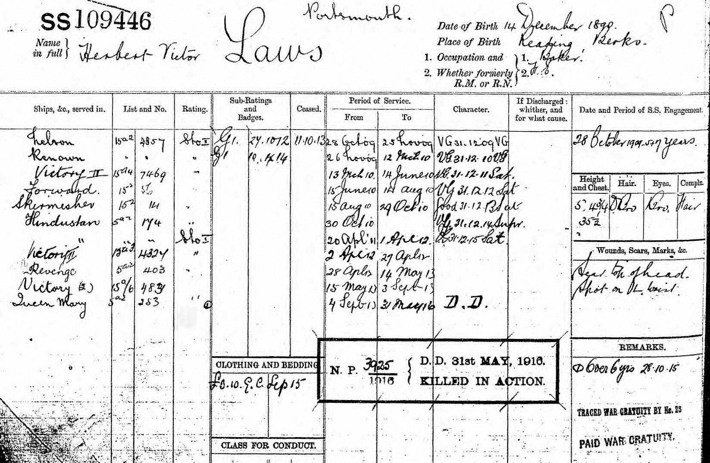

Date of Death:
31/05/1916
Age:25
Panel Reference18.PORTSMOUTH
NAVAL
MEMORIAL

Private Edward Lee, IllusChron 9th Nov 1918
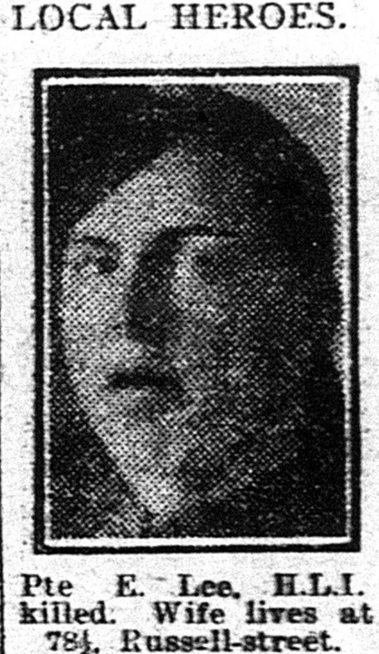
Highland Light Infantry 9th (Glasgow Hds.)Bn.
Service No:333880

1911 census: 78 1/2 Russell Street Leicester
LEE, Harry Head Married28 years M 57 1854 Shoe Trade Nottingham
LEE, Elisabeth Wife Married28 years F 49 1862 Bedfordshire Dedford
LEE, Edith Daughter Single F 27 1884 Card Board Boc Maker Leicester
LEE, Gean Daughter Single F 22 1889 Shoe Trade Sandpaper Leicester
LEE, Ethel Daughter Single F 19 1892 Shoe Trade Leicester
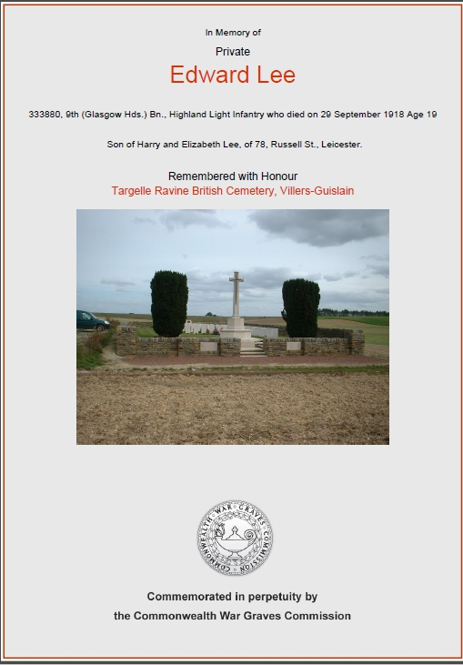
LEE, Harry Son Single M 17 1894 Shoe Trade Leicester
LEE, Edmund Son M 12 1899 School Leicester
LEE, Cyril Son M 10 1901 School Leicester
LEE, Mabel Daughter F 8 1903 Leicester
LEE, Albert Son M 6 1905 Leicester
LEE,Florence Daughter F 31908Leicester

School records give a date of birth for Edmund as 28th Nov 1898 son of Harry Lee and Elizabeth Church, of 78, Russell St., Leicester.And left school on 29th November 1912.His parents married 3rd October 1885 at St Matthew’s Church in Leicester

1901 Census 64, Russell Street, Leicester,
Harry Lee Head Married Male 431858Shoe Hand Nottingham,
Elizabeth Lee Wife Married Female37 1864 Bedfordshire,
Edith LeeDaughter Single Female171884 Cardboard Box Maker
Leicester,
Isabel Lee Daughter Single Female141887Cardboard Box Maker Leicester,
Jean Lee Daughter Single Female12 1889 -Leicester,
Ethel Lee Daughter - Female 9 1892 - Leicester,
George Lee Son - Male 7 1894 - Leicester,
Edmund Lee Son - Male 2 1899 - Leicester,
Cyril Lee Son - Male 0 1901 - Leicester,
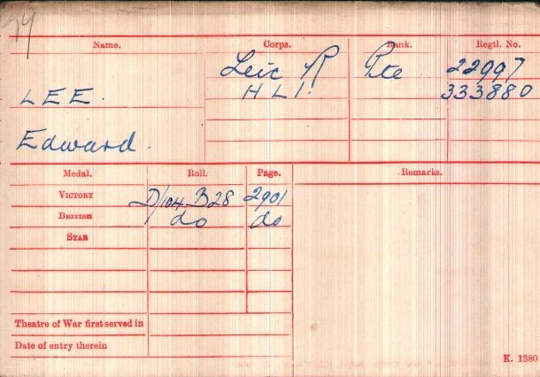

Date of Death:
29/09/1918
Age:19
Grave Reference C. 2.
TARGELLE RAVINE
BRITISH CEMETERY,
VILLERS-GUISLAIN

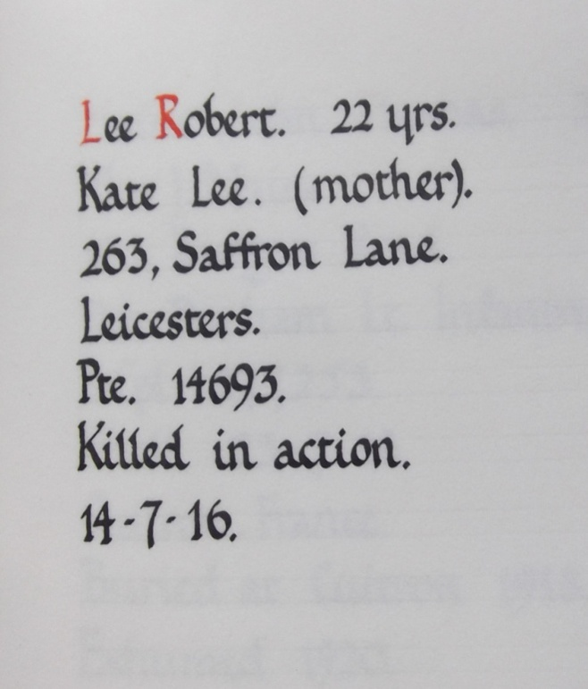
Private Robert LEE
Leicestershire Regiment
Service No:14693
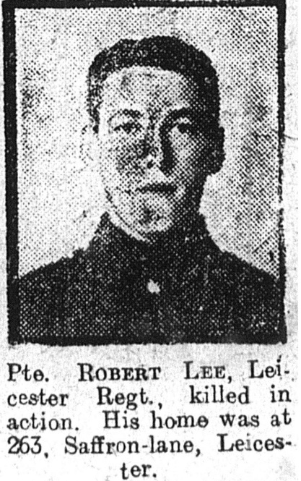

School Records give his Date of birth as
6th September 1894
Sadly no Baptism can be found

Daily Post21-Aug1916

1901 Census 43, Countesthorpe Road, Wigston Magna, Blaby, Leics
James Lee Head Married Male 33 1868 Blaby, Leicestershire, Gas Works Laborer
Kate Lee Wife Married Female 30 1871 Hoby, Leicestershire, Biscuit Packer
Robert Lee Son Single Male 6 1895 South Wigston, Leicestershire, -
Joseph Lee Son Single Male 4 1897 South Wigston, Leicestershire, -

1911 census for: 263 Saffron Lane Leicester
LEE, James Head Married M 44 1867 Chemical Manufacture BlabyLeicestershire
LEE, Kate Wife Married 17 years F 40 1871 Hoby Leicestershire
LEE, Robert Son Single M 16 1895 Rubber Hand South Wigston Leicestershire
LEE, Arthur Son M 10 1901 School South Wigston Leicestershire
LEE, Jack Son M 8 1903 School South Wigston Leicestershire
LEE, Lily Elizabeth Daughter F 6 1905 School South Wigston Leicestershire
LEE, Hilda Daughter F 1 1910 Leicestershire Leicester
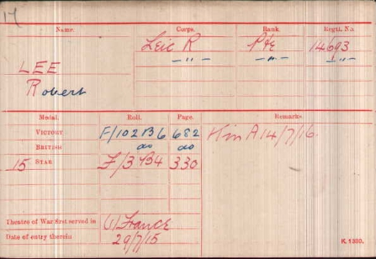

Date of Death:
14/07/1916
Grave Reference:
III. P. 15.
POZIERES BRITISH CEMETERY,
OVILLERS-LA BOISSELLE

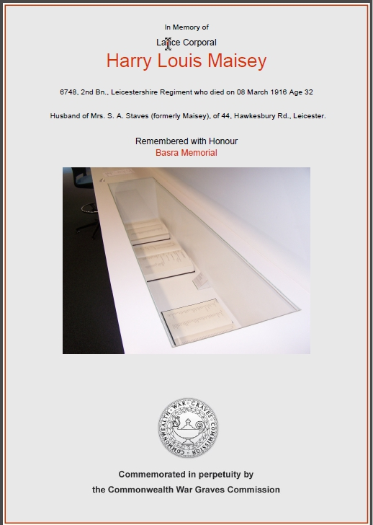
Lance Corporal Harry Louis Maisey,
Leicestershire Regiment 2nd Bn.
Service No:6748

Arthur Thomas Maisey married Annie Hughes in Cheltenham in 1867 Harry was born in Birmingham. School records give their son Harry’s date of birth as 30th June 1883
Harry went on to marry Sarah Ann Ellis in 1903 who went on to remarry Arthur Staves in 1919 Husband of Mrs. S. A. Staves (formerly Maisey), of 44, Hawkesbury Rd., Leicester.

1891 Census Baggrave St., Evington, Billesdon, Leics
Arthur Maisey Head Married Male 44 1847 Clerk Gloucestershire,
Annie Maisey Wife MarriedFemale 421849 Leicestershire,
Ernest Maisey SonMale181873Hatters Apprentice Gloucestershire,
Mabel Maisey Daughter Female61885- Gloucestershire,
Charles Maisey Son Male 13 1878 Errand Boy Gloucestershire,
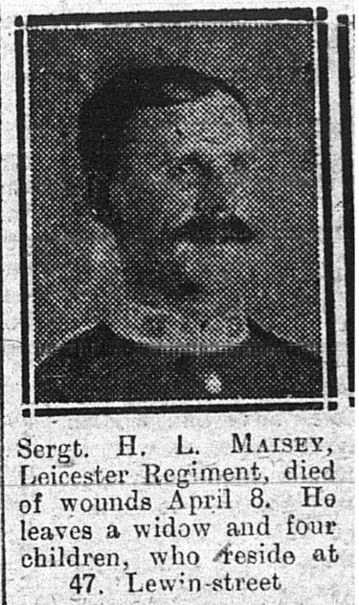
Bertie Maisey SonMale 10 1881 Scholar Gloucestershire,
Harry Maisey SonMale7 1884 Scholar -

1901 Census 10, Brierley Street, Leicester,
Thomas Maisey Head Married Male 53 1848 Wool Dyer Cheltenham, Glos. Annie Maisey Wife Married Female 51 1850 - Barrow, Leicestershire,
Harry Maisey Son Single Male17 1884 Country Carrier Birmingham, Wks,

1911 census: 7 Brierley Street Leicester
MAISEY, Harry Head Married M 28 1883 Leather Dresser Wks Birmingham
MAISEY, Sarah Ann Wife Married 7 years F 30 1881 Blaby Leicestershire
MAISEY, Edith Daughter F 6 1905 Leicestershire Leicester
MAISEY, Beatrice Daughter F 5 1906 Leicestershire Leicester
MAISEY, Ivy May Daughter F 1 1910 Leicestershire Leicester

Illus. Chron13-May1916

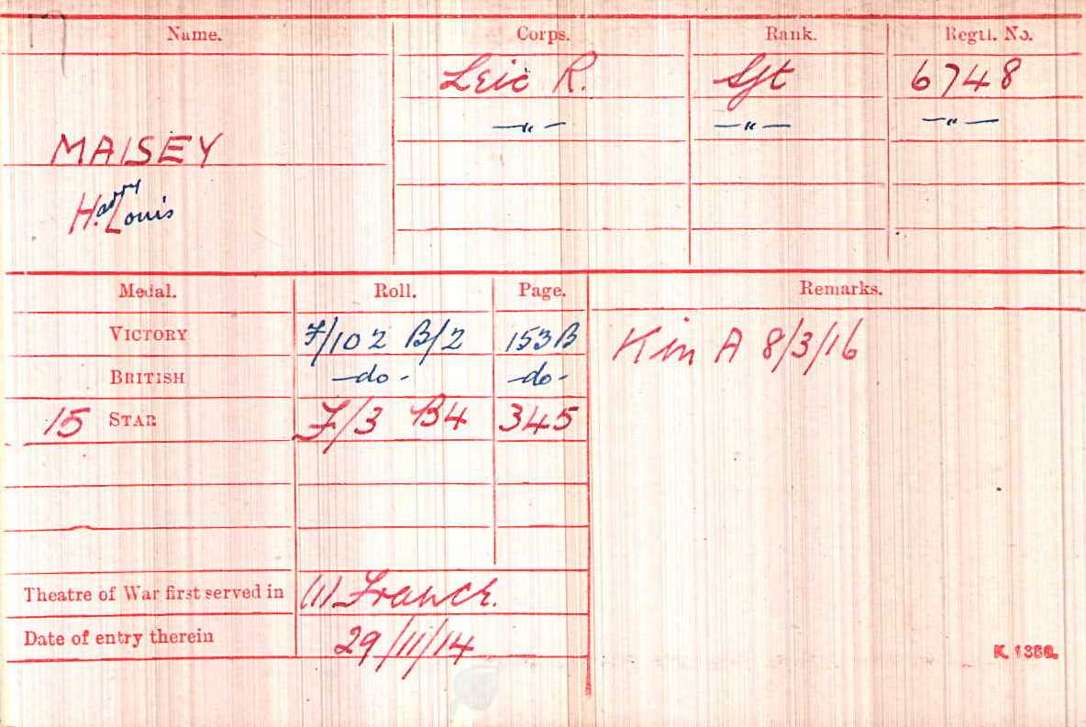

Date of Death:
08/03/1916
Age:32
BASRA MEMORIAL

