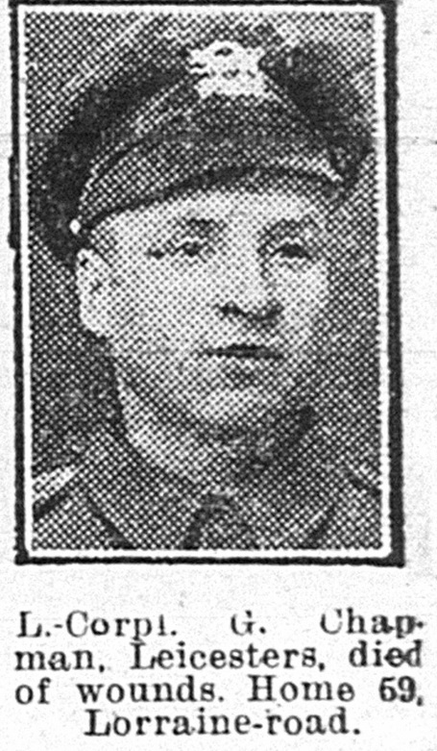
Lance Corporal George Chapman,
Leicestershire Regiment 7th Bn
Service No:30110

School Records give his date of birth as 17th May 1897 Son of George Chapman, of 59, Lorraine Rd., Aylestone Park, Leicester.

He was Baptised on 16th Aug 1897 , 37 Colton St – St George’s Church

1911 census transcription details for: 170 Cavendish Road Leicester
CHAPMAN, George Head Married M 40 1871 Rubber Hand Leicester
CHAPMAN, Dora Wife Married19 years F 40 1871 LeicsOadby
CHAPMAN, Dora Nellie Daughter Single F 18 1893 Hose Boards Leicestershire Leicester
CHAPMAN, Fanny Daughter Single F 16 1895 Shoe Work Machinist Leicestershire Leicester
CHAPMAN, George Son M 13 1898 School Leicester
CHAPMAN, Adelaide Mary Ann Daughter F 12 1899 School Leicester
CHAPMAN, Edith Daughter F 9 1902 School Leicestershire Leicester Illus. Chron 21-Dec 1918
CHAPMAN, John William Son M 7 1904 School Leicester
CHAPMAN Son M (NEWLY BORN) Leicestershire Leicester

1901 Census 37, Colton Street, Leicester,
George Chapman Head Married Male 31 1870 Firewood Dealer Leicestershire,
Dora Chapman Wife Married Female 31 1870 - Oadby, Leicestershire,
Dora N Chapman Daughter Single Female 8 1893 - Leicestershire,
Fanny Chapman Daughter Single Female 6 1895 - Leicestershire,
GeorgeChapman Son Single Male 3 1898 - Leicestershire,
Mary A AChapman Daughter Single Female 2 1899 - Leicestershire,
Ivy Chapman Daughter Single Female 0 1901 - Leicestershire,
Albert White Boarder Single Male 33 1868 General Agent Leicestershire,

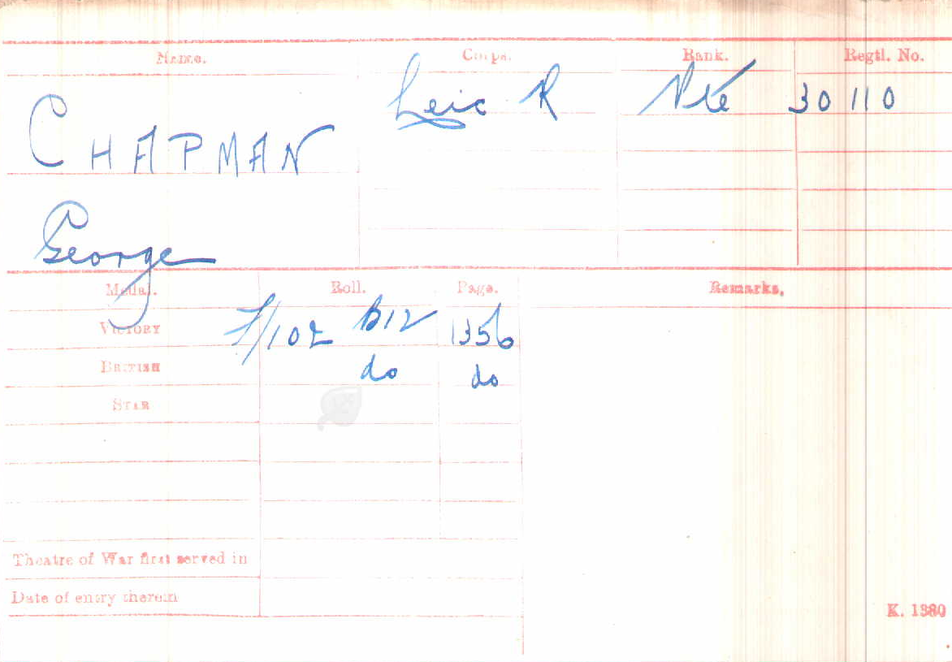

Date of Death:
25/10/1918
Grave Reference
XIII. A. 18.ROCQUIGNY-EQUANCOURT ROAD BRITISH CEMETERY, MANANCOURT

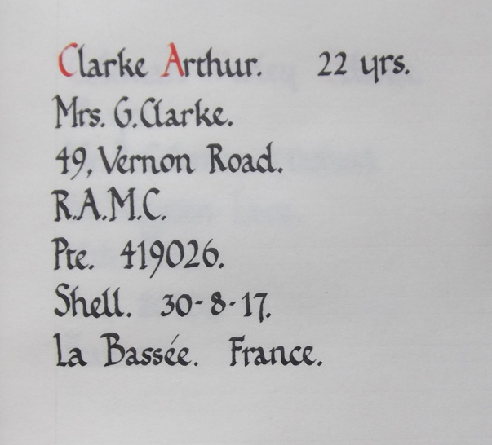
Private Arthur Clarke,
Royal Army Medical Corps
1st/3rd Northumbrian Field Amb
Service No:419026
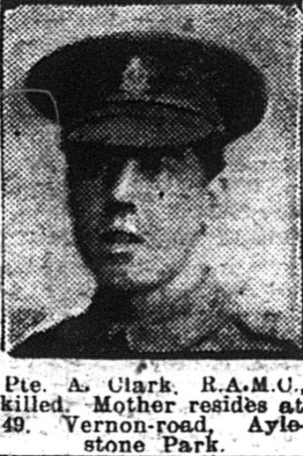

School records give his DOB as 17th September 1895 Son of Mr. G. Clarke, of 49, Vernon Rd. Leicester.

1901 Census 49, Vernon Road, Leicester, Leicestershire,
George Clark Head Married Male 49 1852 Bricklayers Labourer Leics.
Elizabeth Clark Wife Married Female 44 1857 - Glen Parva, Leicestershire,
William Clark Son Single Male 23 1878 Bricklayers Labourer Blaby, Leics.
Emma Clark Daughter Single Female 19 1882 Hosiery Hand Turner Blaby,
George Clark Son Single Male 17 1884 Rubber Hand Blaby, Leicestershire,
Mary J Clark Daughter Single Female 15 1886 Shoe Machinist Blaby, Leics
Lizzie Clark Daughter Single Female 13 1888 Shoe Hand Stockroom Leics
His parents George Clark & Elizabeth Kilby married 2nd May 1876
At Blaby Parish Church

Charles A Clark Son Single Male 11 1890 – Leicestershire,
John Clark Son Single Male 9 1892 - Leicestershire,
Arthur Clark Son Single Male 5 1896 - Leicestershire,

1911 Census for: 49 Vernon Road Leicester
CLARK, George Head M 57 1854 Gas Labourer Belgrave Parish Leicester
CLARK, Elizabeth Wife F 53 1858 Wigstone Leicestershire
CLARK, William Son Single M 33 1878 Bricklayer Labourer Blaby Leicestershire
CLARK, George Son Single M 27 1884 Rubber Hand Cycle Tyre Blaby Leicestershire
CLARK, Charles Albert Son Single M 21 1890 Parking Case Maker Aylestone Park Leicesters
CLARK, Arthur Son Single M 15 1896 Shoe Hand Tacker Aylestone Park Leicesters
HODGES, Hannah- Boarder Widow F 34 1877 Turner And Marker Hosiery Blaby Leicestershire
HODGES, Elsie Boarder F 12 1899 Aylestone Park Leicester
HODGES, Hilda May Boarder F 7 1904 Aylestone Park Leicester
HODGES, Lizzie Boarder F 3 1908 Leicester

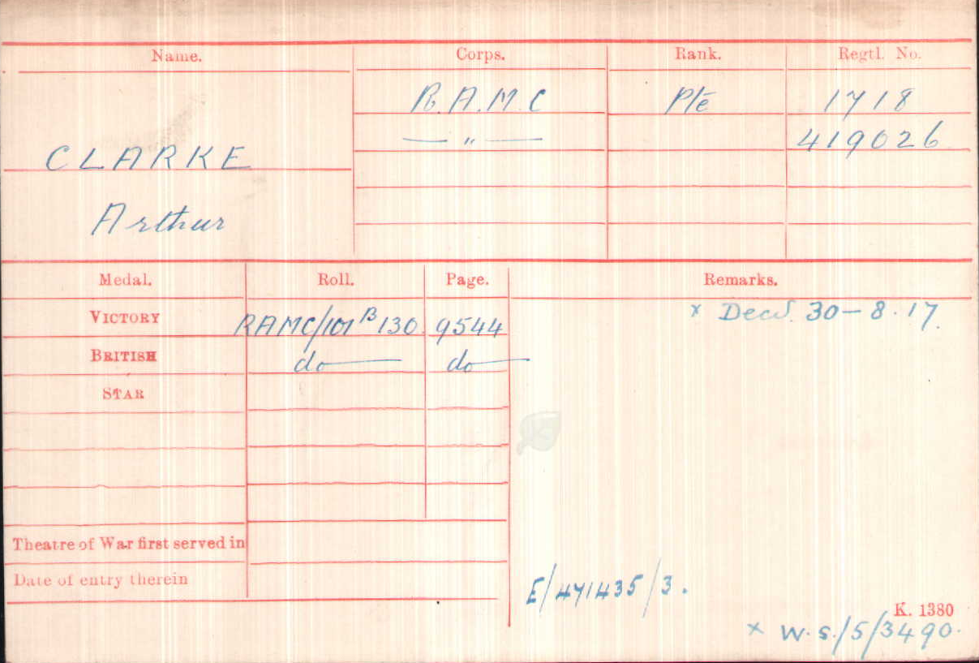

Date of Death:30/08/1917
Grave Reference C. 1.
SAILLY-LABOURSE COMMUNAL CEMETERY EXTENSION

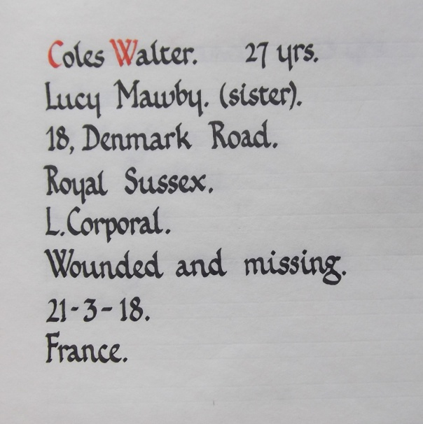
Private Walter Coles,
Royal Sussex Regiment 11th Bn.
Service No:15068

School Records give his date of birth 11thJune 1890
Son of Frederick & Eliza

1891 census: Vernon Road, Aylestone
COLES, Frederick A Head Married M 41 1850 Paper Box Cutter Leicester, Leicestershire
COLES, Eliza Wife Married F 41 1850 Leicester,
COLES, Charlotte R Daughter F 15 1876 Box Maker Leicester,
COLES, Lucy Daughter F 12 1879 Scholar Leicester,
COLES, Mabel Daughter F 10 1881 Scholar Leicester,
COLES, Frederick A Son M 9 1882 Scholar Aylestone Park,
COLES, Robert B Son M 6 1885 Scholar Aylestone Park,
COLES, Walter Son M 0 (9M) 1891 Aylestone Park, Leicestershire

1901 census for: 14, Lower Sandacre Street, Leicester
COLES, Eliza Head Widow F 47 1854 Leicester, Leicestershire
COLES, Robert B Son Single M 15 1886 Brickyard LaborerAylestone Park, Leicestershire
COLES, Walter Son Single M 10 1891 Aylestone Park, Leicestershire
POWELL, George B Boarder Married M 41 1860 Bricklayer's Laborer Leicester, Leicestershire

1911 census : 18 Denmark Road Leicester
MAWBY, Thomas Head M 34 1877 Gas Stoker Leicestershire Town Leicester
MAWBY, Lucy Wife Married13 years F 32 1879 Leicestershire Town Leicester
MAWBY, Louie Daughter F 13 1898 LeicestershireAylestone PK
MAWBY, Thomas Son M 10 1901 LeicestershireAylestone PK
MAWBY, Lily Daughter F 8 1903 LeicestershireAylestone PK
MAWBY, Harry Son M 7 1904 LeicestershireAylestone PK
MAWBY, Arthur Son M 4 1907 LeicestershireAylestone PK
MAWBY, Ethel Daughter F 2 1909 LeicestershireAylestone PK
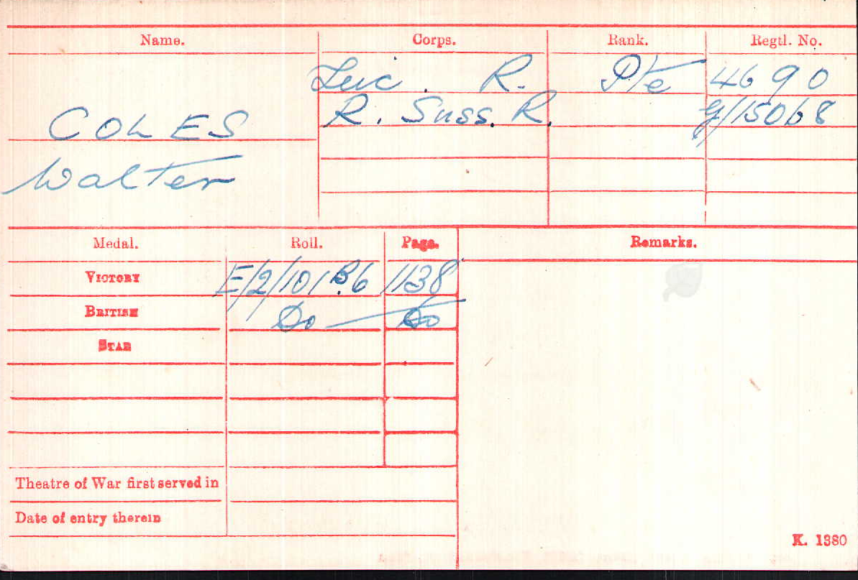
COLES, Walter Boarder Single M 20 1891 Rubber Hand Cycle Tyres LeicsAylestone PK

Date of Death:27/03/1918
Grave ReferenceIII. G. 3.PERONNE COMMUNAL CEMETERY EXTENSION

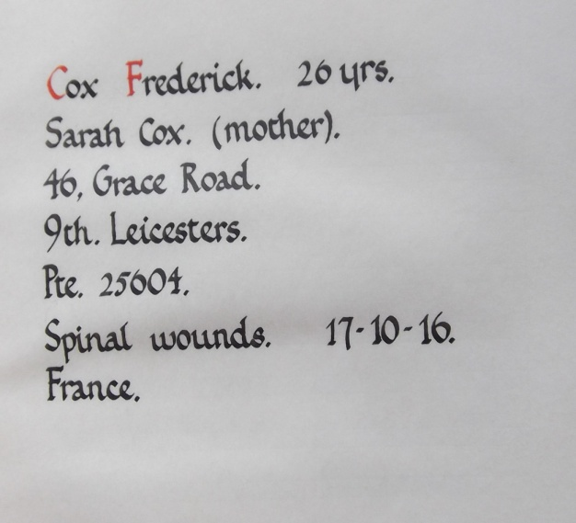
Private Frederick Cox,
Leicestershire Regiment 9th Bn.
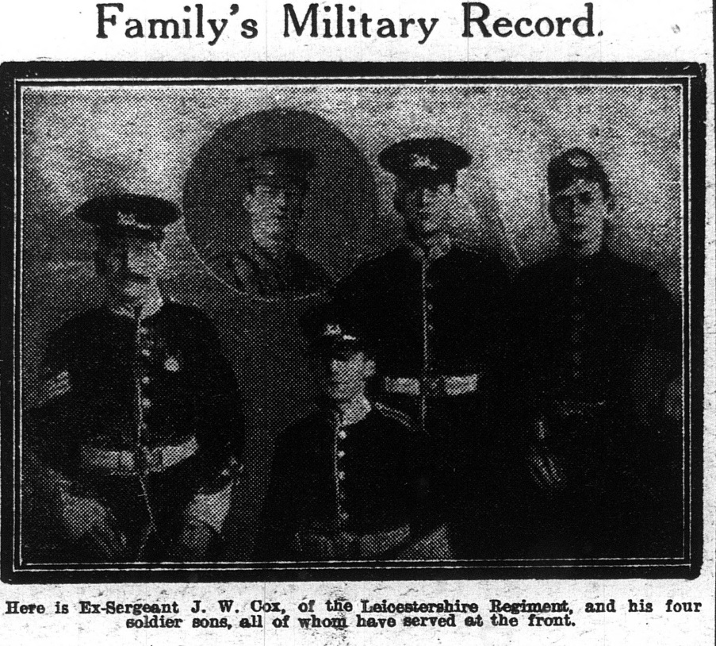
Service No:25601

Baptism 11th May 1890 at Aylestone St Andrew DOB 12th March 1890. Son of James and Sarah Cox, of 64, Grace Rd., Aylestone Park, Leicester. School Records give his date of birth as 12th March 1890

Illus. Chron10-Mar 1917
1911 census for: 54 Grace Road Leicester
COX, James Warren Head Married M 47 1864 Gardener Jobbing Naseby Northants
COX, Sarah Wife Married22 years F 42 1869 Assisting In The Business Nuneaton Wks
COX, Frederick Son Single M 21 1890 Rubber Hand Cycle Tyre AylestoneLeics Leicestershire
COX, Mary-ann Daughter Single F 19 1892 Heel Buider Boot AylestoneLeics Leicestershire
COX, Elsie Lilian Daughter Single F 17 1894 Hosiery Hand Winder AylestoneLeics Leicestershire
COX, Florence Ellen Daughter Single F 16 1895 Aylestone Park Leics Leicestershire
COX, Frank Leslie Son Single M 10 1901 School Aylestone Park Leicestershire
COX, Archibald Son Single M 5 1906 Aylestone Park Leicestershire
COX, Reginald Son Single M 3 1908 Aylestone Park Leicestershire

1901 Census 54, Grace Road, Leicester, Leicestershire,
James W Cox Head Married Male 37 1864 LaborerAt Sand Pit Nuneaton, Warwickshire,
Sarah Cox Wife Married Female 32 1869 - Leicestershire, England
Frederick Cox Son Single Male 11 1890 - Leicestershire, England
Mary A Cox Daughter Single Female 9 1892 - Leicestershire, England
Elsie L Cox Daughter Single Female 7 1894 - Leicestershire, England
Infant - Son Single Male 0 1901 - Leicestershire, England
Joseph Horton Boarder Single Male 25 1876 Railway Plate Layer Norden, Lancashire,
Frederick Cox Son Single Male 1 1890 - Leicestershire,
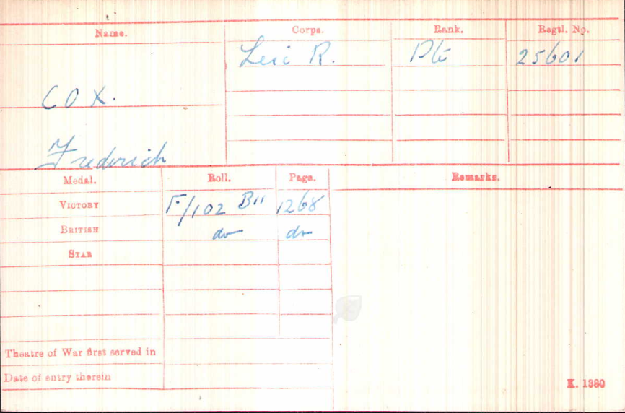

Date of Death:17/10/1916
Age:26
Grave ReferenceH. 607.
LEICESTER (GILROES)
CEMETERY

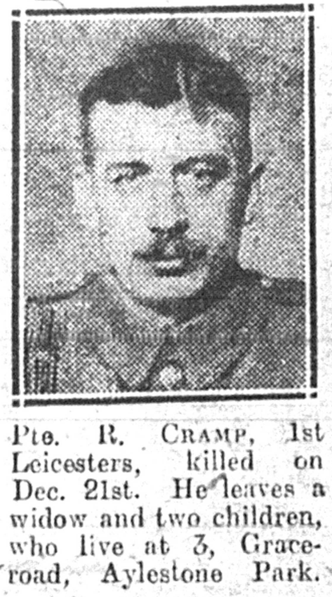
Private Reginald Cramp,
Leicestershire Regiment 1stBn
Service Number 7747

Reginald married Alice Clapham in 1914
They had two children Karen L in 1914,
Reginald C L in 1916, obviously born after his father died.
Reginald C L baptised 1916 at St James Aylestone Park
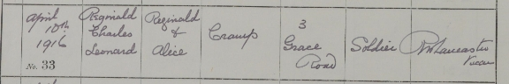

1911 census The Barracks, THE BARRACK
Military details: Private Leicestershire Regiment 413
CRAMP, Reginald Single ? 32 1879 Waiter Sergts Mess Warwick Coventry

1901 census transcription details for: Main Street, Markfield
THORPE, Charles Head Married M 25 1876 Coal Miner Barsby, Leicestershire
THORPE, Patience Wife Married F 20 1881 Markfield, Leicestershire
THORPE, Oliver Son M 0 (7 MOS) 1901 Markfield, Leicestershire
CRAMP, Reginald Boarder Single M 14 1887 Coal Miner Markfield, Leicestershire
CRAMP, John Boarder Single M 42 1859 General Labourer Markfield, Leicestershire

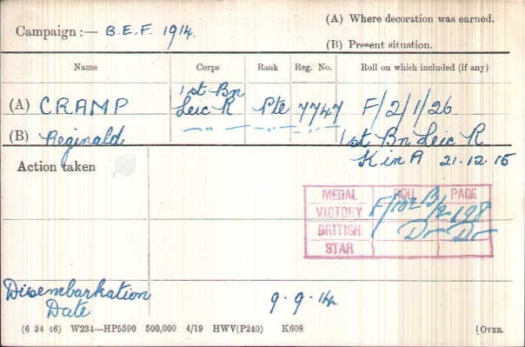
Died 21/12/1915
Remembered at White House Cemetery at St. Juan-Les-Ypres

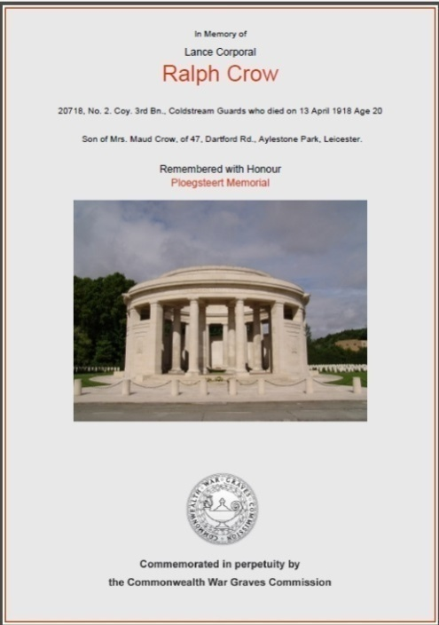
Lance Corporal Ralph Crow,
Coldstream Guards No. 2. Coy.3rd Bn.
Service No:20718

Son of Mrs. Maud Crow, of 47, Dartford Rd., Aylestone Park, Leicester

Baptism 10th July 1898 at Enderby parish Church DOB 26th Feb 1898 s/o John Charles & Maud

1911 census transcription details for: John St Enderby
CROW, John Charles Head Married M 37 1874 Platelayer In Stone Quarry Essex Hockley
CROW, Maud Wife Married16 years F 34 1877 Enderby
CROW, Mabel Emma Daughter F 14 1897 Mothers Help Enderby Leicestershire
CROW, Ralph Charles Son M 13 1898 In Stock Room At Enderby Leicestershire
CROW, Dorothy May Daughter F 10 1901 School Enderby Leicestershire
CROW, Beatrice Emily Daughter F 9 1902 School Enderby Leicestershire
CROW, Albert James Son M 6 1905 School Enderby Leicestershire
CROW, Walter Son M 3 1908 Enderby Leicestershire
CROW, Fredrick William Son M 1 1910 Enderby Leicestershire

1901 Census West Street, Enderby, Blaby, Leicestershire,
John C Crow Head Married Male 26 1875 Hockley, Essex, Plate Layer (Quarry)
Maud Crow Wife Married Female 23 1878 Enderby, Leicestershire,
Mabel ECrow Daughter Single Female 4 1897 Enderby, Leicestershire,
Ralph CCrowSon Single Male 3 1898 Enderby, Leicestershire,
Dorothy M CrowDaughter Single Female 0 1901 Enderby, Leicestershire, -
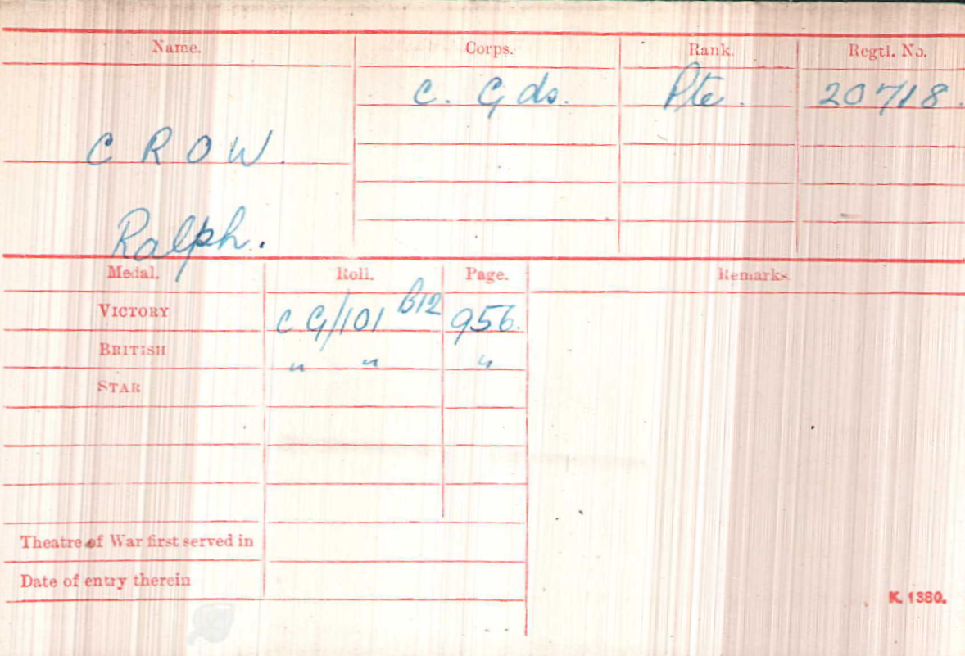

Date of Death:13/04/1918Age:20
Panel 1.PLOEGSTEERT MEMORIAL
E CUNDELL

1911 census transcription details for: 65 Skipworth St Leicester
CUNDILL, Annie Wife Married32 years F 51 1860 Northamptonshire Bugbrook
CUNDILL, Charles Head Married M 60 1851 Journeyman Tailor Grimsby Lincs
CUNDILL, Alfred Son Single M 28 1883 Bugbrook Northants
CUNDILL, William Son Single M 22 1889 Tailors Fitter Heyford Northants
CUNDILL, Earnest Son Single M 18 1893 Printers Apprentice Leics Leicester
CUNDILL, John Charles Son M 13 1898 School Boy Leics Leicester
1901 Census 32, Porter Street, Leicester, Leicestershire,
Charles Cundell Head Married Male 46 1855 Cleethorpes, Lincs. Tailor
Annie Cundell Wife Married Female 42 1859 Northamptonshire,
Alfred Cundell Son Single Male 18 1883 Northamptonshire,
William Cundell Son Single Male 12 1889 Northamptonshire,
Ernest Cundell Son Single Male 8 1893 Leicestershire,
Charles Cundell Son Single Male 3 1898 Leicestershire,

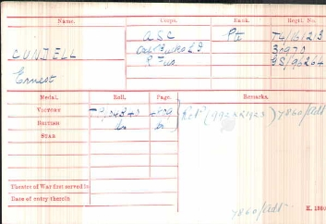
ErnestCundell |  |  | Army Service Corps, Oxfordshire and Buckinghamshire Light Infantry, Royal Fusiliers |  |  |  |  |  |  | T4/161213, 30970, GS/96264
 |  |  | Charles ErnestCundall |  |  |  |  |  |  | Royal Fusiliers |  | 4721
 |  |  | ErnestCundall |  |  |  |  |  |  | Army Service Corps |  | M/304600
 | 1918 | 1 |  | CUNDELL |  | Ernest |  | HODSON |  |  |  | Clara J |  | 7a | 416 | 07-Feb | Leicester, St Peter
These are buried at full age at gilroes

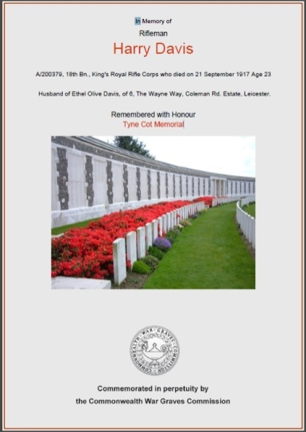
Rifleman Harry Davis
King's Royal Rifle Corps
Service No.A/200379

Born in Bromsgrove in 1893 the son of Henry James & Mary Davis (nee Wheeler) they were married 2nd October 1880 at Bromsgrove Parish Church
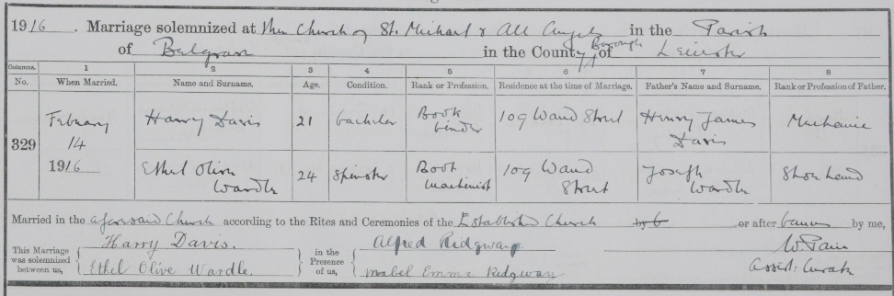
He married Ethel Olive Wardle on Valentine’s Day 1916

1901 Census All Saints Road, Bromsgrove, Worcestershire,
Henry J Davis Head Married Male 41 1860 Packer Shoe Factory Bromsgrove, Worcs
Mary Davis Wife Married Female 39 1862 Bromsgrove, Worcs.
Mary J Davis Daughter Single Female 18 1883 Button Hand At Shoe Factory Bromsgrove, Worcs.
His widow Ethel Olive
remarried at St James Church to Edgar Smith on 24th Dec 1919

Lucy Davis Daughter Single Female 16 1885 Stitcher At Shoe Factory Bromsgrove, Worcs
Nellie Davis Daughter Single Female 14 1887 Leather Cutter At Shoe Factory Bromsgrove, Worcs
George Davis Son Single Male 13 1888 Heel Maker At Shoe Factory Bromsgrove, Worcs
Laura Davis Daughter - Female 11 1890 - Bromsgrove, Worcestershire,
Arthur Davis Son Male 9 1892 - Bromsgrove, Worcestershire,
Harry Davis Son Male 7 1894 - Bromsgrove, Worcestershire,
Charles L Davis Son Male 2 1899 - Bromsgrove, Worcestershire,

1911 Census 53 Paget Road Leicester,
Henry James Davis Head Married Male 51 1860 Greengrocer Bromsgrove Worcestershire
Mary Davis Wife Married Female 49 1862 - Bromsgrove Worcestershire
Mary Jane Davis Daughter Married Female 28 1883 Boot Machinist Bromsgrove Worcestershire
Lucy May Davis Daughter Single Female 26 1885 Boot Machinist Bromsgrove Worcestershire
Nellie Davis Daughter Single Female 24 1887 Boot Machinist Bromsgrove Worcestershire
George Henry Davis Son Single Male 22 1889 Boot Pressman Bromsgrove Worcestershire
Arthur Davis Son Single Male 19 1892 Book Finisher Bromsgrove Worcestershire
Harry Davis Son Single Male 16 1895 Book Binder Bromsgrove Worcestershire
Leonard Davis Son - Male 13 1898 School Bromsgrove Worcestershire
Harold Davis Son - Male 10 1901 School Bromsgrove Worcestershire
Edna Davis Daughter - Female 5 1906 - Leicester Leicestershire

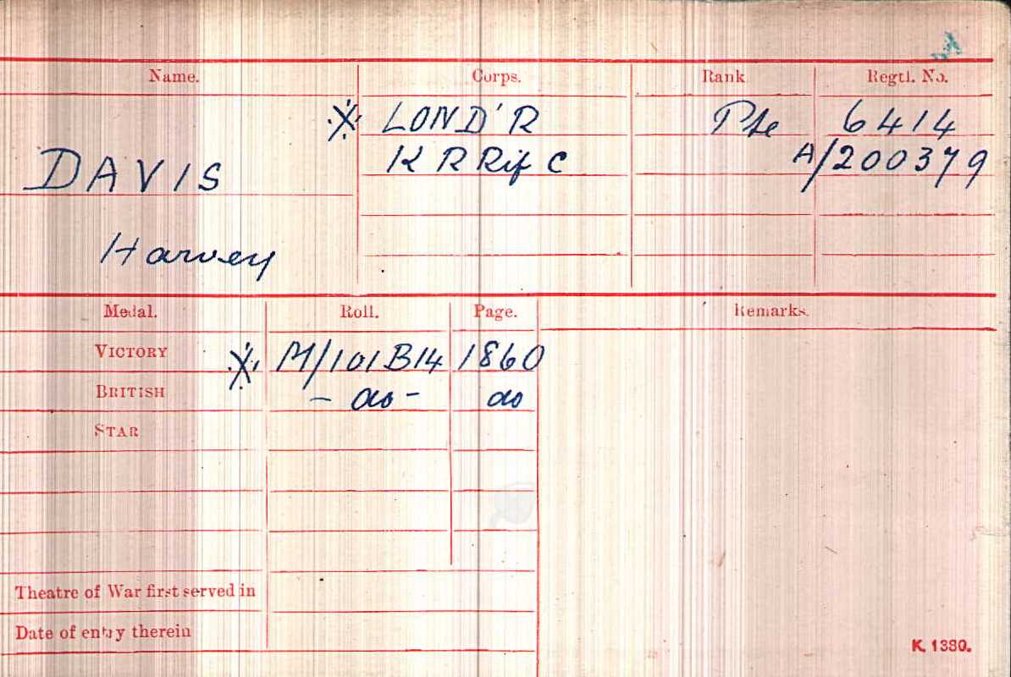
Died on Friday, September 21, 1917
Age 23
TYNE COT MEMORIAL
Panel 115 to 119 and 162A and 163A.

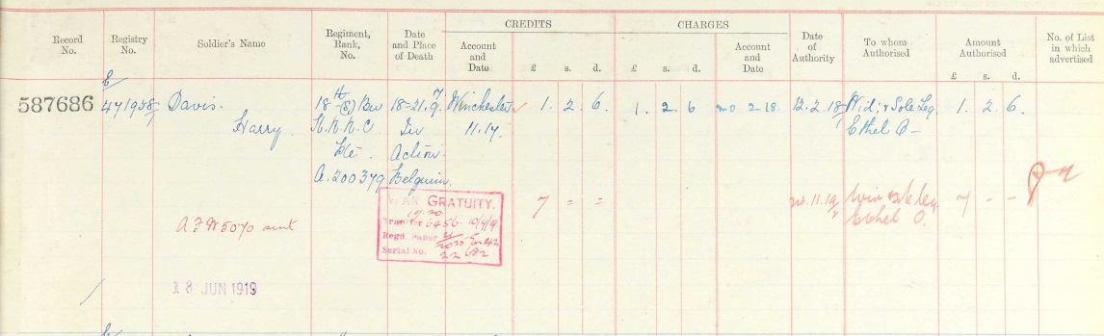
Soldiers Effects

Private Thomas William DEACON
Sadly Thomas does not appear on the Commonwealth War Graves site.
His death on his Service Records is exactly a year later than on his burial – if anyone knows more .........
Leicestershire Regiment 4thBn
Service no 4864/201405

1911 census: 1 Cromwell Road Leicester
DEACON, Thomas Joseph Head Married M 59 1852 Fish Trade Hawker Leicestershire Leicester
DEACON, Mary Ann Wife Married28 years F 45 1866 Leicestershire Leicester
TABERNER, John William Son-In-Law Married M 25 1886 Shoe Hand Edge Setter Staffs Stafford
TABERNER, Frances Mary Daughter Married1 years F 23 1888 Hosiery Hand Turner Leicester
DEACON, Thomas William Son Single M 16 1895 General Labourer Leicestershire Leicester
TABERNER, Ellen Frances Granddaughter F 2 1909

Service Records Died 21st Jan 1921 registered FREEBMD Death 1920Mar 7a 309 age 25
Burial DeaconThomas William 28th Jan 1920Age 25 12 Percy St Leicesterur657cU108095
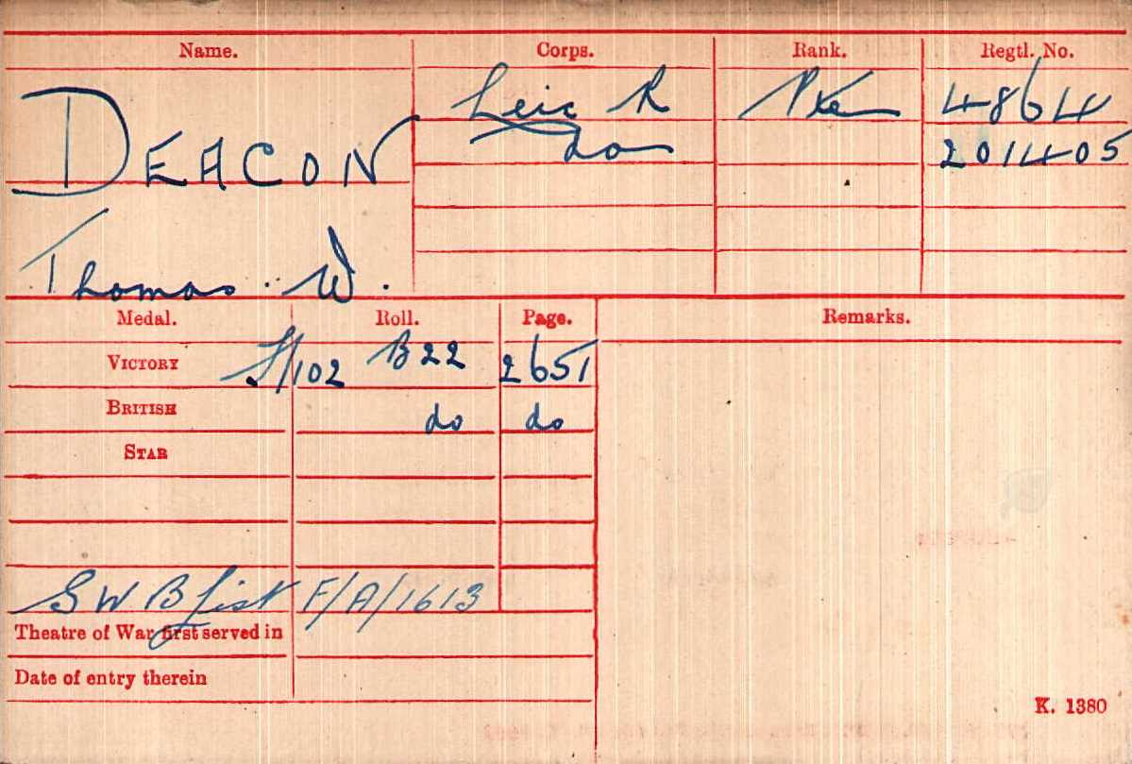

Thomas Wm Deacon
Age 21
Birth1894Aylestone Leics. Service no. 4867/201405
Leicestershire Regiment
Unit / 4th Battalion
Year Attested 1915

Thomas William Deacon, mother’s maiden name Voss
GRO Reference: 1894 J Quarter in LEICESTER Volume 07A Page 298

Possible BaptismThomas WilliamDeacon1896Leicester, St Mary de Castro s/o Tom&Emma
Marriages Mar 1915 Deacon Thomas W Kempin Leicester 7a 397
Kempin Stella B M Deacon Leicester 7a 397

His wife Stella remarried in 1927 and was in Braunstone in 1939

Marriages Jun 1927 Deacon Stella B M Moreton Leicester 7a 710
MORETON Frederick Deacon Leicester 7a 710

1939 Index Moreton Household (11 People) 119 Hand Avenue , Leicester C.B., Leicestershire,
Frederick Moreton 18 Apr 1888 Male Shoe Hand Married 77 1
Stella B M Moreton 16 Apr 1897 Female Household Duties Married 77 2
Lancelot Deacon 06 Sep 1922 Male Tailor Single 77 3
Beryl (M) Whitehead (Deacon)24 May 1924 Female Hosiery Machinist Single 77 4
Sorry, this record is officially closed.X5
Colin Moreton 30 Sep 1930 Male At School Single 77 6
Emily R Vickers 08 Mar 1914 Female Boat & Shoe Machinist Married 77 11

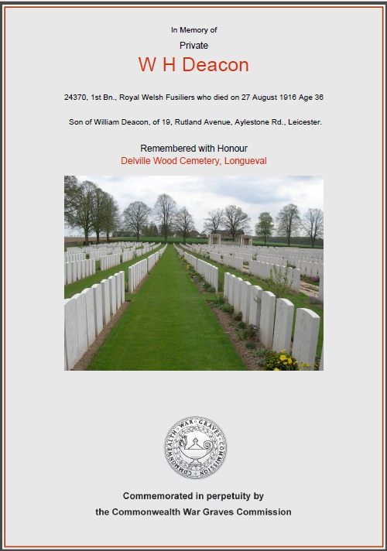
Private William H Deacon
Royal Welsh Fusiliers 1st Bn.
Service No:24370

Baptism 01 Oct 1883 St John the Divine s/o Wm & LauraDeacon, of 19, Rutland Avenue, Aylestone Rd., Leicester.

1881 census: 40, Chatham St, Leicester
DEACON, William Head Married M 21 1860 Joiner Out Of Employment Leicester,
DEACON, Laura Wife Married F 21 1860 Joiners Wife Leicester,
DEACON, William H Son Single M 0 1881 Leicester,
COOPER, Elizabeth Lodger Widow F 44 1837 Dress Maker Leicester,

1901 census: 10, Rutland Avenue, Leicester
DEACON, William Head Married M 41 1860 Retired Licensed Victualler Leicester
DEACON, Laura Wife Married F 40 1861 Leicester

1911 census: 9 Harcourt St Hanley Stoke on Trent
DEACON, William Henry Head Married M 30 1881 Tailors Cutter Leicester
DEACON, Lily Louisa Wife Married11 years F 29 1882 Leicester
DEACON, Laura Louisa Daughter Single F 10 1901 School Leicester
DEACON, Marie Gwendoline Daughter Single F 8 1903 Leicester
DEACON, Ellaline Daughter Single F 2 1909 Leicester
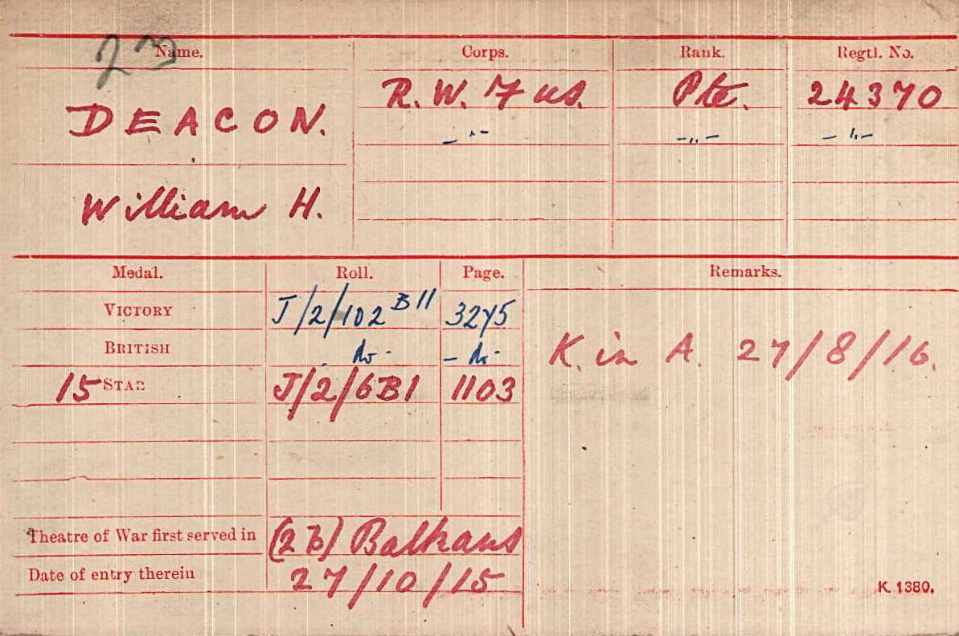

Date of Death :27/08/1916
Age:36
Grave ReferenceXIV. I. 1DELVILLE WOOD CEMETERY, LONGUEVAL

