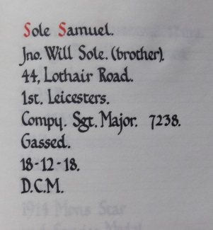
Company Serjeant Major Samuel Sole,
Leicestershire Regiment 1st Bn.
Service No:7238

Baptised at St Mary Magdelan Knighton, 15th March 1885
Gives his Date of Birth as 25th December 1884 son of George & Harriett

Harriett died in 1888 aged 37 and George remarried in 1900

1891 Census Cottages At Brickyard, Fleetwood Road, Knighton, Blaby,
George Sole Head Widower Male 50 1841 Northamptonshire, General Labourer
Sarah Ann Sole Daughter - Female 13 1878 Leicestershire, -
William Sole Son - Male 4 1887 Leicestershire, Scholar
Samuel Sole Son - Male 6 1885 Leicestershire, Scholar
George Sole Son - Male 3 1888 Leicestershire,
1901 census transcription details for: 71, Cavendish Road, Leicester
SOLE, George Head Married M 60 1841 Labourer At Gas Works Lower Bodington, Northamptonshire
SOLE, Lucy Wife Married F 61 1840 Hinckley, Leicestershire
SOLE, Sarah A Daughter Single F 23 1878 Boot & Shoe Machinist Blaby, Leicestershire
SOLE, Samuel Son Single M 16 1885 Warehouse Porter Knighton, Leicestershire
SOLE, George Son Single M 13 1888 Engine Maker Brass Finisher Knighton, Leicestershire

1911 Census in Fort Madras India
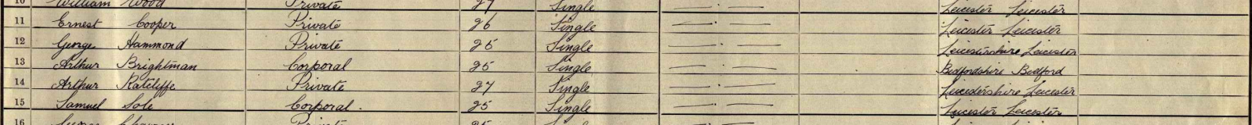
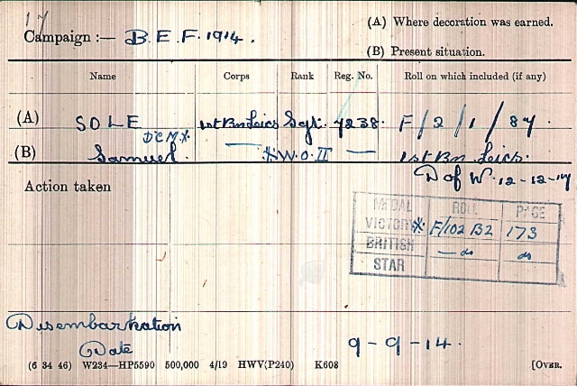
Service Records

Date of Death:12/12/1917
Grave ReferenceVIII. A. 4.ROCQUIGNY-EQUANCOURT ROAD BRITISH CEMETERY, MANANCOURT

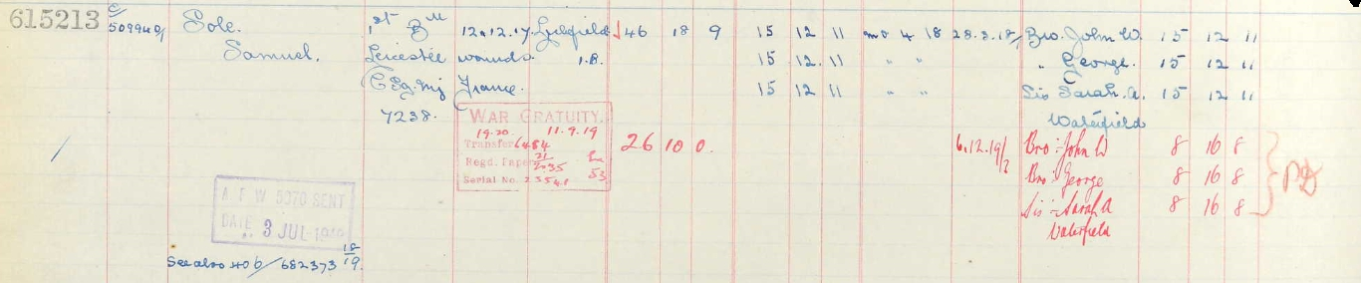
Soldier’s Effects

Private Harold Fredrick Sprigg, Illus. Chron 07-Dec 1918
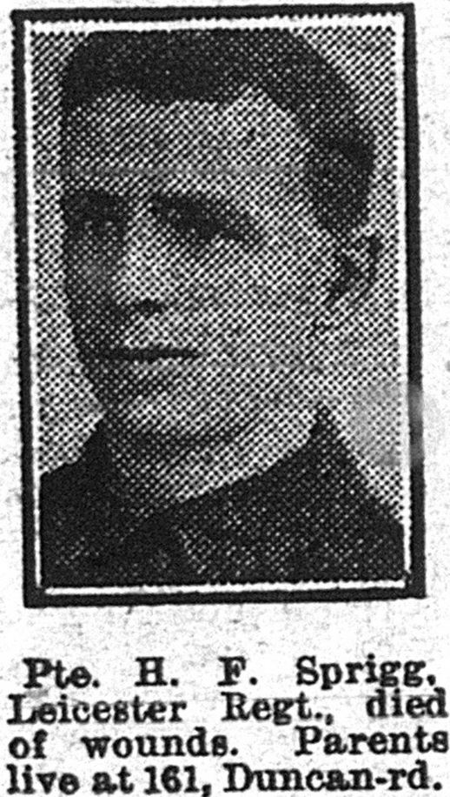
Leicestershire Regiment 1st/5th Bn.
Service No:242000

Born in Kibworth Beauchamp in 1893 the son of
Ephraim Sprigg&and Sarah Ann Jarvis who were married near Coventry in 1879

1901 Census New Road, Kibworth Beauchamp, Leicestershire,
Ephraim WrightSpriggHead Married Male 41 1860 Gas Manager Lubenham, Leics
Sarah Ann Sprigg Wife Married Female 43 1858 - Coventry, Warwickshire,
Cecil William Sprigg Son Single Male 201881 Hosiery Hand Lubenham, Leicestershire,
Francis ThomasSpriggSon Single Male 18 1883 Railway LabourerLubenham, Leicestershire,
Ida Flora Margaret Sprigg Daughter- Female 11 1890 Lubenham, Leicestershire,
Harold Fredk Sprigg Son Male 81893 - Leicestershire,
Ephraim HerbertSpriggSon Male 41897 - Leicestershire,
Constance MarySpriggDaughterFemale2 1899 Leicestershire,

But by 1911 they had moved to Aylestone Park

1911 census Curzon Road Leicester
SPRIGG, Ephraim Wright Head Married M 51 1860 Corporation Gas WorsFitter,ErectorLeicsLubenham
SPRIGG, Sarah Ann Wife Married31 years F 53 1858 Houosewife Warwickshire Coventry
SPRIGG, Ida Flora Margret Isabell Daughter Single F 21 1890 Packer And Sorter Steam Laundry Leics
SPRIGG, Harold Fredrick Son Single M 18 1893 Apprentice French Polishing Kibworth Beauchamp
SPRIGG, Ephraim Herbert Wright Son M 14 1897 Printing Works & Book Binding Kibworth Beauchamp
SPRIGG, Constance Mary Francis Amelia Daughter F 12 1899 School Girl LeicsKibworth Beauchamp
SPRIGG, Vincent Alexza Grandson M 3 1908 Borough of Leicester
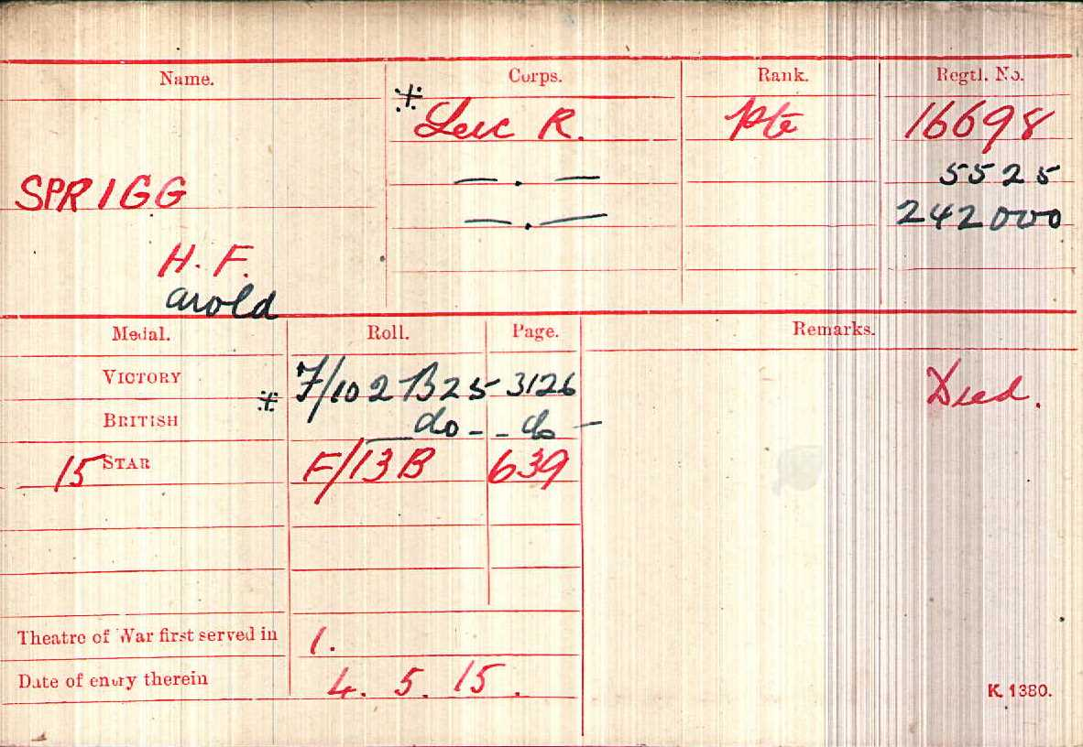

Date of Death:10/10/1918Age:25
Grave VII.A. 12.
TINCOURT NEW BRITISH CEMETERY

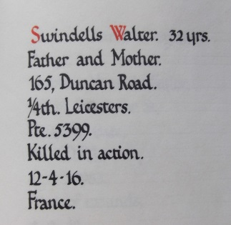
Private Walter Swindell,
Leicestershire Regiment 4th Bn
Service No:5399
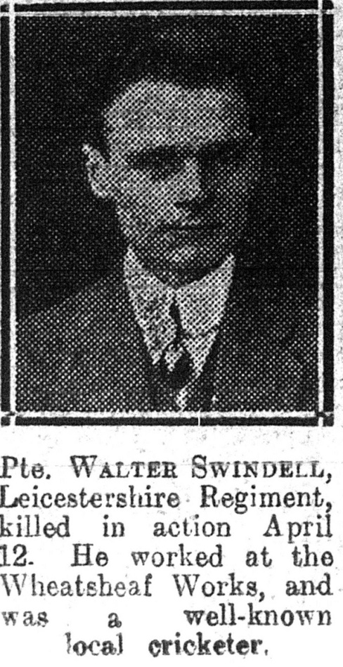

School records give his date of birth as 7th November 1883 son of Isaac & Harriett of Duncan Road

1901 Census 17, Burns St Leicester,
Isaac SwindellHeadMarriedMale 43 1858Staffordshire, Shoe Clicker
Harriett Swindell WifeMarriedFemale42 1859 Stone, Staffordshire,
Walter Swindell Son Single Male17 1884Stone, Staffs.Shoe Clicker
Lilian SwindellDaugSingleFemale18 1883Stone, Staffs. Shoe Fitter
Frances M SwindellDaugSingleFemale5 1896Aylestone Park, Leics.
1911 Census 165 Duncan Road Leicester,
Isaac Swindell Head MarriedMale 53 1858Stone Staffs Shoe Hand Harriet Swindell Wife Married Female 52 1859 Stone Staffs
Lilian SwindellDaug Single Female 27 1884Stone Staffs Shoe Trade
Walter Swindell Son Single Male 26 1885Stone Staffs Shoe Trade
May SwindellDaug Single Female 15 1896Leicester Hosiery Trade

Illus. Chron 06-May 1916

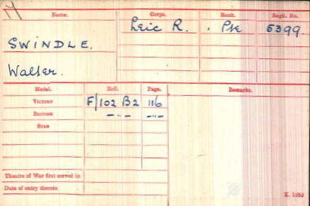
Service Records

Date of Death:12/04/1916 Age:32
Grave Reference:I. A. 3.
ECOIVRES MILITARY CEMETERY, MONT-ST. ELOI
Additional Information:Son of Isaac and Harriet Swindell, of Leicester.

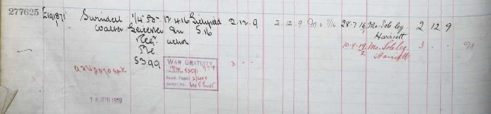
Soldiers Effects

Private George Thornton Illus. Chron01-Mar 1919
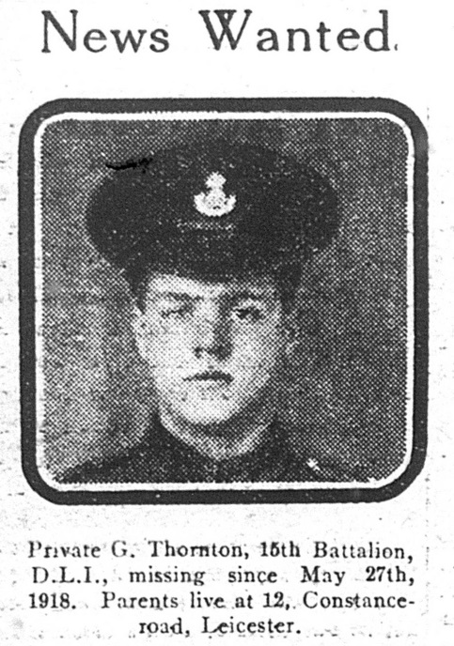
4th Labour Coy. Lincolnshire Regiment
transf. to (25629) 43rd Coy.Labour Corps
Service Number 37564
School Records give his date of birth as 29th December 1891 son of John & Elizabeth Thornton of Vernon Road, He was baptised at Aylestone Park St James26-July 1893 Son of John Henry and Eliza
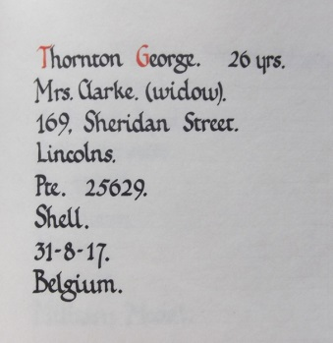

He married Elsie L Bloxam on
5th August 1916 atLeicester,
St Luke after he died his widow Elsie L remarried on 24th July 1920 at
Aylestone Park, St James

1901 Census Vernon Road, Leicester,

John Thornton Head Married Male 45 1856 Leicestershire, Shoe Hand Finisher
Lizzie Thornton Wife Married Female 44 1857 Leicestershire, -
Lucy Thornton Daughter Single Female 21 1880 Leicestershire, Hosiery Hand Tacker & Maker
John Thornton Son Single Male 17 1884 Leicestershire, General Laborer Rubber Works
Charley Thornton Son Single Male 15 1886 Leicestershire, General Laborer Rubber Works
Anna Thornton Daughter Single Female 13 1888 Leicestershire, Hosiery Hand Sock Counter
William Thornton Son Single Male 11 1890 Leicestershire, -
GeorgeThornton Son Single Male 9 1892 Leicestershire, -
Lizzie Thornton Daughter Single Female 7 1894 Leicestershire, -
Henry Thornton Son Single Male 5 1896 Leicestershire, -

1911 Census 48 Vernon Road Leicester,
John Thornton Head Married Male 54 1857 Leicester Shoe Finisher
Elizabeth Thornton Wife Married Female 53 1858 Leics Market Harboro -
William Thornton Son Single Male 21 1890 Leicester Carpinter
George Thornton Son Single Male 19 1892 Leicester Packer
Elizabeth Thornton Daughter Single Female 17 1894 Leicester Turner And Marker
Henry Thornton Son Single Male 15 1896 Leicester Scourer
Francis Fanny Thornton Daughter Single Female 8 1903 Leicester
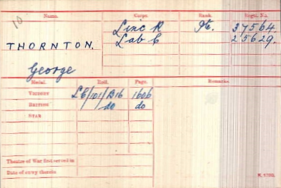

Died 31/08/1917

Aged 25

And is buried at
BLEUET FARM
CEMETERY

I. C. 40.

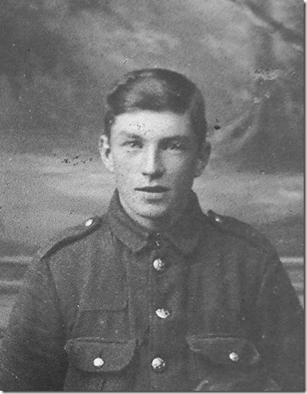
Private John Thomas Toach,
Leicestershire Regiment "D" Coy 2nd Bn.
Service No:20351

Born in 1895 the son of Thomas and Louisa Catherine Toach,
of 140, Duncan Rd., Aylestone Park, Leicester.

1901 census: 60, Mason Street, Byker, Newcastle Upon Tyne
TOACH, Thomas Head Married M 33 1868 Plasterer Leicester
TOACH, Louisa C Wife Married F 32 1869 Fancy Box Maker Leicester
TOACH, Annie M Daughter Single F 6 1895 Northamptonshire
TOACH, John T Son Single M 5 1896 Aylestone, Leicestershire
TOACH, Lilly Daughter Single F 3 1898 Nuneaton, Warwickshire
TOACH, Frederick A Son Single M 1 1900 Leicestershire

1911 census 6 Potter St St Peters Byker Newcastle on Tyne
My thanks to Jeff ToachSon of Gilbert, for this picture of his Uncle
TOACH, Thomas Head Married M 43 1868 Plaster Leicester 9children
TOACH, Louisa Wife Married17 years F 42 1869 Leicester
TOACH, John Son Single M 15 1896 Wood Box Maker Leicester
TOACH, Lilly Daughter F 13 1898 School Nuneaton
TOACH, Frederick Son M 11 1900 School Hinckley
TOACH, Miriam Daughter F 9 1902 School Newcastle on Tyne
TOACH, Walter Son M 7 1904 School Newcastle on Tyne
TOACH, Robert Son M 5 1906 School Newcastle on Tyne
TOACH, Mark Son M 2 1909 Newcastle on Tyne
TOACH, Gilbert Son M 0 (5 MONTHS) 1911 Newcastle on Tyne
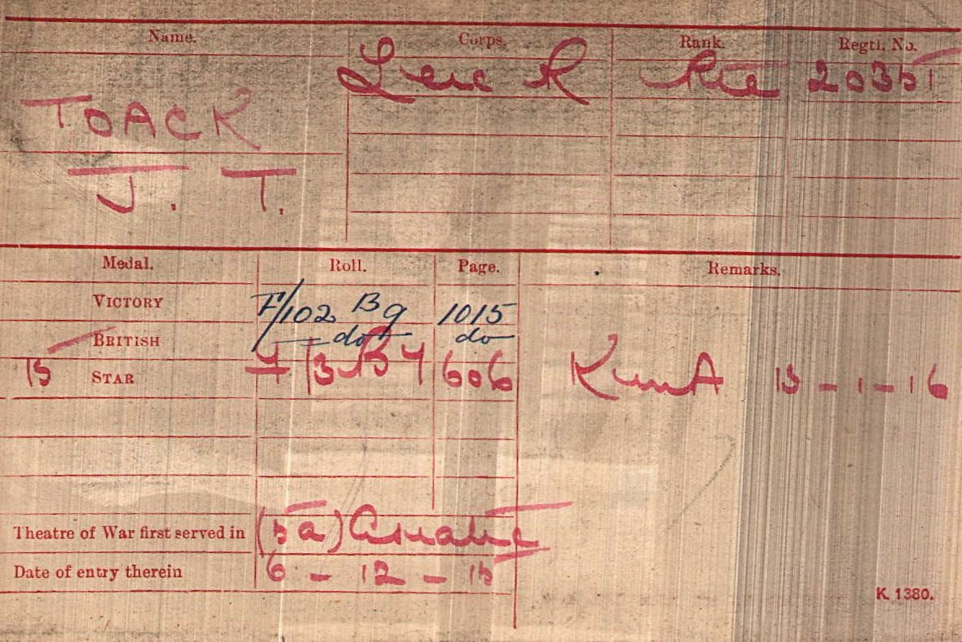

Date of Death:
13/01/1916
Age:20
Panel 12.
BASRA MEMORIAL

Soldiers Effects
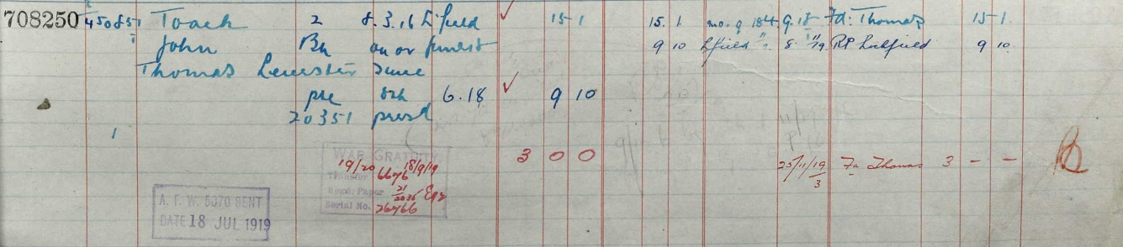

Serjeant Enoch Tunnicliffe, Illus. Chron 14-Apr1917
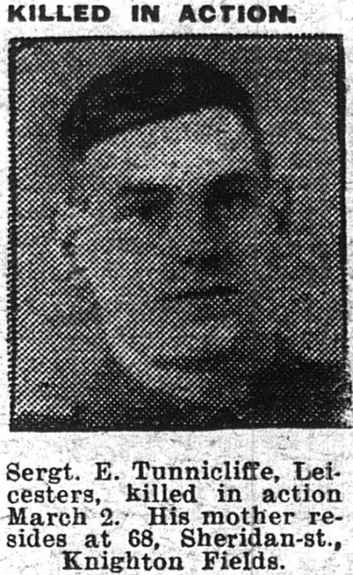
Leicestershire Regiment 9th Bn
Service Number 9/14860

Born in 1897 the son of Henry and Sarah Ann Tunnicliffe,
of 68, Sheridan St., Knighton Fields, Leicester.

1911 Census 68 Sheridan Street Leicester,
Henry TunnicliffeHusbandMarried Male471864BootmakerStone
William HyTunnicliffeSonSingleMale241887Railway PlatelyrStone
Agnes TunnicliffeDaugSingleFemale221889Boot Fitter Stone Staffs
Carrie ElizthTunnicliffeDaughterSingleFemale201891 Boot MachinestNorthampton
Enoch TunnicliffeSonSingleMale181893Boot FinisherLeicester
ClementTunnicliffeSon- Male15 1896 Gpo Messenger Leicester
Gladys IreneTunnicliffeDaughter Female 41907 - -

1901 Census 68, Sheridan Street, Leicester,
Henry Tunnicliffe Head Married Male 38 1863 Shoe Laster Stone, Staffordshire,
Sarah A Tunnicliffe Wife Married Female 38 1863 Laundress Stone, Staffordshire,
Agnes Tunnicliffe Daughter - Female 12 1889 - Stone, Staffordshire,
Carrie E Tunnicliffe Daughter - Female 10 1891 - Northamptonshire,
Enoch Tunnicliffe Son - Male 8 1893 - Leicestershire,
Clement Tunnicliffe Son - Male 5 1896 - Leicestershire,

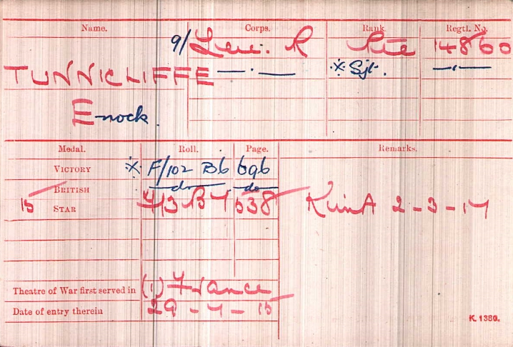

Enlisted Aug., 1914.
Died 02/03/1917
Aged 23

Remembered with Honour
Vermelles British Cemetery

Soldiers Effects
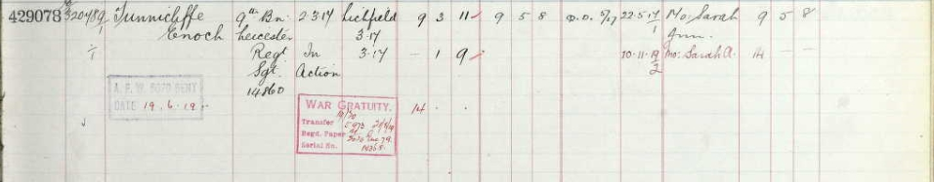

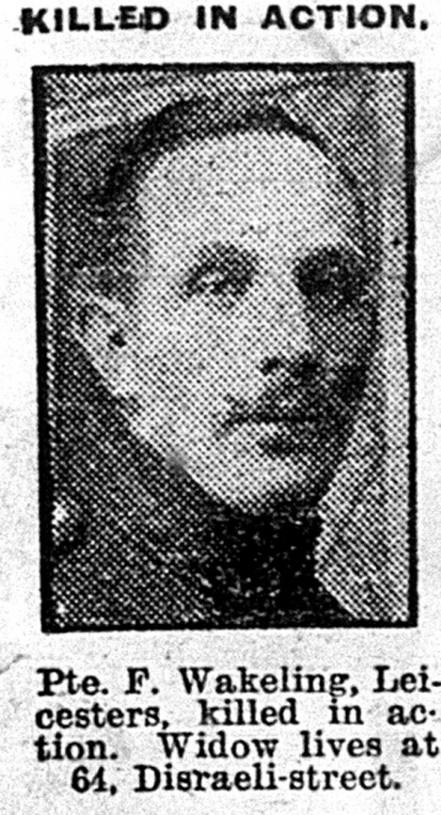
Private Fred WAKELING Illus.Chron 18-May 1918
Leicestershire Regiment 8th Bn. formerly 7th Bn.
Service No:36351
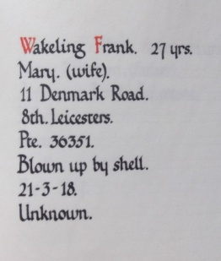
School Records give his date of birth as 8th April 1891 son of Charles & Hannah Wakeling, of 2, Harold St., AylestonePark;FredWakeling& Mary Ann Duffy married in 1916 and had a daughter Nellie in 1918 named after his sister, Mary Ann did not remarry and died 1981 aged 89

1911 census : 2 Harold St Leicester
WAKELING, Charles Head M 65 1846 Gas Works LabrLeics Whetstone
WAKELING, Hannah Wife Married 39 years F 64 1847 Leics Willoughby Waterless
WAKELING, Mary Jane Daughter Single F 28 1883 Machinist Shoe Trade Whetstone
WAKELING, Nellie Daughter Single F 26 1885 Gold Stamper Bookbinding Whetstone
WAKELING, Florence Daughter Single F 21 1890 Packer In Factory Cotton Whetstone
WAKELING, Fred Son Single M 19 1892 Shoe Finisher AylestonePk

1901 Census 2, Harold Street, Leicester,
Charles Wakeling Head Married Male 55 1846 Whetstone, Leics, Labrer At Gas Works
HannahWakeling Wife Married Female541847Leicestershire,
Walter Wakeling SonSingleMale221879Whetstone, Leics, Bricklayer's Labourer
Mary Wakeling Daughter Single Female 181883 Whetstone, Shoe Hand Machinist
Nellie Wakeling Daughter Single Female 161885 Whetstone, Leics, Book Binder's Gold Stamper
Florrie Wakeling Daughter Single Female 111890 Whetstone, Leicestershire,
Fred Wakeling Son Single Male 9 1892 Leicester Service Records
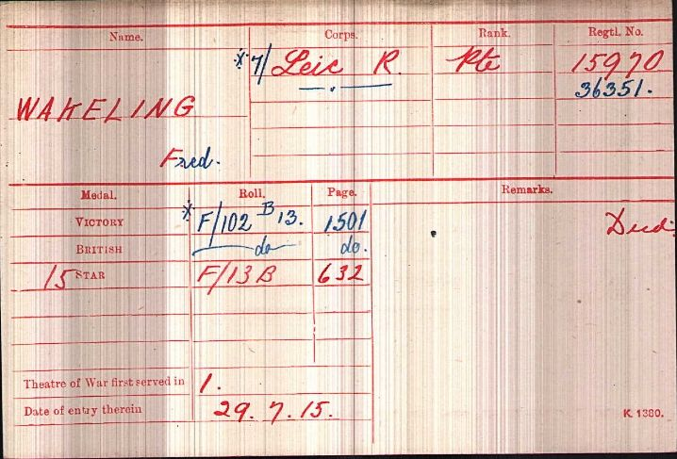

Enlisted Oct., 1914.
Three times wounded.

Date of Death:
21/03/1918
Age:26
Panel Reference
29 & 30.
POZIERES
MEMORIAL

Soldier’s Effects
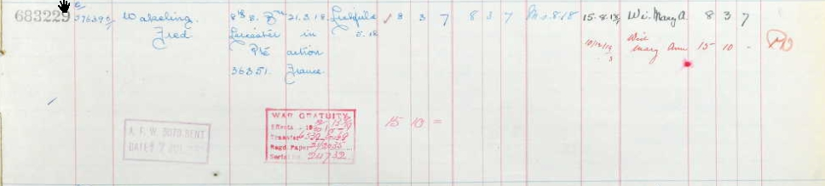

Private Walter Wakeling
Sadly Walter cannot be found on the Commonwealth War Graves listing
Leicestershire Regiment 3rd Btn
Service No: 6380. 22610,
Labour Corps no 589600

Born in Whetstone the son of Charles & Hannah Wakeling
His school records give his date of birth as 18th July 1878

1891 Census Lorraine Road, Aylestone, Blaby, Leicestershire,
Charles Wakeling Head Married Male 43 1848 Labourer Leicestershire,
Hannah Wakeling Wife Married Female 44 1847 - Leicestershire,
Elizabeth Wakeling Daughter Single Female 18 1873 Elastic Web Weaver Leicestershire,
George Wakeling Son Single Male 15 1876 - Leicestershire,
Walter Wakeling Son Single Male 13 1878 - Leicestershire,
Mary J Wakeling Daughter - Female 9 1882 Scholar Leicestershire,
Nelly Wakeling Daughter - Female 7 1884 Scholar Leicestershire,
Florry Wakeling Daughter - Female 2 1889 - Leicestershire,

1901 Census 2, Harold Street, Leicester,
Charles Wakeling Head Married Male 55 1846 Whetstone, Leics, Labourer At Gas Works
Hannah Wakeling Wife Married Female 54 1847 Leicestershire,
Walter Wakeling Son Single Male 22 1879 Whetstone, Leics, Bricklayer's Labourer
Mary Wakeling Daughter Single Female 18 1883 Whetstone, Leics, Shoe Hand Machinist
Nellie Wakeling Daughter Single Female 16 1885 Whetstone, Leics, Book Binder's Gold Stamper
Florrie Wakeling Daughter Single Female 11 1890 Whetstone, Leicestershire,
Fred Wakeling Son Single Male 9 1892 Leicester

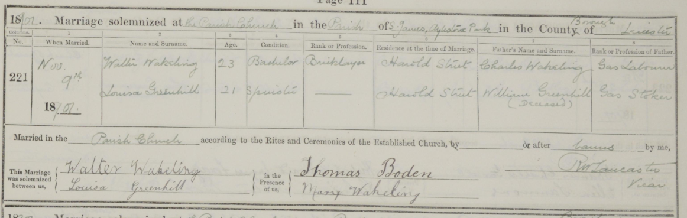
1911 Census
10 Harold St Leicester,
Walter Wakeling
Head Married Male 34 1877 Gas Labourer Boro Council Whetstone
Louisa Wakeling Wife Married Female 30 1881 Shoe Machinist Leicester
Marriage 9th November 1901 St James Aylestone Park Walter Wakeling & Louisa Greenhill
In 1902 their daughter Doris is born but sadly dies after a few months
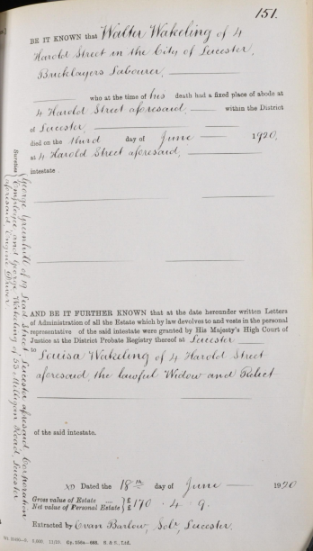
A copy of Walter’s probate gives his date of death as 3rd June 1920 at 4 Harold Street,
and he is buried at Welford Road Cemetery Leicester aged 42 in Grave no M 268 (concecrated) on 7th June 1920

Private Albert Walker, Illus. Chron27-Nov1915
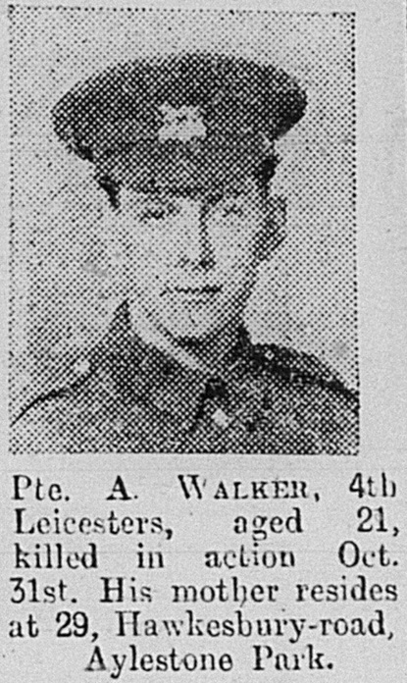
Leicestershire Regiment 1st/4th Bn.
Service No:3982

(step brother of Michael J Keighton also died)
Son of Katherine Walker, of 93, Knighton Lane, Aylestone Park, Leicester, and the late William Walker.

1901 census: 19, Milligan Road, Leicester
WALKER, William Head Married M 36 1865 Window Cleaner Leicester
WALKER, Catherine Wife Married F 38 1863 Ireland
WALKER, Mary E Step Daughter Single F 17 1884 Laundry Maid Chatham, Kent
WALKER, Margaret K Step Daughter Single F 16 1885 Laundry Maid Plymouth
WALKER, Michael J Step Son Single M 14 1887 Folder Corset Making Ireland
WALKER, Emma Daughter Single F 10 1891 Ireland
WALKER, William S Son Single M 9 1892 Aldershot, Hampshire
WALKER, Albert Son Single M 7 1894 Aldershot, Hampshire
WALKER, Catherine Daughter Single F 14 1887 Leicester

1911 census: 56 Lothair Road Leicester
WALKER, Catherine Head Widow F 48 1863 Cahirciveen Kerry Ireland
WALKER, Emma Daughter Single F 20 1891 Packer And Sorter Fermoy Co Cork Ireland
WALKER, William Samuel Son Single M 19 1892 Points Aldershot Hants
WALKER, Albert Son Single M 17 1894 Machinist Aldershot Hants
WALKER, Catherine Daughter Single F 14 1897 Assistant Leicester
KEIGHTON, Michael Joseph Son Single M 24 1887 Attendant Caherciveen Co Kerry Ireland
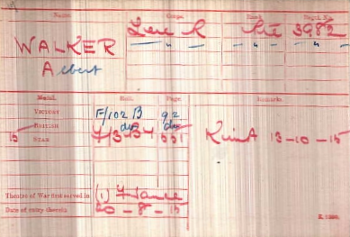

Date of Death:
13/10/1915
Age:21
ReferencePanel
42 to 44.
LOOS MEMORIAL

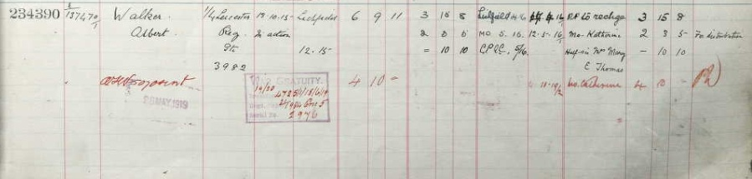

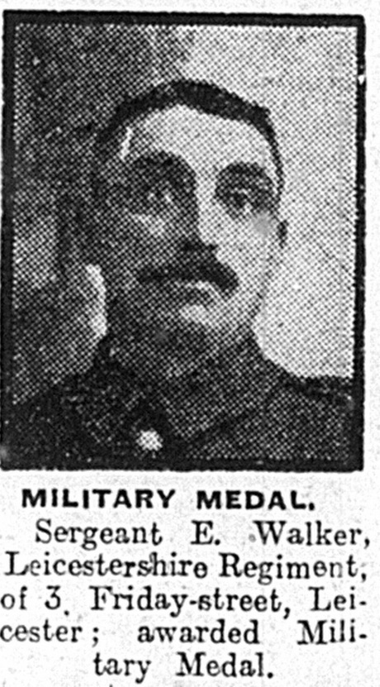
E WALKER

WALKER E Serg Friday St Leicesters MM Mercury 14-Oct 1916 5

WALKER E Serg Friday St Leicesters MM Daily Post 14-Oct 1916 6

WALKER E Private Friday Street Leicesters MM Illus. Chron 28-Oct 1916 BP
Marriages Dec 1909
GRANT | Ada |  | Leeds | 9b | 977
WALKER | Edgar |  | Leeds | 9b | 977
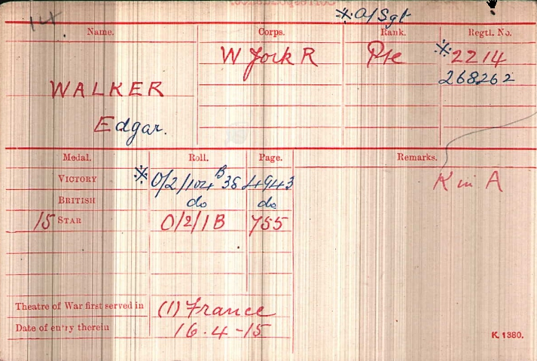

SERJEANTWALKER, EDGAR

Service Number 268262

Died 09/10/1917

1st/8th Bn.

West Yorkshire Regiment (Prince of Wales's Own)

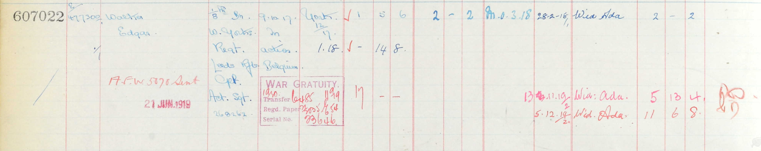
Walker, Ernest Rank : Lance Sergeant
Army Number : 11359
Served with Leicestershire Regiment during World War One. Listed as 7/11359.Was awarded the Military Medal. See London Gazette 21.9.1916 page 9204. Also served as Private 85220 Northumberland Fusiliers.
Period of Service : 1910s
Conflicts : WW1 Not on CWWG
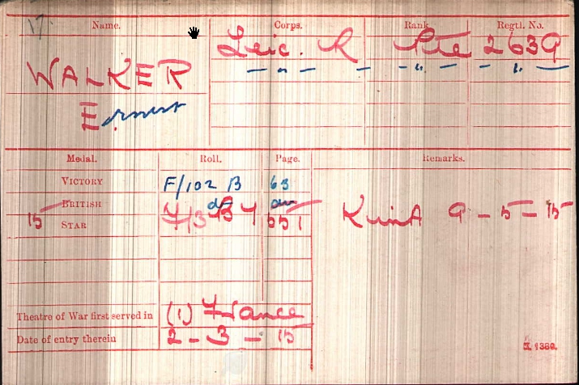
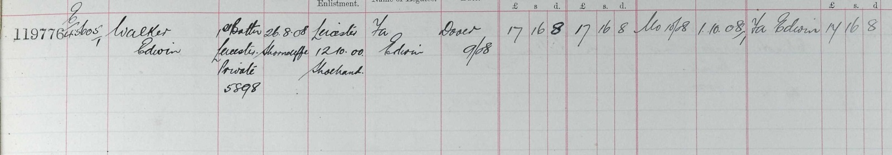

1891 Census Percy Street, Leicester,
Edwin Walker Head Married Male 46 1845 Shoe Maker Leicestershire,
Emma Walker Wife Married Female 46 1845 House Work Leicestershire,
Lily Walker Daughter Single Female 19 1872 Hosiery Winder Leicestershire,
Louisa Walker Daughter Single Female 16 1875 Hosiery Winder Leicestershire,
Elizabeth Walker Daughter - Female 13 1878 Scholar Leicestershire,
Edwin Walker Son - Male 10 1881 Scholar Leicestershire,
? Walker Daughter - Female 7 1884 Scholar St Margaret's, Leicestershire,

