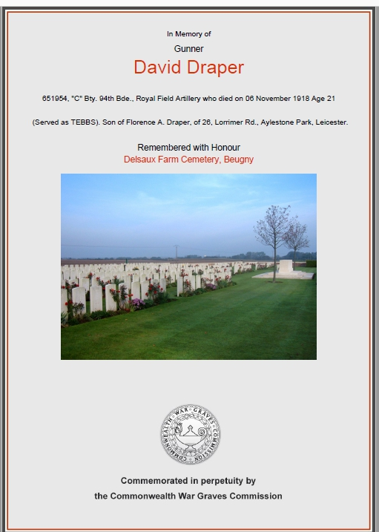
Gunner David Draper
Royal Field Artillery "C" Bty. 94th Bde
Service No:651954

Born in 1897 the son of David Draper & Florence A (nee Ellis)
His parents were married at St James Church on 25th December 1892

1901 Census26, Lorrimer Road, Leicester,
David Draper Head Married Male 34 1867 Borough Labourer Rutland,
Florence A Draper Wife Married Female 29 1872 Boot Machinist Leicestershire,
Mabel E Draper Daughter - Female 7 1894 - Leicester
Kate Draper Daughter - Female 6 1895 - Leicester,
David Draper Son - Male 3 1898 - Leicestershire,
Florence M Draper Daughter - Female 1 1900 - Leicestershire,
John C Ellis Nephew Single Male 18 1883 Boot Finisher Leicestershire,
Florry Ellis Niece Single Female 12 1889 - Leicestershire,

1911 census: 26 Lorrimer Road Leicester
DRAPER, David Head Married M 44 1867 Borough Waggoner Aylestone Park Leics
DRAPER, Florence Wife Married18 years F 39 1872 Housework Aylestone Park Leicester
DRAPER, Mabel Daughter Single F 17 1894 Stockroom Shoes Aylestone Park Leicester
DRAPER, Kate Daughter Single F 16 1895 Shoe Machinist Aylestone Park Leicester
DRAPER, David Son Single M 14 1897 Shoe Hand Heel Building Aylestone Park
DRAPER, May Daughter Single F 11 1900 Aylestone Park Leicester
DRAPER, George Son M 2 1909 Aylestone Park Leicester
ELLIS, John Boarder Single M 28 1883 Shoe Finisher Aylestone Park Leicester

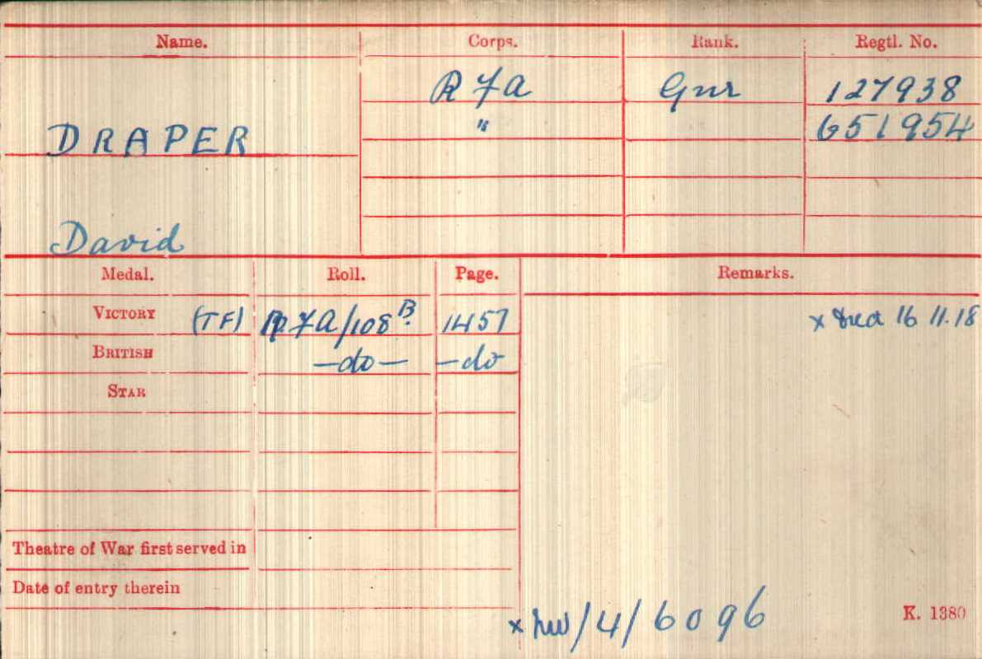

Date of Death: 06/11/1918 Age:21
GraveReferenceII. F. 24. DELSAUX FARM CEMETERY, BEUGNY
(Served as TEBBS).
Son of Florence A. Draper,
of 26, Lorrimer Rd.,
Aylestone Park, Leicester

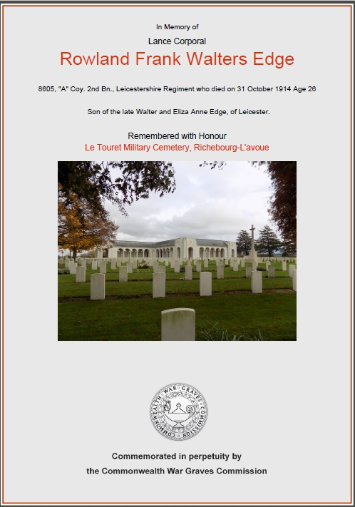
Lance Corporal Rowland Frank Walters Edge
Leicestershire Regiment "A" Coy.2nd Bn.Service No 8605

Baptism at Aylestone
14 Aug 1892 son of Walter Hugh & Eliza Ann

CWWG has son of the late Walter and Eliza Anne Edge, of Leicester.

1911 census 2nd Bn Leicestershire Regiment,
2nd Battalion Leicestershire Regiment, Fort Saint George, Madras, India
Military details: Pte 2 Leicestershire Regt
EDGE, Rowland Frank Walter Single ? 23 1888 LeicesterLeicester

1901 Census 213, Grasmere Street, Leicester,
Patrick H Edge Head Single Male 18 1883 Corset Packer Ireland
Rowland Edge Brother Single Male 13 1888 Errand Boy Leicester,
Marion Edge Sister Single Female 15 1886 Shoe Fitter Ireland
Nellie Edge Sister Single Female 25 1876 Book Binder Folder & Sewer Islington, M/sex,

1891 census transcription details for: Saffron Hill Road, Aylestone
EDGE, Eliza A Head Married F 36 1855 Nurse Plymouth, Devonshire
EDGE, Nellie G M Daughter Single F 15 1876 Boot Folder London
EDGE, Frederick E Son M 12 1879 Clicker Boot & Shoe Trade London
EDGE, Walter Son M 10 1881 Scholar London
EDGE, Patrick H Son M 8 1883 Scholar Ireland
EDGE, Marian J Daughter F 5 1886 Scholar Ireland
EDGE, Rowland F W Son M 3 1888 Leicester, Leicestershire

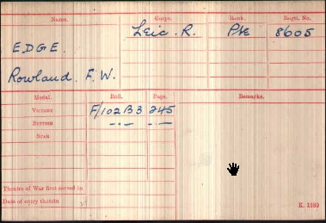
Date of Death:31/10/1914
Age:26
Grave ReferenceI.E.4.
LE TOURET
MILITARY
CEMETERY,
RICHEBOURG-L'AVOUE

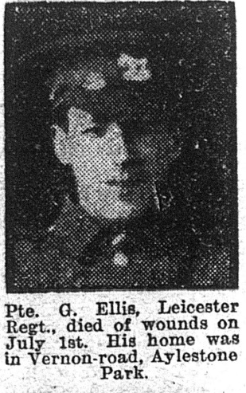
Private George Ellis
Leicestershire Regiment 1st/4thBn
Service No:4319
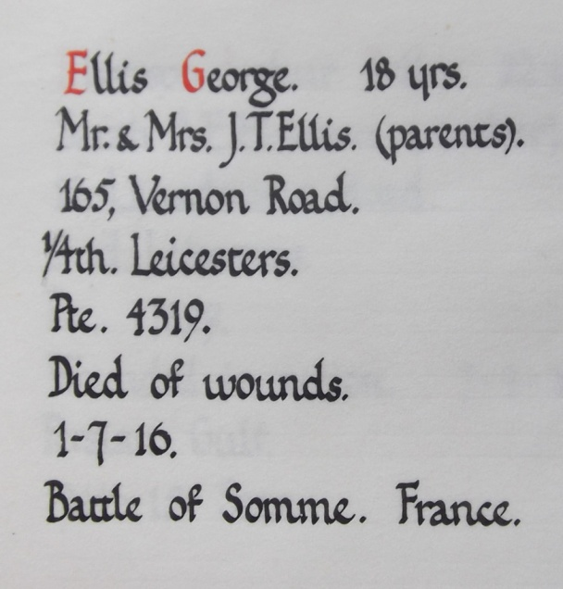
Born in 1898 the son of John Thomas & Ada Ellis (nee Mabbutt)
He left Granby Road School on 28th July 1911 Aged 13 – His parents were married
On 3rd August 1891 at
St Andrew’s church, Aylestone

Illus. Chron 09-Sep 1916
1901 Census Vernon Road, Leicester, Leicestershire,
John T Ellis Head Married Male 34 1867 Stoker At Gas Works Blaby, Leics
Ada Ellis Wife Married Female 31 1870 Shop Keeper Moulton, Northants,
Joseph Ellis Son Single Male 9 1892 - Leicestershire,
Edith Ellis Daughter Single Female 7 1894 – Leicestershire,
Maggie Ellis Daughter Single Female 5 1896 - Leicestershire,
George Ellis Son Single Male 3 1898 - Leicestershire,
Elizabeth Ellis Daughter Single Female 1 1900 - Leicestershire,

1911 census details for: 165 Vernon Road Leicester
ELLIS, John Thomas Head Married M 48 1863 Stoker Gas - Works Leics Blaby
ELLIS, Ada Wife Married19 years F 41 1870 In The House Northampton Northamptonshire
ELLIS, Joseph Alfred Son Single M 19 1892 Builders Navvy LeicsAylestone Park
ELLIS, Edith Daughter Single F 17 1894 Runner - On Glover LeicsAylestone Park
ELLIS, Maggie Daughter Single F 15 1896 Winder LeicsAylestone Park
ELLIS, George Son M 13 1898 School LeicsAylestone Park
ELLIS, Lizzie Daughter F 11 1900 School LeicsAylestone Park
ELLIS, Edward Alexander Son M 3 1908 School LeicsAylestone Park
ELLIS, Amy Gladys Daughter F 2 1909 LeicsAylestone Park
ELLIS, Mary Ann Daughter F 0 (2 MONTH) 1911 LeicsAylestone Park
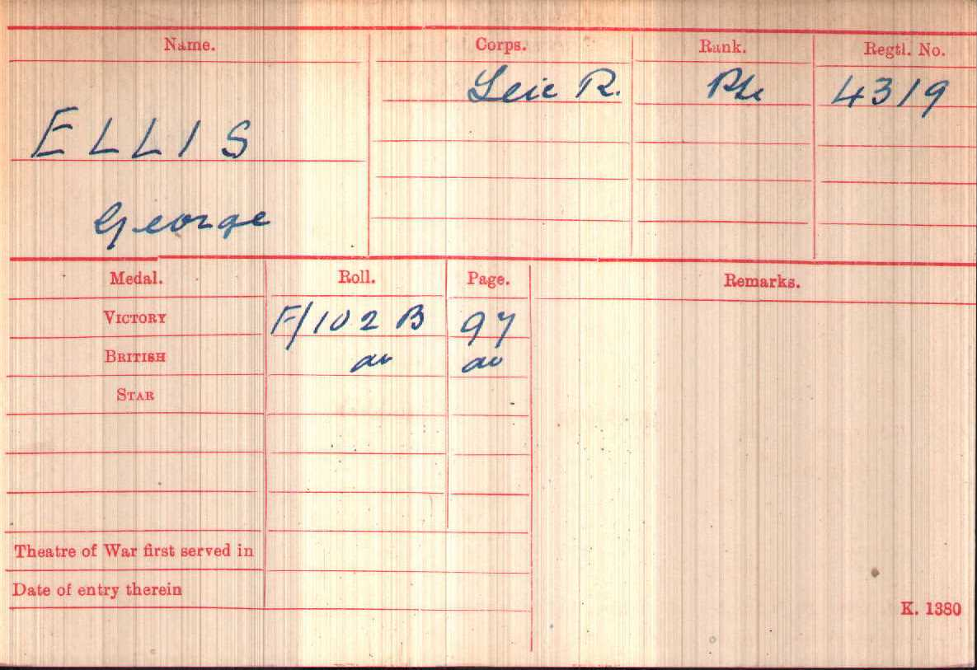

Date of Death:01/07/1916
He is buried at Warlincourt Halte
British Cemetery, Saulty
Grave Reference I. E. 10.

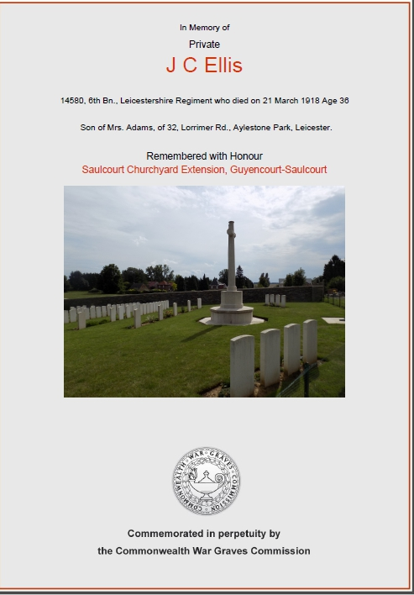
Private James Clive Ellis
Leicestershire Regt 6th Bn.
Service No:14580

Son of Mrs. Adams, of 32, Lorrimer Rd., Aylestone Park, Leicester.

Marriages Mar 1920
Adams Henry G Ellis Wareham 5a 592
Ellis Ethel Adams Wareham 5a 592

1911 census Old School House Holt Norfolk
WILLSON, Dallas Alexander Wynne Head Married M 45 1866 Asst Master & Boarding Master London
WILLSON, Mary Helen Wife Married5 years F 38 1873 Surrey Teddington
WILLSON, Helen Margaret Wynne Daughter F 2 1909 Norfolk Holt
WILLSON, Dorothy Mary Wynne Daughter F 2 1909 Norfolk Holt
NEWCOMB, Ada School Matron Single F 39 1872 Matron Of School Boarding House Of Lincs Boston
ELLIS, James Clive Boarder M 12 1899 School Leicester Leicester
+ 35 other pupils& 9 staff

1901 census: The Gables, Ashby Road, Glenfield
ELLIS, James B Head Married M 39 1862 Fruit Grower Leicester
ELLIS, Ethel S Wife Married F 35 1866 Leicester
ELLIS, Maud Daughter F 8 1893 Leicester
ELLIS, James C Son M 2 1899 Glenfield, Leicestershire
HUBBARD, Elizabeth Servant Single F 25 1876 Nursemaid Littlethorpe, Leics
LOMAS, Susan Servant Single F 20 1881 General ServLowesby, Leics

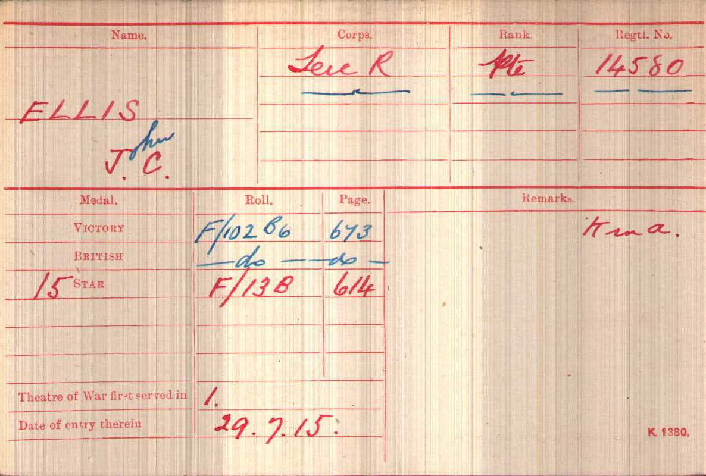

Date of Death:
21/03/1918
Age:36
Grave ReferenceD. 1. SAULCOURT CHURCHYARD EXTENSION, GUYENCOURT-SAULCOURT

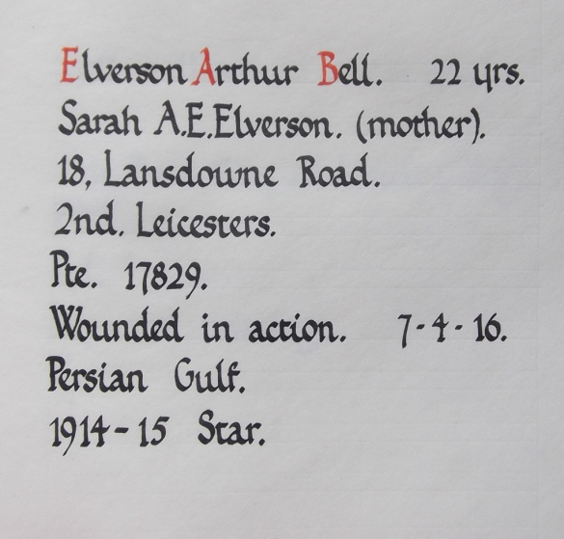
Private Arthur Bell Elverson,
Leicestershire Regiment 2nd Bn.
Service No:17829

Born in Swepstone, his school records give his date of birth as 24th November 1893, s/o William & Sarah Ann (nee Bell) who married in Swepstone on 28th Sept 1880

Sadly Arthur’s father died when he was eleven.
Deaths Dec 1904 ELVERSON William 44 Ashby Z. 7a 53
And Sarah moved to Aylestone

1911 census details for: 18 Lansdowne Road Leicester
ELVERSON, Sarah Head Widow F 47 1864 Charwoman Ashby de la Zouch Leicestershire
ELVERSON, Arthur Son Single M 17 1894 Engineers Pattern Maker Swepstone Leicestershire

1901 census transcription details for: Main Street, Swepstone
ELVERSON, William Head Married M 41 1860 Cattle Man On Farm Swepstone, Leicestershire
ELVERSON, Sarah A C Wife Married F 37 1864 Ashby de la Zouch, Leicestershire
ELVERSON, Arthur B Son M 7 1894 School Boy Swepstone, Leicestershire
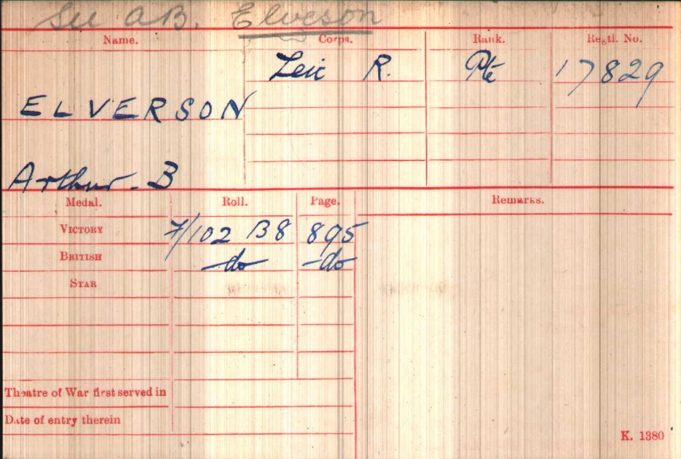

Service Records
Date of Death 07/04/1916 Age:22
He is buried at Amara War Cemetery Grave ReferenceXXI. B. 9.

Son of Sarah A. C. Elverson, of 18, Lansdowne Rd., Aylestone Park, Leicester, & the late William Elverson.
His mother was still living in Lansdowne Road when she died in 1950

Soldier’s effects
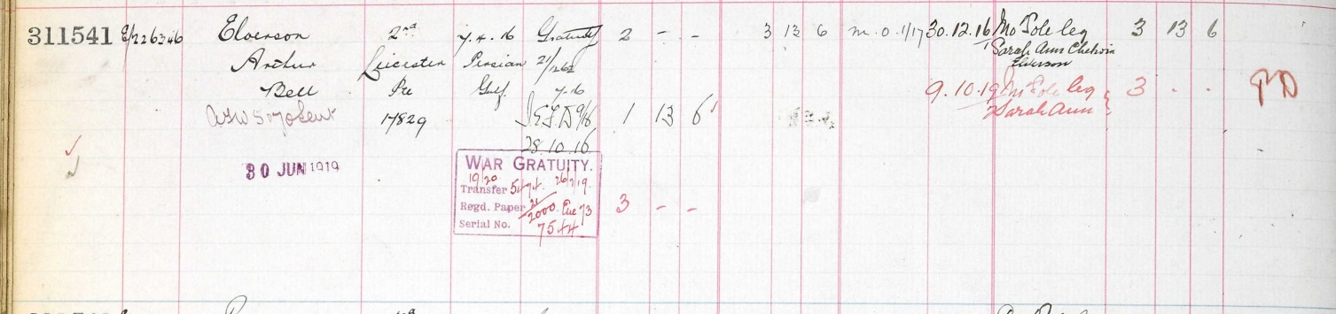

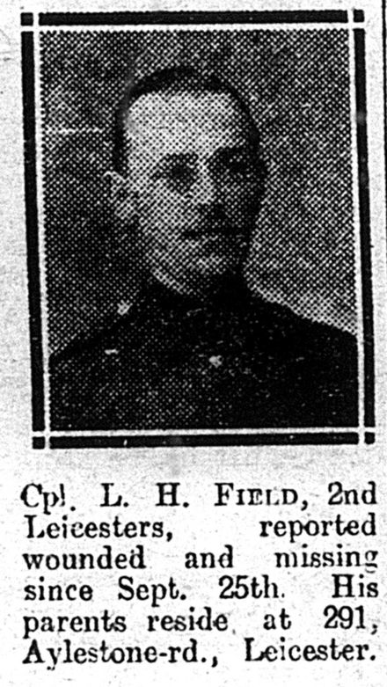
LanceCorporal Lawrence Henry Field
Leicestershire Regiment 2nd Bn
Service No:8442

Born in 1891 son of William Field & Elizabeth (Beasley)

1911 census: 2nd Bn Leicestershire Regiment,
2nd Battalion Leicestershire Regiment, Fort Saint George, Madras, India
Military details: Pte 2 Leicestershire Regt
FIELD, Lawrence Henry Single ? 20 1891 LeicesterLeicester

1901 census transcription details for: 10, Lothair Road, Leicester
FIELD, William Head Married M 49 1852 Engineers Iron Turner Leicester
FIELD, Elizabeth Wife Married F 41 1860 Netherton, Worcestershire
FIELD, Catherine Daughter Single F 14 1887 Cigar Maker Leicester
FIELD, William T Son M 12 1889 Leicester
FIELD, Henry L Son M 9 1892 Leicester
Illus. Chron 18-Dec 1915
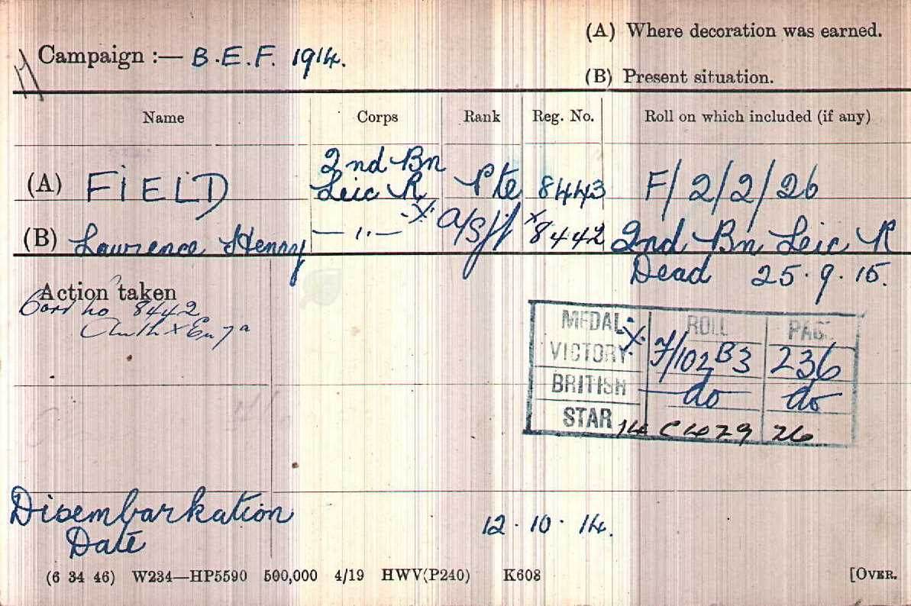

Date of Death: 25/09/1915
Panel 42 to 44.
LOOS MEMORIAL

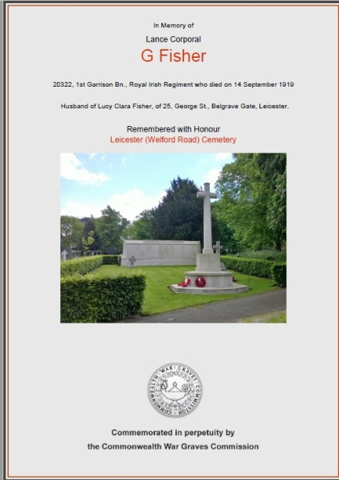
Lance Corporal George Fisher,
Royal Irish Regiment 1st Garrison Bn.
Service No:20322

Husband of Lucy Clara Fisher, of 25, George St., Belgrave Gate, Leicester.

1901 Census Cranham Hill, Cranham, Stroud, Gloucestershire,
GeorgeFisherHead Single Male 29 1872 General Labourer Cranham, Gloucestershire,
Elizabeth Fisher Mother Widow Female 67 1834 Housekeeper Cranham, Gloucestershire,
Francis P Fisher Nephew Single Male 10 1891 School Cranham, Glos.
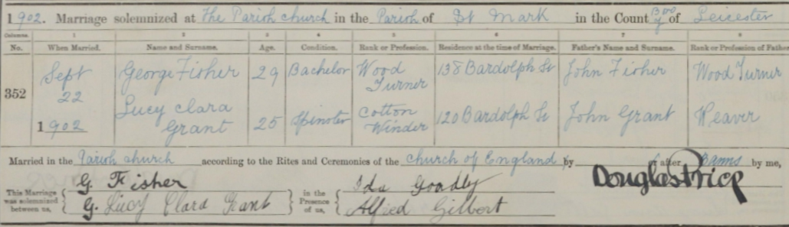
Married on 22nd September 1902 at St Marks Church
1911 census transcription details for: 113 Harrington Street Leicester
FISHER, George Head Married M 37 1874 Laundryman Gloucestershire
FISHER, Lucy Clara Wife Married 8 years F 38 1873 Stroud
FISHER, Louie Daughter F 7 1904 Leicestershire Leicester
FISHER, George Son M 4 1907 Leicestershire Leicester
FISHER, William Son M 1 1910 Leicestershire Leicester

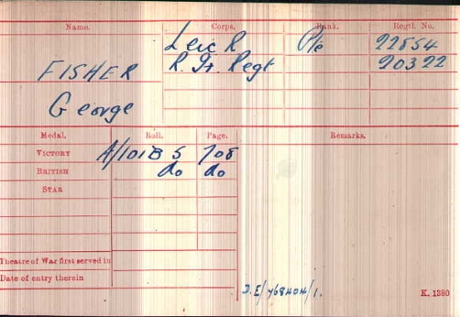
Date of Death:14/09/1919
Grave Reference
Screen Wall. O1. 388.
LEICESTER (WELFORD ROAD) CEMETERY
Buried on 17th Sept 1919
his burial record gives his age as 37

Private Percy Flude
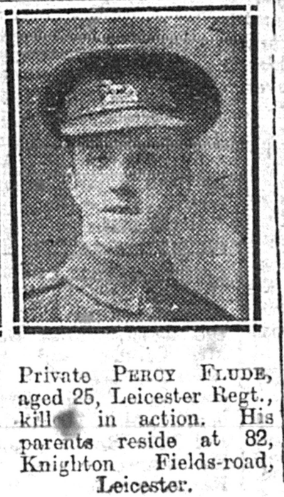
Leicestershire Regiment 1st/4th Bn Illus. Chron 13-May 1916
Service No:3313

Percy left school on
15th March 1904 aged 13
Son of William and Ada Flude,
of Leicester.

1911 census: 15 Richmond Avenue Leicester
FLUDE, William Head Married M 48 1863 Boot Rivetter Leicester Leics
FLUDE, Ada Wife Married 21 years F 42 1869 Leicester
FLUDE, Percy Son Single M 19 1892 Cycle Tyre Maker Leicester

1901 Census 140, Syston Street, Leicester,
WilliamFludeHeadMarriedMale38 1863Boot Rivetter Leicester,
Ada Flude Wife Married Female 32 1869 - Leicester,
Percy Flude Son Single Male 9 1892- Leicester,
Marion CoatesVisitor Widow Female 52 1849 Housekeeper Lutterworth, Leics.
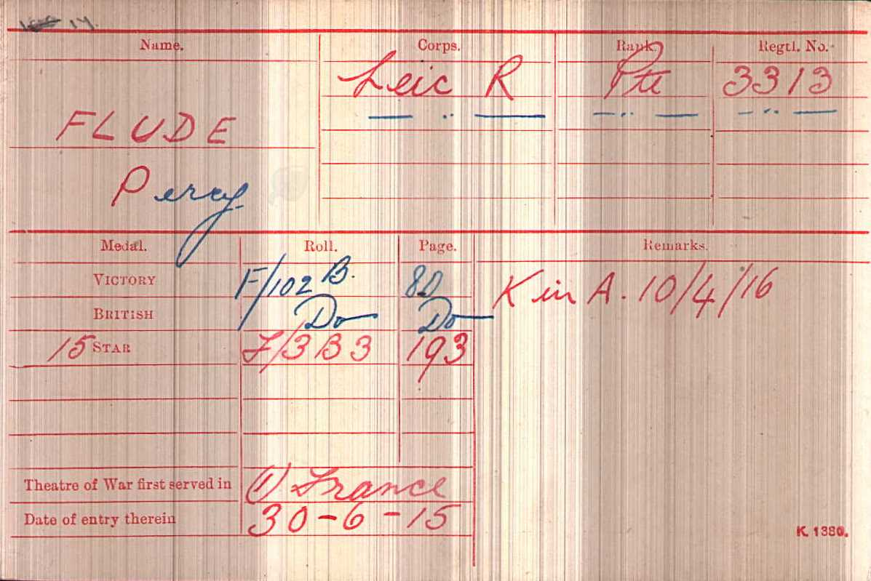

Date of Death
10/04/1916

Age:24

Grave Reference
I. B. 24. ECOIVRES MILITARY CEMETERY, MONT-ST. ELOI

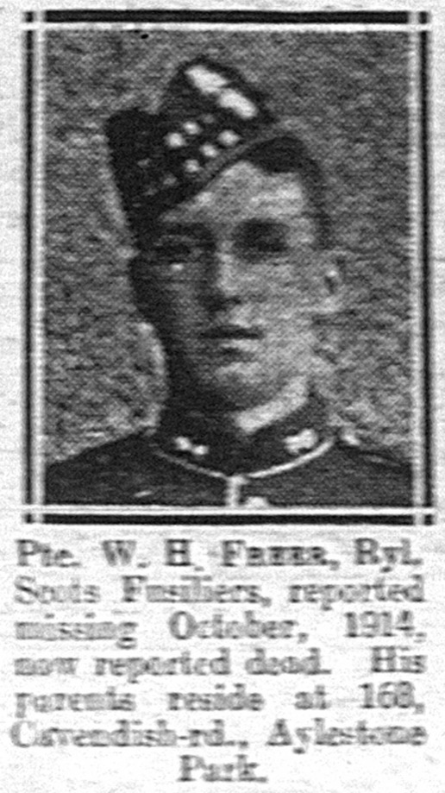
Private William H Freer
Royal Scots Fusiliers "C" Coy. 2nd Bn.
Service No: 10717

He was Baptised07Feb 1897 at St Mary de Castro Son of William Cooper Freer and Alice Freer, of 168, Cavendish Rd., Aylestone Park, Leicester.

School records give his date of birth as 21stMarch 1895

1901 Census 52, Hughendon Drive, Leicester,
William Freer Head Married Male 33 1868 General Labourer Syston, Leicestershire
Alice Freer Wife Married Female 26 1875 - Leicester
William Freer Son - Male 6 1895 - Leicester
John Freer Son - Male 3 1898 - Leicester
AlbertFreer Son - Male 1 1900 - Leicester

1911 census for: 168 Cavendish Road Leicester Illus. Chron 10-Jun 1916
FREER, William C Head Married M 41 1870 Gas Stoker Leics Syston
FREER, Alice Wife Married 17 years F 34 1877 Leics Leicester
FREER, William H Son Single M 16 1895 Shoe Hand Clicker Leicester
FREER, John T Son M 13 1898 Leics Leicester
FREER, Annie Daughter F 6 1905 Leics Leicester
FREER, Ernest L Son M 1 1910 Leics Leicester
FREER, Herbert E Son M 0 (3 MONTHS) 1911 Leics Leicester
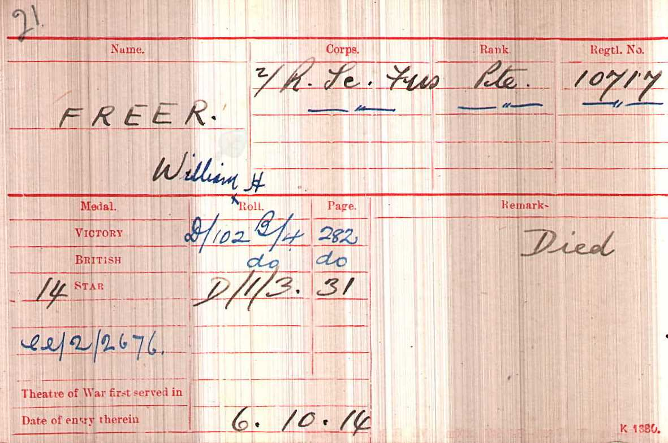

Date of Death :24/10/1914
Age:19
Panel 19 and 33.
YPRES (MENIN GATE) MEMORIAL

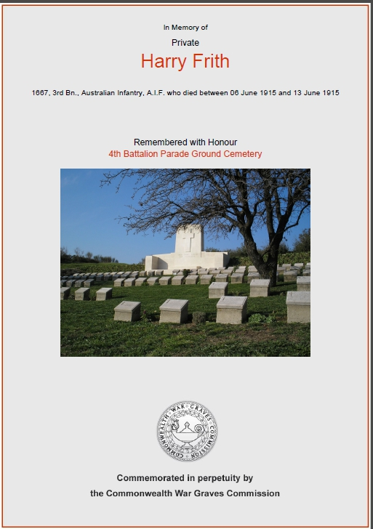
Private Harry Frith,
3rd Bn. Australian Infantry, A.I.F.
Service Number 1667

1881 Census Blaby Dairy, Lansdowne Rd, Aylestone, Leicester
George Frith Head Married Male 39 1842 Marine Store Dealer (GenlDllr) Leicester,
Mary Frith Wife Married Female 36 1845 East Langton, Leics
Albert Hy Frith Son Single Male 12 1869 Scholar Leicester,
Harry Frith Son Single Male 7 1874 Scholar Leicester,
Jane Frith Daughter Single Female 5 1876 ScholarLeicester,

In 1891 George and Mary have moved to Percy Rd, Aylestone
In 1891 Harry aged 18 is with the Lincolnshire Regiment at Shorncliffe Camp

1901 CensusPercy Road, Leicester,
George Frith Head Married Male 61 1840 General Dealer Leicester
Mary Frith Wife Married Female 57 1844 - East Langton, Leicestershire,
Lois Frith Daughter Single Female 16 1885 Boot Machinist Leicestershire,
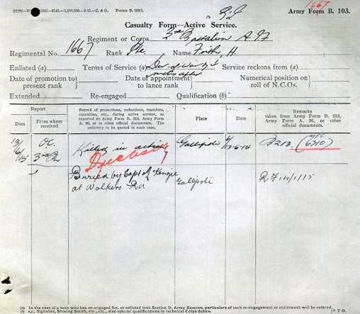
Albert HFrith Grand Son - Male 1 1900 - Leicestershire,
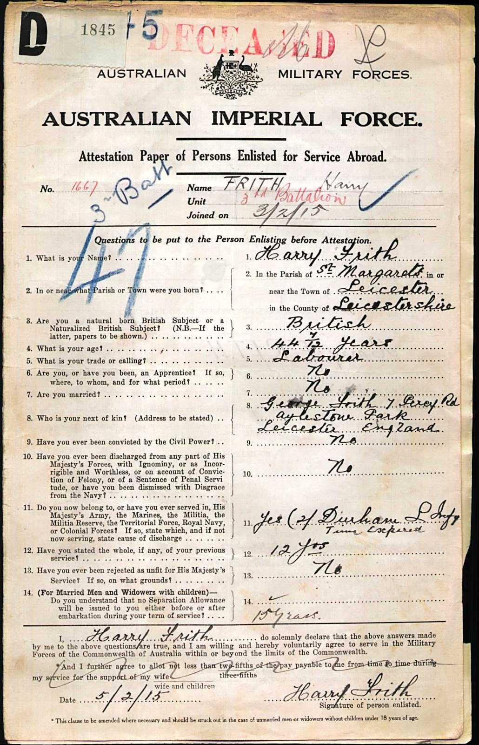

Died Between
06/06/1915 and 13/06/1915

Remembered with Honour
4th Battalion Parade Ground Cemetery

