VERNON ROAD METHODIST CHURCH
AYLESTONE PARK

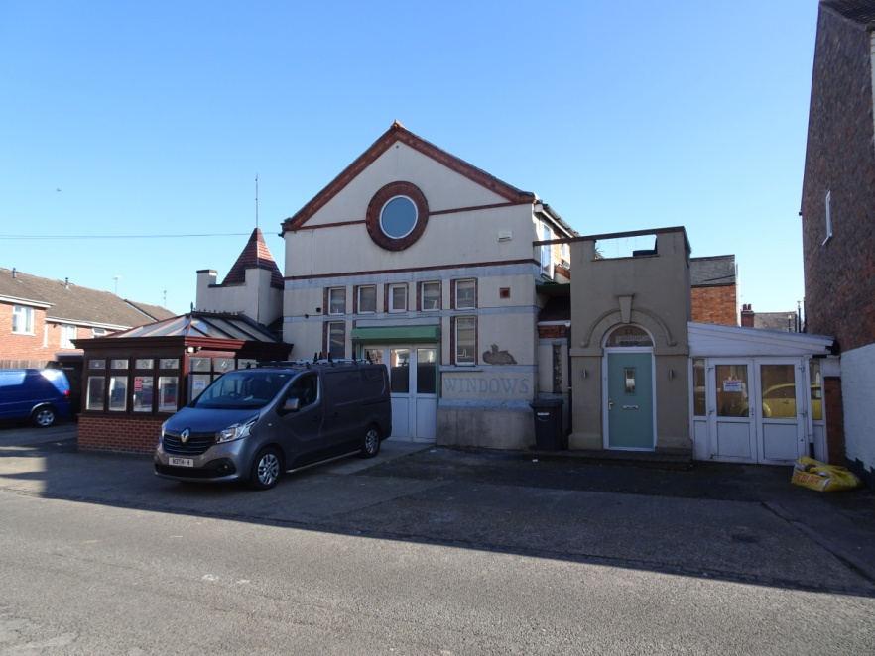
The Methodist Church today.

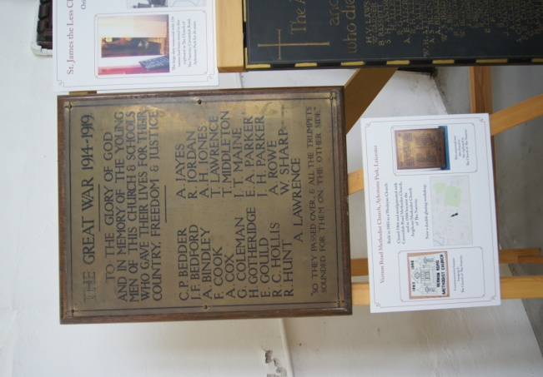
The Church was in use by the Methodists from 1894 to 1966 when it was amalgamated with the Cavendish Road Church. The building was in industrial use from 1966 to 1984 and it was used as a Mosque from 1984 to 1987. Today it is occupied by a Double-Glazing company.

“SO THEY PASSED OVER, & ALL THE TRUMPETS SOUNDED FOR THEM ON THE OTHER SIDE”
Quote taken from John Bunyan’s Pilgrim’s Progress, where Mister Valient-For-Truth faces death.

Name on Memorial | Full Name | Rank Service No. & Regiment | Death
C.P. Bedder | Charles Percy | Private 23936 Leicestershire Regt | Killed In Action 10/12/1916 Aged 34
J.F. Bedford | John Tom | Gunner 294971 Royal Garrison Artillery | Killed In Action 23/08/1918 Aged 28
A. Bindley | Alfred | Private 21549 Leicestershire Regt | Killed In Action 24/09/1918 Aged 21
G. Coleman | George | Private 20017 Leicestershire Regt | Died 19/11/1915 Aged 54
F. Cook | Frank | Private 75696 Manchester Regt | Died 24/02/1919 Aged 28
A. Cox | Albert | Private 282177 Highland Light Infantry | Killed In Action 22/03/1918 Aged 21
H. Gotheridge | Harold | Private 515416 London Regt | Died Of Wounds 18/6/1918 Aged 21
E. Gould | Edward Francis | Private PS/7846 Royal Fusiliers | Killed In Action 30/07/1916 Aged 32
R.C. Hollis | Roland Canning | Private 16547 Leicestershire Regt | Killed In Action 22/03/1918 Aged 24
R. Hunt | David Reginald | Lieutenant Royal Air Force | Killed While Flying 18/08/1918 Aged 19
A. Jayes | Alfred | Private 3032 Leicestershire Regt | Killed In Action 04/07/1915 Aged 18
A.H. Jones | Albert Henson | Private 23031 Leicestershire Regt | Died 18/10/1918 Aged 26
R. Jordan | Rowland | Private 202812 Leicestershire Regt | Died Of Wounds 25/03/1918 Aged 30
A. Lawrence | Albert (brother of Thomas) | Private 50839 Cheshire Regt | Killed In Action 01/08/1917 Aged 27
T. Lawrence | Thomas (brother of Albert) | Private 23837 Leicestershire Regt | Died 10/07/1916 Aged 22
J.T Maine | John Thomas | Lance Corporal 277253 Durham Light Infantry | Killed In Action 23/07/1918 Aged 29
T. Middleton | John Thomas | Lance Sergeant 2157 Leicestershire Regt | Killed In Action 13/10/1915 Aged 19
E.A. Parker | UNABLE TO CONFIRM | Private 38038 Lincolnshire Regt | Killed In Action 26/10/1917
J.H Parker | John Henry | Private 201832 Leicestershire Regt | Killed In Action 05/07/1917 Aged 21
A. Rowe | Albert Edward Roe | Private 3581 Leicestershire Regt | Killed In Action 13/10/1915 Aged 21
W. Sharp | William Sharpe | Acting Bombardier 294979 Royal Garrison Artillery | Died of Wounds 06/08/1917 Aged 25

Charles Percy Bedder (C. P. Bedder)
Private 23936 Leicestershire Regt 7th Battalion
Charles Percy Bedder was born in 1882, the son of Thomas Bedder and Sarah Elizabeth Wesbury who had married in 1878. At the time of his birth the family, which included his mother’s son Edward Thomas Westbury and Charles’s older sister, Emma Jane were living at Disraeli Street in Aylestone.
Following his mother’s death in 1883, Charles, his Father and Edward moved in with Charles’s grandparents John and Annie Bedder and their five children in Florence Street. His sister Emma was now a domestic servant for the Newsome Family in New Walk.
His Father, who was a bricklayers Labourer died in 1893 aged 34. Charles and Edward still living with his grandparents had moved to Vernon Road by 1901.
In 1906 Charles married Hilda Gill and was working as a Plasterer. By 1911 they were living at 41 Denmark Road with their 2 daughters, Doris Eva, born 16/03/07 and Florence Irene, born 30/09/1908. A son, William Sydney was to follow in 1913, but sadly he died on 31/03/16 aged 2.
Charles joined the Leicestershire Regiment and was mobilized on 5th January 1916. He was Killed In Action on 10th December 1916 aged 34 and is buried at Vermelles British Cemetery, his Inscription reads; “Peace Perfect Peace In This Dark World Of Sin”
The cemetery near Lens in France, holds 2134 casualties of these 198 are unidentified, six of which were from the United Kingdom.
Charles Bedder is also remembered on the Granby Road School Memorial.
Hilda never remarried and died in 1953. His daughter Doris married Sidney Carter, a Coal Man in 1931, they lived at 95 Cavendish Road. Florence married Sidney Edwards, a Motor Van Driver in 1934 and lived at 37 Gunthorpe Road.
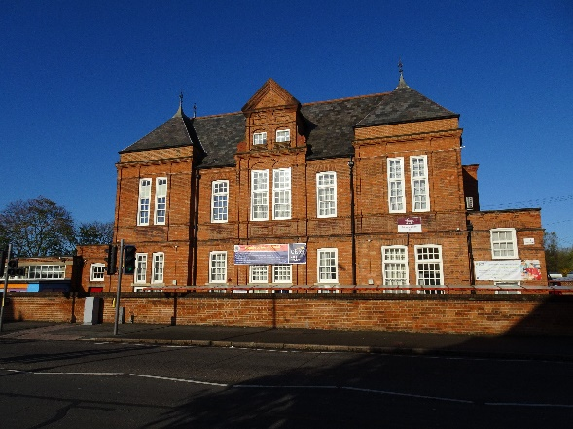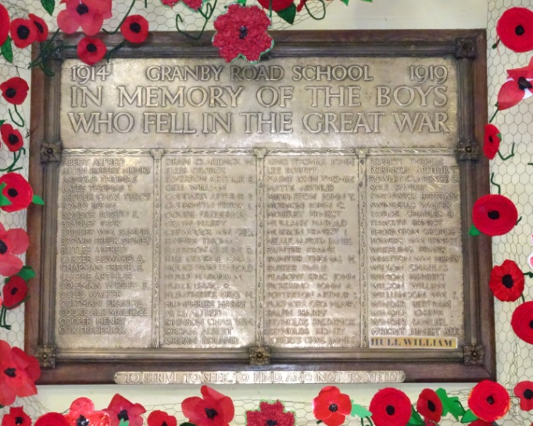
Granby Road School Memorial
GG

John Tom Bedford (J. F. Bedford)
Gunner 294971 Royal Garrison Artillery 147th Battery Regt
Although the memorial shows J F Bedford, the only J Bedford who died in the war in the area was John Tom Bedford. He was born in 1890, the son of Robert Bedford a Gas Stoker and Emma Robinson who had married in 1889. The couple had two further children, Dorothy Ivy was born in 1896 and Clara Lillian who was born in 1899. They lived at The Gas Cottages, number 239 Aylestone Road. By 1911 John aged 20, was working as a Shoe Clicker on a press and his sister Dorothy aged 14 was working as a book keeper for a boot manufacturer.
On 13th October 1915 when he was 25, John Enlisted to 147 Heavy Battalion, he had previously served for four years as a Private in the Territorial’s in the Leicestershire Regiment, but had purchased his discharge in 1912.
He married Louisa Hadley on 4th December 1915, at the Parish Church in Knighton, who was living at Eastwood House in Macauley Street in Knighton with her family.
John was posted overseas on the 30th June 1916. On the 7th July 1916 he was charged with not complying with an order and had to forfeit 3 days pay as well as 3 days Field Punishment No 1. This involved the offender being attached to a fixed object for up to two hours a day, this would sometimes be within range of enemy shell fire. The British Army issued this punishment on 60,210 occasions during the war, but this form of punishment was abolished in 1923.
In 1917 he was attached to the 2 nd Army Artillery School, B Battery, Royal Horse Artillery. In 1917 he was attached to the Officers Rest House before re-joining his unit on the 24th January 1917. On the 27th January he was posted to II Anzac Heavy Artillery HQ.
On 16th February 1917 he was admitted to hospital as ‘sick’, then following his discharge on the 1st March 1917 he re-joined the 147th Battery.
On the 19th March 1917 he was charged with committing a nuisance by urinating in the public thoroughfare and was awarded 3 days Field Punishment No 2, which was similar to Field Punishment No 1 except the offender was shackled, not fixed to anything. This was so he could march under restraint.
John was killed in Action on the 23rd August 1918 and is buried in Duisans British Cemetery, Etrun, Pas De Calais. The Cemetery is near to Arras and most of the graves there relate to the Battles of Arras in 1917.
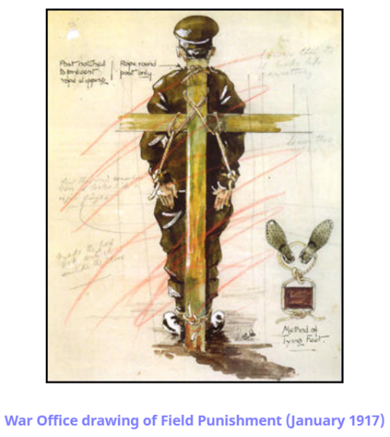
His widow was awarded a weekly pension of eighteen shillings and nine pence on the 17th March 1919. She never remarried, and by 1939 she was living with her mother Frances Hadley at 22 Richmond Close. She died in 1976.
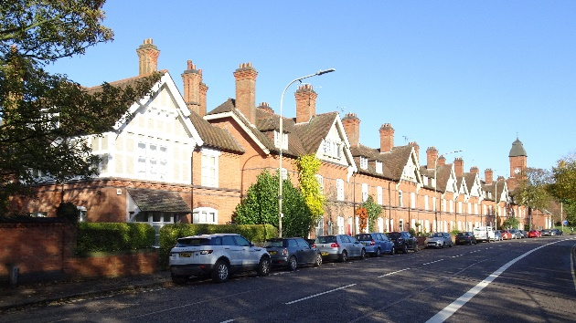
The Gas Cottages, the family lived at 239 Aylestone Rd
ALFRED BINDLEY (A. Bindley)
Private 21549 Leicestershire Regt. 1/5 Battalion
Born in 1897 the son of Alfred Bindley and Lucy Barratt Mawby from Kibworth Beauchamp, they married at St Marks Church on May 22nd 1894, while living at 199 Syston Street.
The Family later moved to Thackeray Street with Alfred’s father who was running a grocer’s shop at 68 Knighton Fields Road West. By 1911 Alfred had 3 siblings, older sister Laura who was 15, and 2 younger siblings Nellie aged 11 and John who was 7.
Alfred joined the Leicestershire Regiment on the 15th October 1915, with his first posting on the 18th March 1916. The Leicester Dailey Post, dated 6th November 1917 reported that Alfred had been wounded. His final posting was to France on the 18th March 1918 where he was Killed in Action on the 24th September 1918 aged 21. He died a month after his older sister, Laura’s marriage to Claude Wesson who was in the Sherwood Foresters.
He is buried at Cerisy-Gailly Military Cemetery, Somme, France. The Cemetery was designed by Sir Edwin Lutyens, who also designed the Arch of Remembrance, Leicester’s War Memorial in Victoria Park.
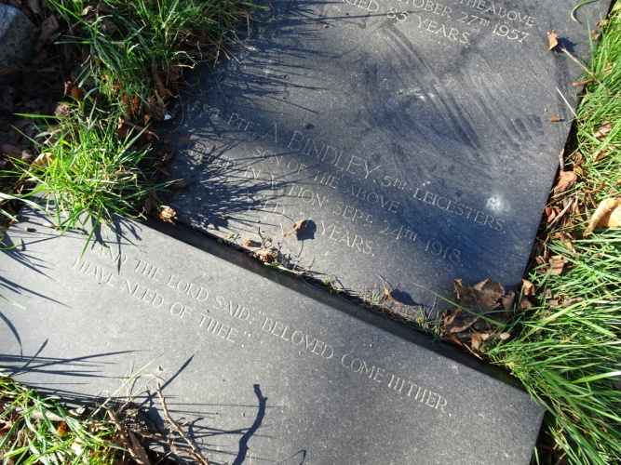
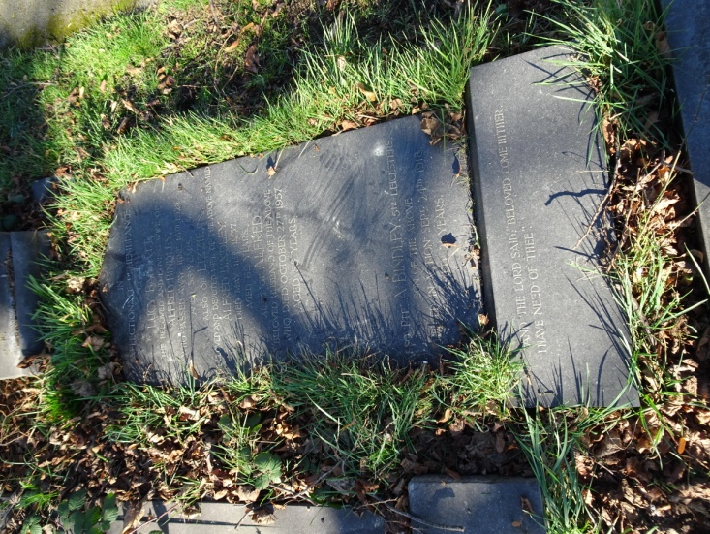
Alfred is also remembered on his parent’s gravestone at Welford Road Cemetery.
Grave reference Co1.2015
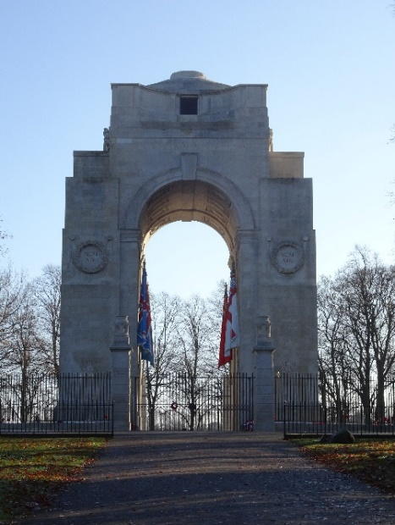 The Arch of Remembrance in Victoria Park designed by Edwin Lutyens.
George Coleman (G. Coleman)
Private 20017 Leicestershire Regt 2/5 Battalion
George Coleman was the son of James Coleman a Frame Work Knitter and his second wife Elizabeth Taylor. The 1861 census shows the family was living at 92 Bedford Street in St Margaret’s. However, the ever-increasing family had moved to 4 Bay Street by 1871. As well as living with his parents, George was living with 5 of his sisters, he was now 14 and working as a Woolwinder.
By 1891 George was working as a Shoe Finisher and was living at 14 Milton Street with his mother who was now a widow and his younger sister Catherine, who was working as a Shoe Fitter. By the time he was 40 he was living at number 8 Milton Street as a Boarder with Betsy Goodliffe and still working as a Shoe Finisher.
In 1910 George married Clara Howkins, who in 1901 was working as a General Servant Domestic at Malbourne Hall Convalescent House in Castle Donington. The couple lived at 20 Hughenden Drive. George was working as a Shoe Operative and became connected with the No 1 Branch of the Boot and Shoe Trade Union as a trustee and a member of the Executive Committee.
By 1915 George was doing Guard Duty at Donington Hall, which had been requisitioned to house captured German Officers. Earlier that year Donington Hall POW camp became notorious for being the scene of the only successful escape when naval pilot Gunther Pluschow escaped on the 4th July 1915.
George became ill and died at the 5th Northern Hospital from Pneumonia on 19th November 1915 aged 54. The Leicester Journal dated 26th November 1915 recorded that George had a Military Funeral at Welford Road Cemetery on the 23 November. The funeral cortege which started from the family home at 9 Gartree Street, was preceded by 30 soldiers of the Leicesters and National Reserve, who in charge of Colour Sergeant Earl had come over from Donington. At the cemetery a Firing Party fired a volley over the grave and the last post was rendered. As well as members of his family, representatives from The National Union of Boot and Shoe Operative attended the funeral.
In his Will dated the day before he died, he left an estate worth £175 to his wife Clara in recognition to her faithfulness to Duty through their married life.

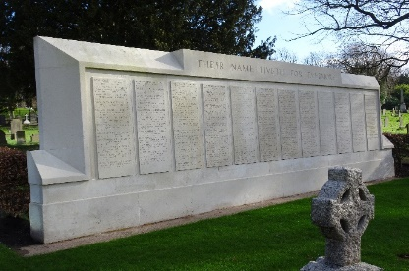 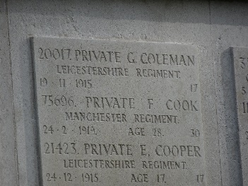 Memorial Wall at Welford Road Cemetery
The Cemetery has 286 First World War burials, more than half are buried in the War Graves Plot and their names are listed on the Memorial Wall. As well as George, the wall includes Frank Cook also on the Vernon Road Methodist Church Memoria
Frank Cook (F. Cook)
Private 75696 Manchester Regt. 1/7 Battalion
Frank Cook was born in 1890 the son of Joseph Morris Cook a Shoe Finisher and Mary Ann Kilbourne, who had married in 1883. In 1891 they were living at 28 Livingstone Street, Frank was the youngest of four children, he had two older sisters, Florence born in 1884 and Edith born in 1887 and a brother, Ernest born 1889.
By 1901 the family had moved to 199 Milligan Road in Aylestone. Frank’s older sister Edith had died in 1898 aged 11. However, he now had two younger sisters Ethel born in 1893 and Elsie born in 1896.
Frank married Ellen Elizabeth Hall in 1915, they were living at 38 Turner Road, Humberstone, when she gave birth to their son Gerald James Cook on 7th March 1918.
He died on 24th February 1919 aged 28 and is buried at Welford Road Cemetery. The Cemetery has 286 First World War burials, more than half are buried in the War Graves Plot and their names are listed on the Memorial Wall. As well as Frank, the wall includes George Coleman also on the Vernon Road Methodist Church Memorial.
Ellen never remarried and died in 1966, Gerald died in 1993.

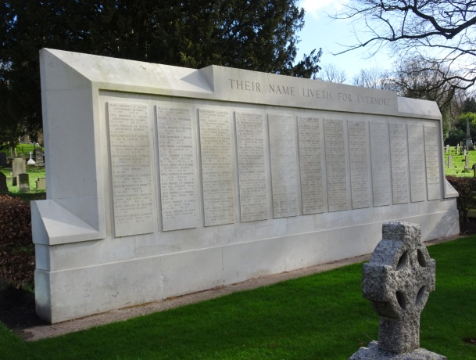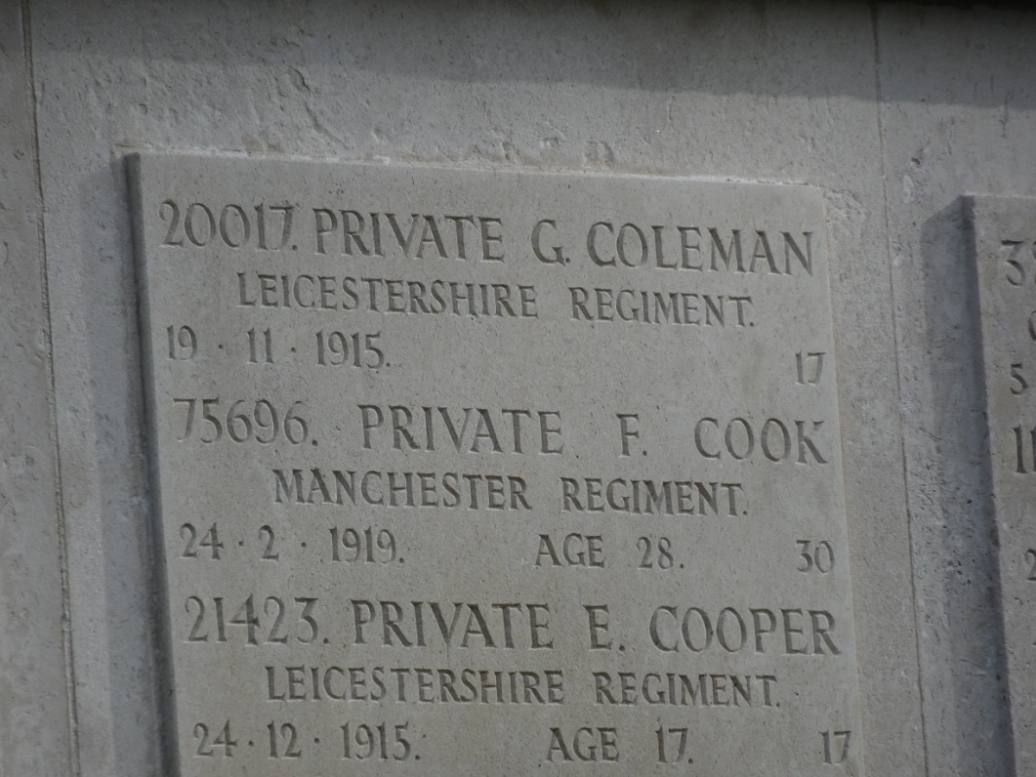
The Memorial Wall at Welford Road Cemetery

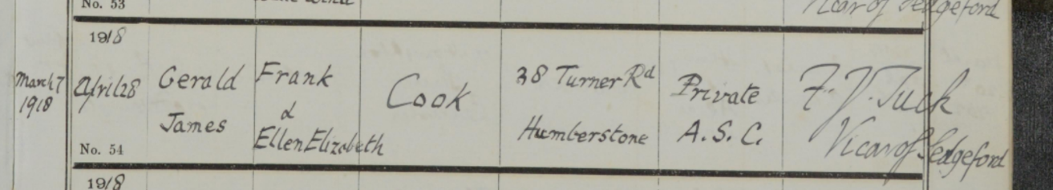
Gerald Cook’s baptism showing Frank Cook’s occupation as ‘Private A.S.C’
Albert Cox (A. Cox)
Private 282177 Highland Light Infantry 10/11 Battalion
Albert Cox was born in 1897 son of David Cox a Leather Lace Maker and Sarah Leigh both from Northamptonshire, who had married at St Mary de Castro Church on 8th November 1870. At the time they were living at Castle Street in Leicester, but later moved to Lawrence Street.
The Cox family lived at 125 Cavendish Road for over 20 years, but by 1911 they had moved to Chelveston House, 160 Knighton Lane, according to the census, Albert was the youngest of 10 children, although 2 had died by 1911. Albert who was 14, was working as a Grocers Assistant.
He joined the Highland Light Infantry. The War Office Daily List reported him as missing on 18th May 1918. He was Killed in Action on the 22nd March 1918 aged 21, coincidentally the same day as R C Hollis who is also remembered on the Vernon Road Methodist Church memorial.
Albert’s burial commemoration is at the Arras Memorial, Pas De Calais, France. The memorial, which was unveiled in 1932, commemorates nearly 35,000 soldiers of the British, South African and New Zealand Forces with no known grave.
He is also remembered on his parent’s grave at Welford Road Cemetery.

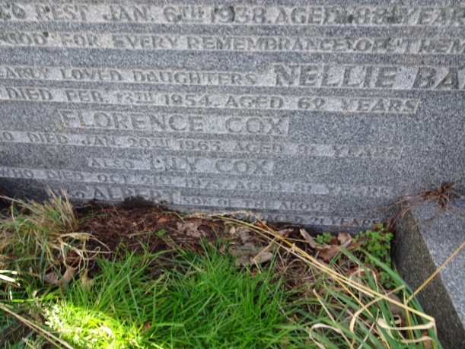
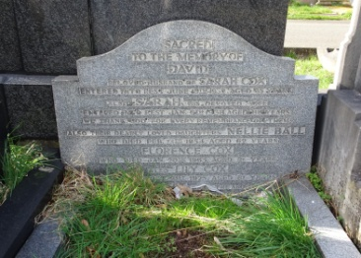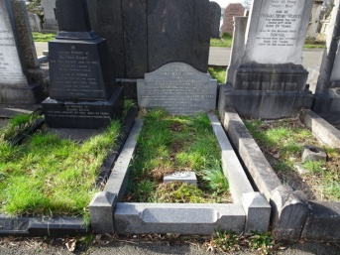
Welford Road Cemetery Grave reference Ud.51

Harold Gotheridge (H. Gotheridge)
Private 515416 London Regt 1/14 Battalion London Scottish
Harold Gotheridge was born in 1897 the fourth son of Henry Gotheridge, a Detective Sergeant and Harriett Bloor who he had married in 1888. The couple originally came from Hartshorn in Derbyshire, but settled in Leicester, living at 15 Sutherland Street in Highfields.
The 1911 Census shows the family, which by now expanded to 8 children, living at the Aylestone Police Station, on the corner of Lansdowne Road and Richmond Road. Harold was 14 and working as an Errand Boy.
After being promoted to Inspector Harold’s father retired in 1914, but died a year later aged 48. He was buried at Welford Road Cemetery.
Harold was working as a Clerk when he attested on 14th February 1916, his paperwork stated he was living at 79 Avenue Road Extension, he was 5 feet 8 inches tall and weighed 147 lbs (10.5 stone.
He was Posted to France arriving at No. 7 Infantry Base Depot Havre on 11th July 1917. He died aged 21 from Wounds received in Action on 18th June 1918, at No. 57 Casualty Clearing Station in France.
Harold is buried at Aubigny Communal Cemetery Extension in France, his inscription reads ‘Ever In Our Thoughts’.
In November 1918 his personal effects when returned to his family were listed as, Photos, Thimble, Button Hook, Broken Rosary, Cap Badge, Cigarette. Case and Pocket Wallet.
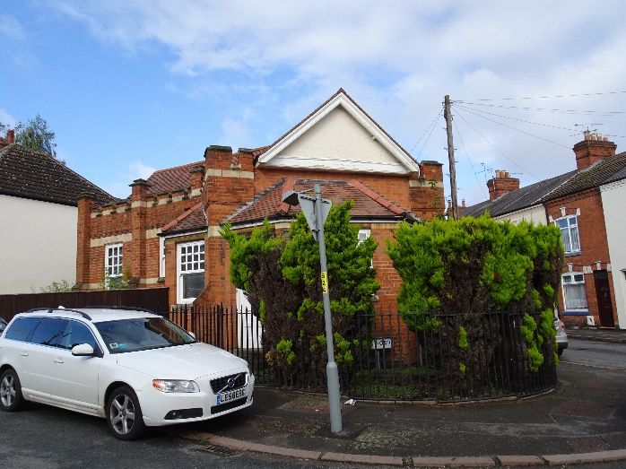
Aylestone Police Station Today
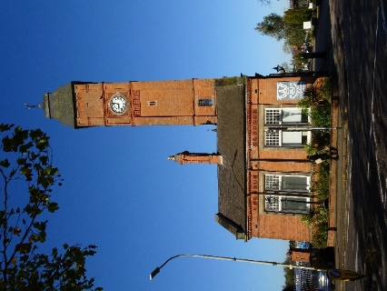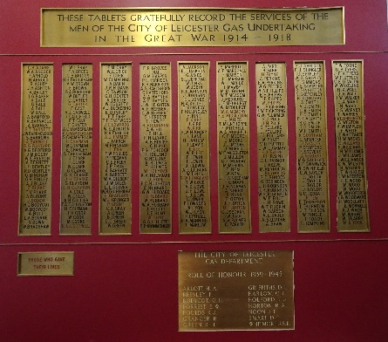
Harold’s oldest brother William who worked as a Gas Fitter is remembered on the Gas Board Roll of Honour which can be seen at the National Gas Museum on Aylestone Road.
Edward Francis Gould (E. Gould)
Private PS/7846 Royal Fusiliers 20 Battalion
Edward Gould was born in 1884 to Alfred Gould, a Tailor Cutter and Lydia Price from Gloucestershire. The couple had married in Stroud in 1878, but later moved to Leicester. The 1881 census shows that they were living at ‘York Cottages’ in Cavendish Road.
Still living at Cavendish Road, by1891 the couple had 5 children, also living with them was Alfred’s sister Eva.
After Edward’s mother death in 1898 aged 47, the Family moved to 1 Rutland Avenue. On the 1901 census Edward was working as a County Council Clerk, his older sister Eva was a School Board Teacher. His younger sisters Elizabeth aged 14, was a Pupil Teacher and Lydia was 11 years old. The youngest sibling Harold had already died in 1894 aged 3.
On the 8th April 1901 Edward’s father married his 2nd wife Katherine Oliver in Holy Trinity Church in Rugby. By 1911 the couple had 3 children and together with 2 daughters from his first marriage were living at 13 Rutland Avenue. Edward meanwhile was following his fathers footsteps and was working as a Tailor Cutter in Bradford, living in a Boarding House, at 112 Midland Road.
Edward enlisted to the Royal Fusiliers 20 Battalion. On 27/08/1916 he was listed as wounded on the casualty list issued by the War Office. He was listed again on 5/12/1916 as Wounded and Missing. Finally on 17/09/1917 the War Office Daily List stated ‘Previously Reported Wounded and Missing Now Reported Killed’. The Leicester Journal on 21st September 1917 stated that he had been killed in action on 30th July 1916 aged 32.
His is buried at Caterpillar Valley Cemetery, Longueval, on the Somme in France, which in August 1918 was a small cemetery containing just 25 graves. After the Armistice it was increased when the graves of more than 5,500 men were brought in from the battlefields and other small cemeteries, of these 3798 of the buriels are unidentified. Edward’s inscription reads “SON Of A. GOULD, LEICESTER, THE RUGGED CRAGS OF DUTY SCALED”.
He is also remembered on his mothers grave stone at Welford Road Cemetery.
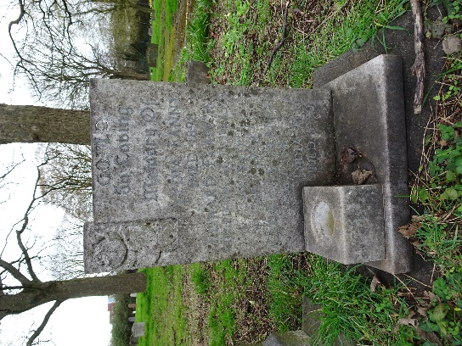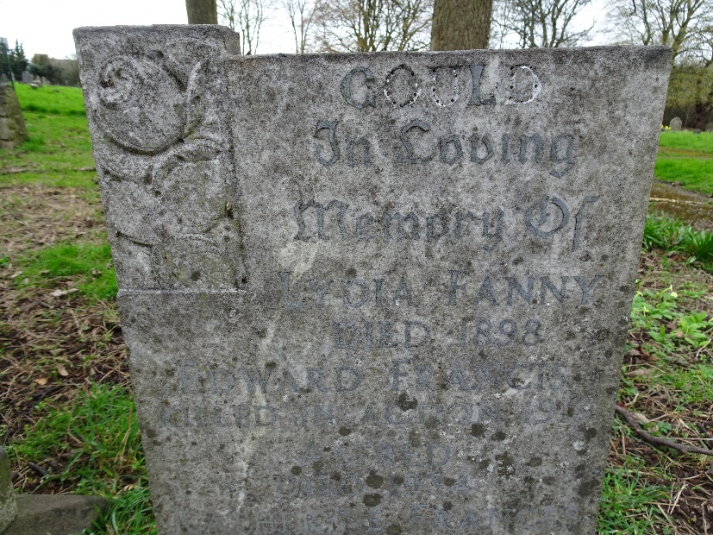
Welford Road Cemetery Grave Reference Co.2737
Roland Canning Hollis (R. C. Hollis)
Private 16547 Leicestershire Regiment 8 Battalion
Fred Hollis a Draper Shop Keeper from Wellingborough married Emma Canning from Birmingham on Boxing Day 1887. The couple went on to have three children, Rose Ethel born 1889, Roland born in 1893 and a second son Shirley Frederick born 1899.
The family lived at 1 New Park Road on the corner of Cavendish Road in 1901, by the 1911 census the adress was changed to 131 Cavendish Road, in fact this appears to be the part of the same building, one side was the shop.
By 1911 Roland was working as a Hosiery Warehouseman, his older sister, Rose was a Miliner, she was also married, her husband Arthur Brewin was a plumber and the couple were living with her father, who was widowed in 1909. Fred would later marry again to Mary Morey in 1913. Rose and Arthur would later move across the road to 132 Cavendish Road, to run a Greengrocers.
After joining the Leicestershire Regiment Roland was listed as wounded on the Casualty List issued by the Home Office on 18/10/1915. He was lised as wounded again on 22/11/16, a year later he appeared on the War Office Daily List as wounded on 13/11/17.
He was lised as missing on 21/5/1918, but sadly he had been killed in action on 22/03/1918 aged 24, the same day as Albert Cox also on the Vernon Road Methodist Church memorial.
Roland’s burial commemeration is at Pozieres Memorial, Somme, France. The memorial lists over 14,000 casualties of the United Kingdom with no known grave who died on the Somme from 21st March to 7th August 1918.
Arthur Brewin, Roland’s brother in law, survived the war after serving in the Royal Horse & Field Artillery 330th Brigade, his grocers shop at 132 Cavendish Road was bombed in the second World War.
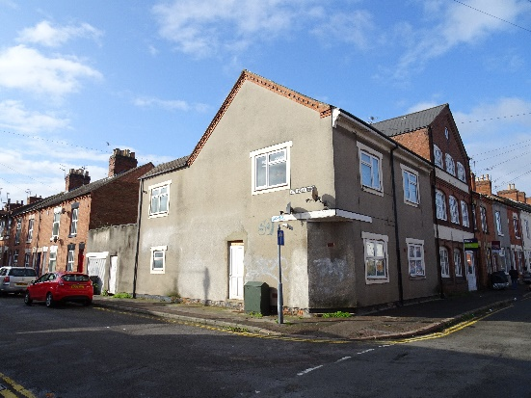

131 Cavendish Road on the corner of New Park Road today

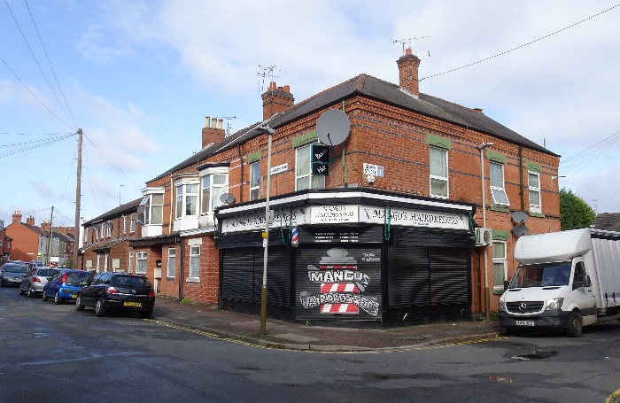 Across the road from 131 Cavendish Road where the bombs fell in the Second World War. New build houses now stand where 132 Cavendish Road once stood.
David Reginald Hunt (R. Hunt)
Lieutenant Royal Air Force
David Reginald Hunt’s mother, Charlotte Cox, originally from Kingsthorpe in Northamptionshire, worked as grocers assistant for Frank Hawkins in Cavendish Road. She was 24 and living at 30 Duns Lane, at the time of her marriage to 19 year old David Hunt on 14th April 1895.
In 1901 the couple were living at 7 Rutland Avenue with their two children, Edith May, born 1896 and David Reginald born 1898. David senior was a Leather Traveller in the Shoe Trade. By 1911 the family which now included Sydney James born in 1903 and Kenneth Winston born in 1908 had moved to ‘Heatherdene’ on Milliagan Road.
David Reginald attended Wyggeston Grammar School for Boys from 1909 to 1914 and later worked for the London City and Midland Bank.
He joined the Inns of Court Training Corps in January 1917 and after three months at Berkhampstead was transferred to the Royal Flying Corps.
The Leicester Daily Post dated 28th August 1918 reported that Mr and Mrs David Hunt had been notified by the Air Minister that their eldest son Lieut David Reginald Hunt of the Royal Air Force was Killed While Flying in France on the 18th August 2018.
He was ferrying a Sopwith Dolphin, serial no. E4491, belonging to No 1 Aircraft Supply Depot, when the engine caught fire causing the aircraft to crash. He was dead on arrival at the 35 General Hospital in Calais.
His buriel commemeration is at Les Baraques Military Cemetery Sangatte, Pas de Calais France. His inscription reads; “A Noble Life Sacrified For Love Of Home And Country Beloved By All”.
In his will dated 12/11/17 he left a total estate of £204 to his parents. He was remembered in the Wyggeston Grammar School Roll of Honour of Former Pupils, published on 31st January 1920. His name also appears on the St James Church Memorial also held by the At Risk War Memorials Project.
His family were living at 147 Lutterworth Road by the time the Second Wold War had started.
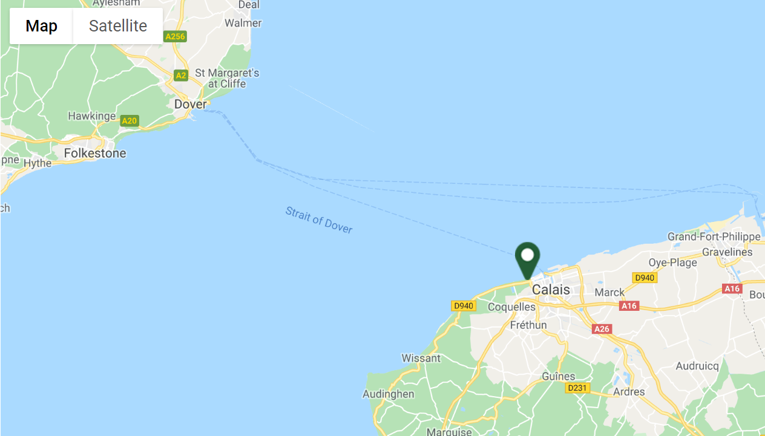

Les Baraques Military Cemetery Sangatte

Alfred Jayes (A. Jayes)
Private 3032 Leicestershire Regiment 1/4 Battalion
Born in 1897, Alfred was the second son of Arthur Eddy Jayes and Emma Shaw from Coventry, who together with his older brother Arthur Horace lived at 113 Burgess Road. Originally his father worked as a Stone Mason, but later he was a Florist, Chrysanthemum Grower and Grocer, Alfred’s mother was assisting in the Grocery and his older brother was a Florist working in the garden.
Alfred enlisted in the Leicestershire Regiment on 25th September 1914, but was Killed in Action on the 4th July 1915 aged 18.
He is buried at Sanctuary Wood Cemetery, Zillebeke, Belgium. Originally there were 3 Commonwealth cemeteries at Sanctuary Wood before June 1916, but all of them were obliterated on the battle of Mount Sorrel, however, traces of the second cemetery were found and became the nucleus of the present cemetery.
His inscription reads; “Hearts That Loved You Never Forget”.
Within his army paperwork is a Statement of the Names and Addresses of all Relatives Form, which shows that his older brother was at Present with the Army in France. The Declaration at the bottom is signed by Alfred’s father and dated 21st May 1919. The form was also to be signed my a Minister or Magistrate. It looks like his father added the following message at the bottom, ‘Sir, I am too busy to go running after a JP or a minister, I am an Englishman, my word is Good’. The form was eventually signed by an Alderman on 4th July 1919.
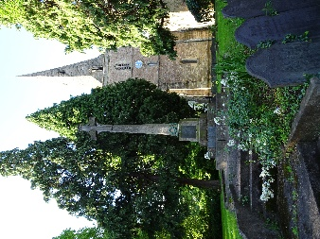 He also appears on the Granby Road School, St James Church, 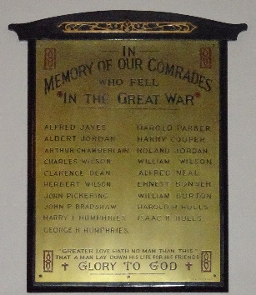 St Andrew’s Churchyard Aylestone Baptist Church memorial

Albert Henson Jones (A. H. Jones)
Private 23031 Leicestershire Regiment 2/4 Battalion
Albert was born in 1892 the eldest son of John Jones from Baldock in Hertfordshire and Lucy Henson who had married in 1891.
In 1901 the family which now included a second son, William, born in 1899 was living at 14 Burns Steet. His father was working as a Boot Finisher.
The 1911 census shows the family living at 18 Park Avenue. As well as his parents and younger brother William, he now had a second brother, John born in 1910. Also his parent now had an adopted daughter, Cecilia Lowe, born 1904. They had two lodgers, Albert and Betty Kasanowski from Russia. Albert was not living with the family at this time.
Albert came back from Canada to enlist in the Leicestershire Regiment. He was reported missing on the 22nd May 1918. The War Office Daily list on 22nd November 1918 stated ‘Previously reported missing, now reported Prisoner of War in lists received from the German Government’.
However, he had died on 18th October 1918 aged 26. His buriel commeration is at Hautmont Communal Cemetery in France, which was a communal cemetery used by German troops to bury their dead, and the Allied prisoners who had died in the local German hospitals.
Albert’s younger brother William enlisted to the Royal Flying Corps in 22nd October 1917 and was transferred to the new RAF on 1st April 1918, he served with 96 Squadron as a Air Mechanic 3rd Class.

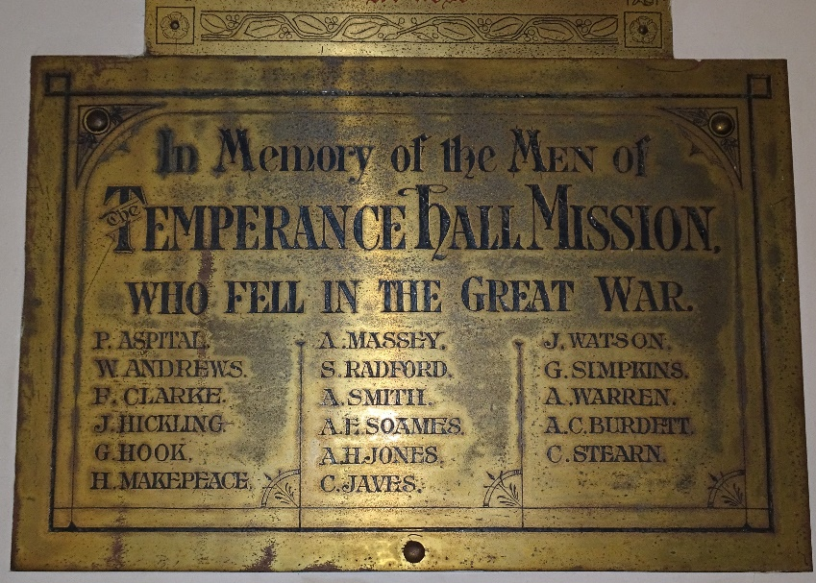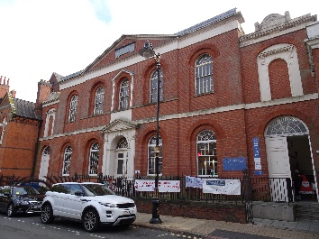

The Temperance Hall Mission war memorial, held by the Bishop Street Methodist Church includes A H Jones, but as there were two A H Jones’s in the Leicestershire Regiment it is not known which one this memorial would relate too.
Rowland Jordan (R. Jordan)
Private 202812 Leicestershire Regiment 2/4 Battalion
Rowland was the second child of Thomas Jordan, a Warehouse Man and Harriett Bray who had married in 1883. They were living in Old Church Street in Aylestone in 1891 with Rowland’s older sister May, born in 1884 and younger brother William Henry born in 1889.
By 1901 the family which now included Gladys born in 1898, had moved to Wigston Road. Rowland was now aged 14 and working as a Shoe Hand in a Pressroom.
He married Clara Parker on the 5th November 1910 at St Mary Magdelen Church in Knighton. She was was living at 196 Saffron Lane. The couple moved to 103 Cavendish Road and the 1911 census shows that he was a Boot Maker, Clara was working as a Boot Machinest. Clara gave birth to a baby boy, Harry in 1914.
He enlisted in the Leicestershire Regiment and Died of Wounds on the 25th March 1918 aged 30. Heis buried at BAC-DU-SUD British Cemetery, Bailleulval in France, which was designed by Charles Holden, who is best known for designing many London Underground Stations. His inscription reads; “Only Sleeping Till The Dawning Of The Bright Millennial Day”.
Rowland’s younger brother William Henry served in the Army Service Corps in the War. In 1939 Clara was living at 16 Sheridan Street and died on 25th August 1962. Their son Harry was a Draper and living at 223 Saffron Land with his wife Gertrude.
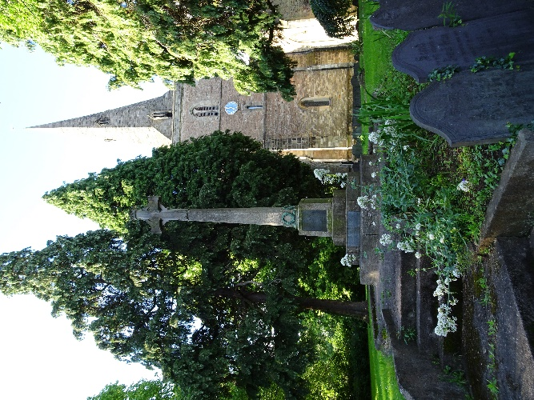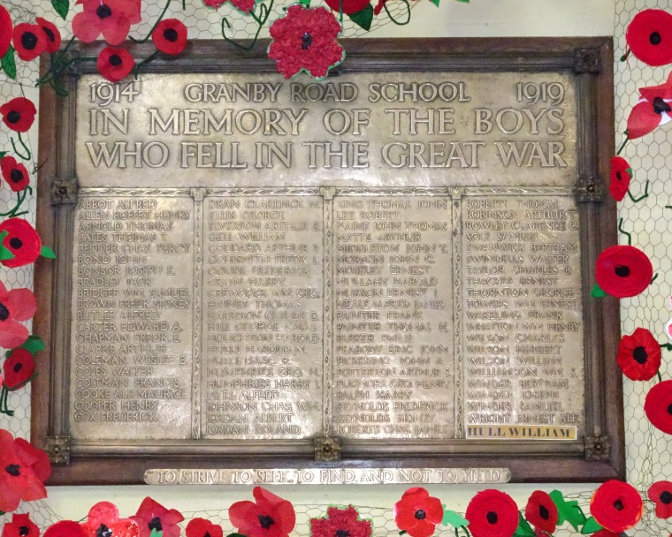
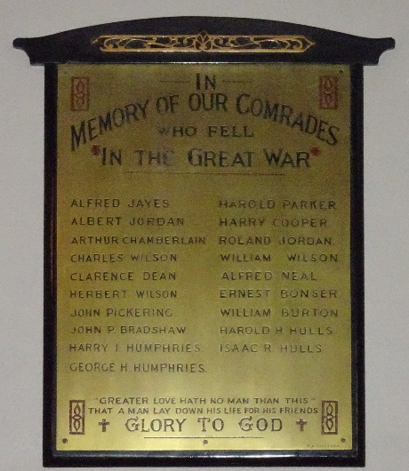 Rowland is also Remembered on the St Andrew’s Church war memorial, Granby Road School memorial as well as the Aylestone Baptist Church.
Albert Lawrence Private 50839 Cheshire Regt 10 Battalion
Thomas Lawrence Private 23837 Leicestershire Regt 2 Batt
BROTHERS (A. & T. Lawrence)
In 1891 the Lawrence family was living at 29 Frank Street and was made up of the Father, Joseph Lawrence from Earl Shilton, who was a Railway Guard and his wife Mary White, at the time they had four children, Minnie born in 1885 Joseph born in 1887, Ellen born in 1889 and Albert born in 1891.
By 1901 the family had moved to 11 Sheridan Steet and now included another son, Thomas who was born in 1894. The father was now a Railway Foreman and oldest son, Joseph was working as a Telegraph Messenger.
Later the two oldest sons, Joseph and Albert were working as Postmen and youngest son Thomas, was a Shoe Clicker according to the 1911 census, which also showed that originally there were nine children in total but four had died in childhood. Their older brother Joseph died in 1913 and is buried at St Mary’s Church Knighton.
Albert was working as a Rubber Hand when he enlisted to the Cheshire Regiment on 8th December 1915. He was fighting in France from the 3rd May 1917 until he was killed in action on 1st August 1917 aged 27. His paperwork dated 28th February 1918 states that he was ‘killed, but no definate evidence possed’.
As there is no known grave his Burial Commemeration is at Ypres on the Menin Gate Memorial in Belgium, which is one of the best known war memorials in the world, and lists more than 54,000 soldiers.
Thomas died on 10th July 1916 Aged 22 in Mesopatamia. He was buried at Basra War Cemetery in Iraq. In 1935 all the headstones were removed as they had deterioted due to the salty soil. All the Commonweath casualties are commemorated on a Memorial Screen Wall built the same year.
Both brothers were remembered on the St Michael’s Church, Scott Street Memorial. The church which was in Knighton, was demolished in 1997 for a new housing development. The memorial is also held by the At Risk War Memorials Project.
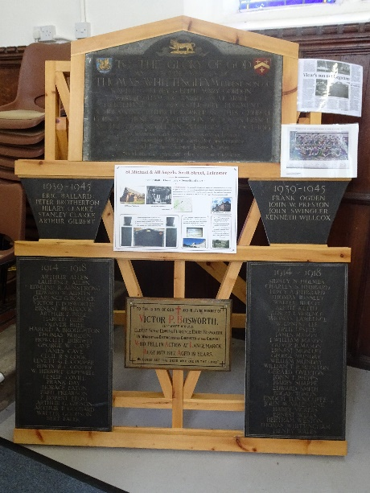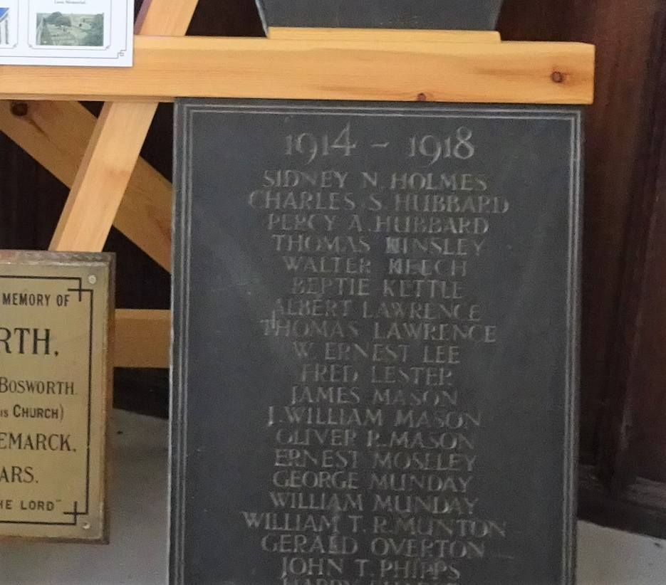
St Michael’s Church Memorial
John Thomas Maine (J. T. Maine)
Lance Corporal 277253 Durham Light Infantry 1/9 Battalion
Born in 1889, the son of John Maine and Mary Ann Berridge from Huncote, who had married in 1882.
The 1891 Census shows the family living at Milligan Road, his father was a Wood Sawyer. They had four son’s, George born 1885, William born 1888, John born 1889 and Alfred born 1898 who died not long after the Census was taken.
By the time of the 1901 Census the family were living at Burgess Road, George aged 16 and William aged 13 were working as Cigar Box Makers. The family now included three daughters, Louise born 1894, Emma born 1896 and Lydia born 1898.
The next census in 1911 shows that the Louise aged 17 was working as a Shop Assistant, Emma aged 15 was working as a Laundry Packer, Lydia was at school. William aged 23 and John Thomas aged 22 were working as Gardeners. Although John Maine Senior was working as a Curcular Sawyer, the Family buisness was now ‘John Maine and Son Florist’. The oldest son, George was married to Beatrice and they were living at 196 Milligan Road, he was still working as a Wooden Box Maker. John and Mary had nine children in total but three had died before 1911.
John Thomas was Killed in Action on 23rd July 1918 aged 29. He is buried at Courmas British Cemetery, Marne in France, the Cemetery was made after the Armistice and now has over 200 casualties, of which over a quarter are unidentified. His inscription reads; “Tis Not For Nought Thy Earthly Loss Is Heavenly Gain”.

He is also remembered on the Granby Road School memorial.
John Thomas Middleton (T. Middleton)
Lance Sergeant 2157 Leicestershire Regiment 1/4 Battalion
Thomas was born in 1896 the son of Thomas Middleton, from Wellingborough and Mary Dale from Somerby in Melton Mowbray. The family lived at 4 Cyprus Road in Aylestone in 1901 with Thomas’s older brother and sister, also living them was Mary’s parents and unmarried sister, Annie Dale.
The 1911 census shows that Thomas’s father was a Laundry Proprietor with Mary assisting. His oldest brother, James aged 18 was working as a Confectionery Sugar Boiler. Thomas aged 15 was working as a Hosery Hand. Mary’s mother was still living with them, but was a widow , also living with them was John Dale aged 9 who was listed as a Nephew.
Thomas enlised on 7th August 1914 and was posted to France on 2nd March 1915. He was listed as missing on the Casualty List issued by the War Office on 7th November 1915.
He was killed in action on 13th October 1915 aged 19 at the Battle of Loos, Hohenzollern Redoubt, the same day as Albert Rowe also on the Vernon Road Memorial, who was in the same regiment as Thomas. They are both remembered at Loos Memorial in France, which commemorates over 20,000 men with no known grave.

Thomas is also included on the Granby Road School Memorial.

E. A. Parker
Private 38038 Lincolnshire Regiment 1 Battalion
KILLED IN ACTION 26/10/1917
COMMEMERATION - TYNE COT MEMORIAL, ZONNEBEKE, WEST VLAANDEREN, BELGIUM
______________________________
Unable to find a link to the Aylestone Park area from the above information as supplied in the Leicestershire and Rutland, Soldiers Died 1914-1920 records on www.findmypast.co.com.
The St James Church, Aylestone memorial includes an ‘A. E. Parker’ who may be the same person as the church was in the same area as the Vernon Road, Methodist Church.

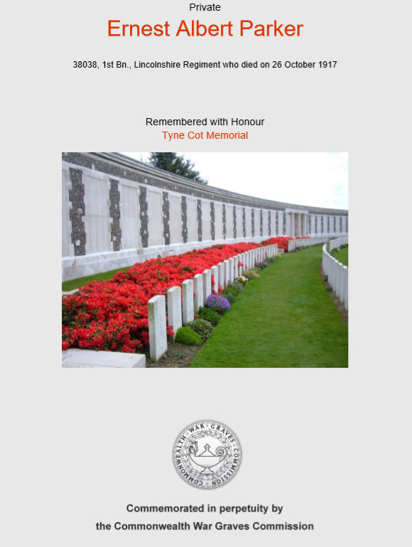
John Henry Parker (J. H. Parker)
Private 201832 Leicestershire Regiment 2/4 Battalion
John Henry Parker was born in 1896, he was the son of Ernest Arthur Parker from Warwickshire and Sarah Richardson from Countersthorpe, who had married on 2nd October 1879.
On the 1891 Census the family were living at Harold Street, Aylestone. Ernest and Sarah had four children, Albert born 1881, Mary born 1885, Clara born 1887 and Maud born 1890. By the time of the 1901 Census three more children had been born, Lizzie born 1893, John Henry born 1896 and Arthur born 1900 and they had moved to Swanscombe Road. John’s father and his three oldest children were all working in the Boot and Shoe manufacturing.
The family had moved to 196 Saffron Lane by the 1911 Census. The couple had another daughter, Dora who was born in 1902. Maud was working as a Shoe Hand Skiver, Lizzie was an Hosiery Hand and John who was now 15 was working as a Shoe Hand Clicker. The three oldest children were no longer living with the family.
John was Killed in Action on 5th July 1917 aged 21. He is remembered on the Thiepval Memoral, Somme in France, which is the largest Commonwealth memorial to the missing in the world. It commemorates more than 72,000 men, the majority had died during the Somme Offensive of 1916.

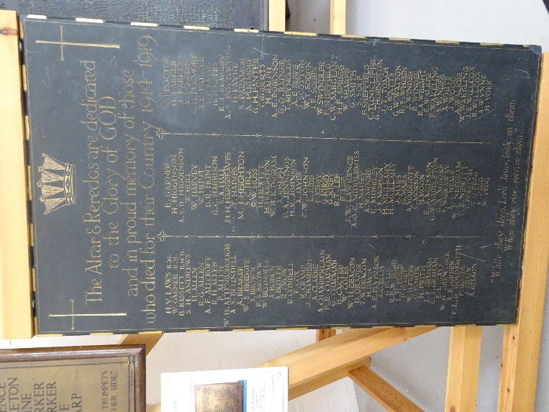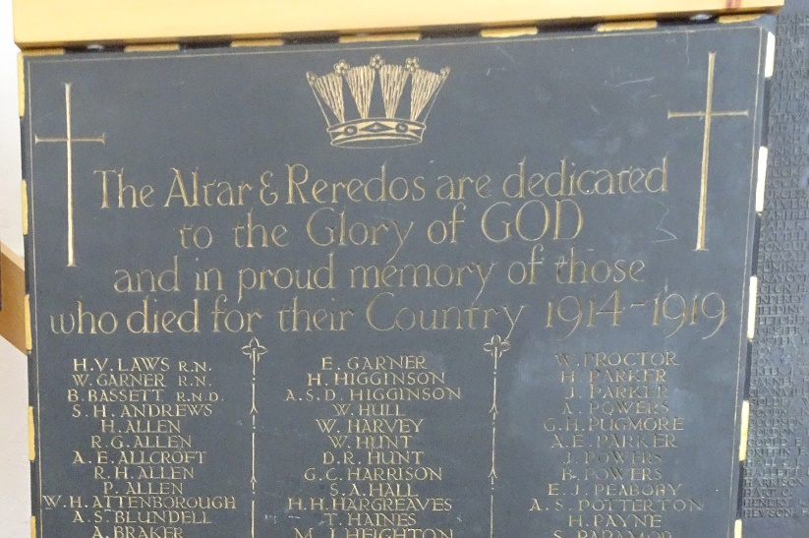

The St James Church memorial, also held by the At Risk War Memorials Project, includes a ‘J. Parker’, who may be the same person as both churches were in the same area.

Albert Edward Roe (A. Rowe)
Private 3581 Leicestershire Regiment 1/4 Battalion
The son of Ernest Roe and Margaret Lane who married on 4th January 1893. Albert was born in 1894 and was followed by a sister Gertrude in 1897, the family were living at Batten Street.
The 1901 census shows that it was a full house at Batten Street. Three generations were living at the house, Albert’s Grand Parents, John and Elizabeth Lane their children Mary, John, Alice and Margaret Roe who was a widow by now. Albert’s father had died in 1897 aged 23, and grandchildren, Albert who was 6 and Gertie aged 4. Margaret was working as an Ironer in Hosiery.
At the age of 26 Albert’s mother got married again on 26th December 1901 to William George Day, who was a Gas Labourer. The couple married at St Michaels and All Angels in Knighton. By the 1911 census still living at Batten Street, Albert aged 16 was working as Hosiery Hand Warehouseman, his sister aged 14 was in the Corset Trade. Margaret and William now had a daughter of their own, Margaret who was 5 months old. A previous daughter named Nellie was born in 1904, but died at the age of 5 in 1909.
Albert was killed in action on 13th October 1915 aged 19 at the Battle of Loos, Hohenzollern Redoubt, the same day as Thomas Middleton also on the Vernon Road Memorial, who was in the same regiment as Thomas. They are both remembered at Loos Memorial in France, which commemorates over 20,000 men with no known grave.
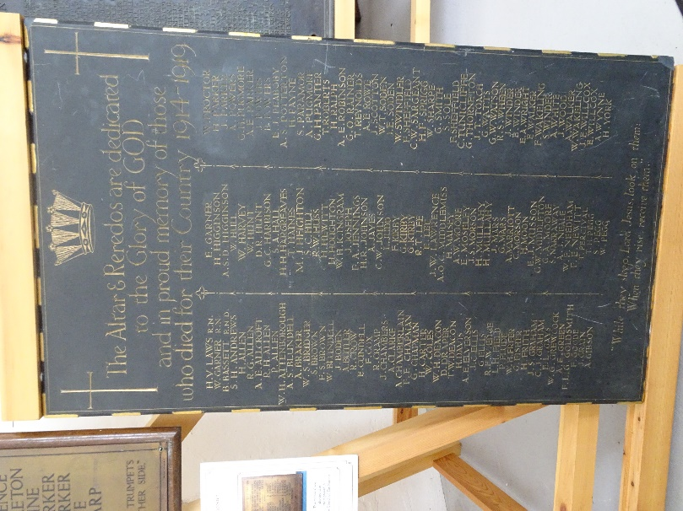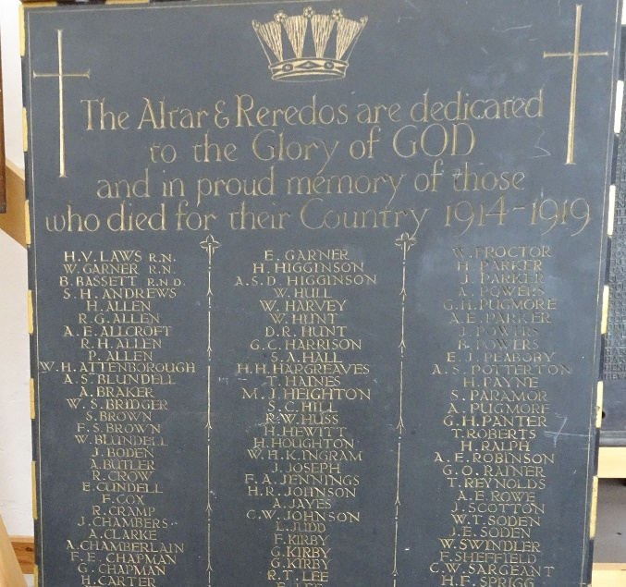

As well as being on the Vernon Road Memorial as A Rowe, he is also listed on the St James Church, Aylestone Park Memorial also held by the At Risk War Memorials Project, as A E Rowe.

William Sharpe (W. Sharp)
Acting Bombardier 294979 Royal Garrison Artillery 147th Heavy Battery
The son of Harry Sharpe and Frances Standley from Croft, who had married in 1885, on the 1901 Census the family were living at 35 Denmark Road, Williams parents were aged 39, Harry was working as a Labourer at a Shoe Works. William was aged 8, his older sister Florence Annette was 12. Also living with them was William’s Uncle Alfred aged 29,who was a Shoe Hand Rivatter.
By 1911 they had moved to 245 Milligan Road, Williams Father was working as a Hoistman in Boot Manufacturing. His sister Florerence was a Boot Machinist and William now 18 was a Boot and Shoe Manufactures Clerk. His uncle Alfred who was now married to Ellen was living next door at 243 Milliagan Road together with Ellen’s sister Minnie Moseley . Albert Townsend aged 25 who was a Music Hall Artist from Hackney, London was a Visitor staying with them.
William Died of Wounds on 6th August 1917 aged 25. He is buried in the Belgian Battery Corner Cemetery at Ypes in Belgium. The cemetery was begun in June 1917 after the Battle of Messines and was used largely for buriels from a dressing station in a cottage near by. His inscription reads ‘The Fragrance Of a Good Life Lives Forever’.
Williams father Harry, died in 1916, his mother Frances, died in 1919 and his sister Florence who was living at 18 Leeson Street with her Uncle Alfred and his wife died unmarried in 1958.

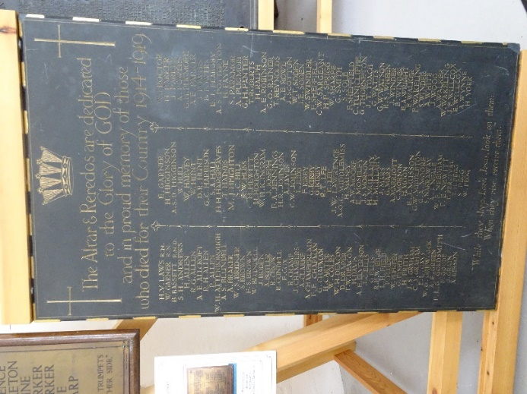

He is also remembered of the St James Church memorial, which is also held by the At Risk War Memorials Project following the demolition of the church.

